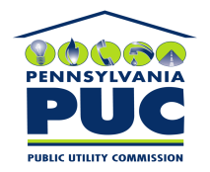 | COMMONWEALTH OF PENNSYLVANIA  PENNSYLVANIA PUBLIC UTILITY COMMISSION  P.O. BOX 3265, HARRISBURG, PA 17105-3265 | IN REPLY PLEASE REFER TO OUR FILE

July 22, 2011
U-2011-2248314

KIM G FLOWERS
AGENCY COORDINATOR
PPL ELECTRIC UTILITIES CORP
TWO NORTH NINTH STREET
ALLENTOWN PA 18101-1179

Agreement dated June 20, 2011 between PPL Electric Utilities Corp and Franconia Township of Montgomery County grates PPL the right to construct, operate and maintains its electric line facilities.

To Whom It May Concern:

We enclose herewith the original and one (1) copy of certificate of filing issued by this Commission in accordance with Section 507 of the Public Utility Code, 66 Pa. C.S. §507.

You should serve the enclosed copy of this certificate upon the Township of Franconia.

Very truly yours,


Rosemary Chiavetta
Secretary

mh
encls.
cert.mail

