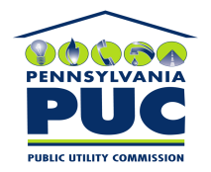 | COMMONWEALTH OF PENNSYLVANIA  PENNSYLVANIA PUBLIC UTILITY COMMISSION  P.O. BOX 3265, HARRISBURG, PA 17105-3265 | IN REPLY PLEASE REFER TO OUR FILE

AUGUST 1, 2011
U-2011-2250107

JOHN C HALDERMAN ESQUIRE
EXELON BUSINESS SERVICES CO
2301 MARKET STREET/S23-1
PO BOX 8699
PHILADELPHIA PA 19101-8699

Agreement dated March 31, 2011 between PECO Energy Company and The Philadelphia Authority for industrial development relative to the right to enter onto the Premises for the purpose of constructing and maintaining a recreational trail for the use by the general public for walking, hiking, jogging, rollerblading and bicycling.

To Whom It May Concern:

We enclose herewith the original and one (1) copy of certificate of filing issued by this Commission in accordance with Section 507 of the Public Utility Code, 66 Pa. C.S. §507.

You should serve the enclosed copy of this certificate upon the City of Philadelphia.

Very truly yours,


Rosemary Chiavetta
Secretary

mh
encls.
cert.mail

