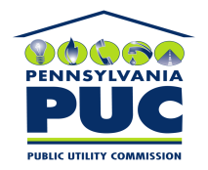 | COMMONWEALTH OF PENNSYLVANIA  PENNSYLVANIA PUBLIC UTILITY COMMISSION  P.O. BOX 3265, HARRISBURG, PA 17105-3265 | IN REPLY PLEASE REFER TO OUR FILE

September 19, 2011
U-2011-2257555

JOHN C HALDERMAN ESQUIRE
EXELON BUSINESS SERVICES CO
2301 MARKET STREET/S23-1
PO BOX 8699
PHILADELPHIA PA 19101-8699

Agreement dated May 5, 2011 between PECO and County of Montgomery relative with leasing the property non-commercial, recreational, educational purposes.

To Whom It May Concern:

We enclose herewith the original and one (1) copy of certificate of filing issued by this Commission in accordance with Section 507 of the Public Utility Code, 66 Pa. C.S. §507.

You should serve the enclosed copy of this certificate upon the County Of Montgomery.

Very truly yours,


Rosemary Chiavetta
Secretary

mh
encls.
cert.mail

