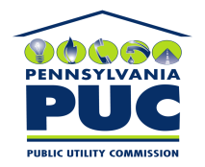 | COMMONWEALTH OF PENNSYLVANIA  PENNSYLVANIA PUBLIC UTILITY COMMISSION  P.O. BOX 3265, HARRISBURG, PA 17105-3265 | IN REPLY PLEASE REFER TO OUR FILE

October 4, 2011
U-2011-2261475

PAUL E RUSSELL ESQUIRE
PPL
TWO NORTH NINTH STREET
ALLENTOWN PA 18101-1179

Agreement dated July 5, 2011 between PPL Electric and the Borough of Montoursville relative with granting PPL the right to construct, operate and maintain the electric line facilities in the Borough of Montoursville.

To Whom It May Concern:

We enclose herewith the original and one (1) copy of certificate of filing issued by this Commission in accordance with Section 507 of the Public Utility Code, 66 Pa. C.S. §507.

You should serve the enclosed copy of this certificate upon the Borough of Montoursville.

Very truly yours,


Rosemary Chiavetta
Secretary

mh
encls.
cert.mail

