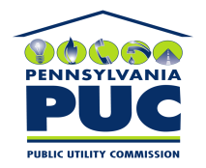 | COMMONWEALTH OF PENNSYLVANIA  PENNSYLVANIA PUBLIC UTILITY COMMISSION  P.O. BOX 3265, HARRISBURG, PA 17105-3265 | IN REPLY PLEASE REFER TO OUR FILE

October 5, 2011
U-2011-2261478

CHARLOTTE KRUPA
AGENCY COORDINATOR
PPL
TWO NORTH NINTH STREET
ALLENTOWN PA 18101-1179

Agreement dated August 25, 2011 between PPL Electric and County of Schuylkill relative with granting PPL the right to construct, operate, and maintain its electric line facilities in the Township of Tremont, County of Schuylkill.

To Whom It May Concern:

We enclose herewith the original and one (1) copy of certificate of filing issued by this Commission in accordance with Section 507 of the Public Utility Code, 66 Pa. C.S. §507.

You should serve the enclosed copy of this certificate upon the Township of Tremont.

Very truly yours,


Rosemary Chiavetta
Secretary

mh
encls.
cert.mail

