PENNSYLVANIA
PUBLIC UTILTY COMMISSION
Harrisburg, PA 17105-3265

Public Meeting held October 14, 2011

Commissioners Present:

Robert F. Powelson, Chairman
John F. Coleman, Jr., Vice Chairman
Wayne E. Gardner
James H. Cawley - Absent
Pamela A. Witmer, Statement

Petition of Duquesne Light Company :
for Approval of its Energy Efficiency :
and Conservation and Demand Response Plan : M-2009-2093217
(Petition for Approval of Modifications to :
its Demand Response Programs) :

ORDER

BY THE COMMISSION:

We adopt as our action the Initial Decision of Administrative Law Judge John H. Corbett, Jr. dated September 14, 2011;

THEREFORE,

IT IS ORDERED:

- That the Joint Petition for Settlement that Duquesne Light Company, the Office of Consumer Advocate, Duquesne Industrial Intervenors, and Comverge, Inc. have submitted on August 26, 2011 at Docket No. M-2009-2093217 is hereby approved.

- That the Petition of Duquesne Light Company for Approval of Changes to its Energy Efficiency and Conservation and Demand Response Plan filed on May 9, 2011 at Docket No. M-2009-2093217 is moot and, therefore, is denied.

- That Duquesne Light Company is permitted to implement its Energy Efficiency and Conservation and Demand Response Plan, as modified by the terms and conditions set forth in the Joint Petition for Settlement filed on August 26, 2011, consistent with this Recommended Decision.

- That any directive, requirement, disposition or the like contained in the body of this Recommended Decision that is not the subject of an individual Ordering Paragraph shall have the full force and effect as if fully contained in this part.

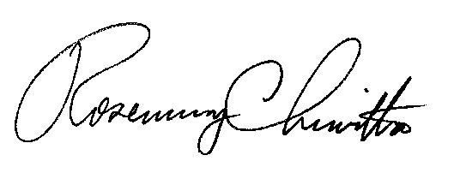
BY THE COMMISSION

Rosemary Chiavetta
Secretary

(SEAL)

ORDER ADOPTED: October 14, 2011

ORDER ENTERED: October 14, 2011

