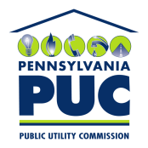 | COMMONWEALTH OF PENNSYLVANIA  PENNSYLVANIA PUBLIC UTILITY COMMISSION  P.O. BOX 3265, HARRISBURG, PA 17105-3265 | IN REPLY PLEASE REFER TO OUR FILE

November 3, 2011
A-2009-2113604

COMVERGE INC

FRANK LACEY

511 SCHOOLHOUSE ROAD SUITE 20
KENNETT SQUARE PA 19348

Re: Application to Re-Register as a Conservation Service Provider

Dear Mr. Lacey:

On September 20, 2011, Comverge Inc. filed an application to re-register as a Conservation Service Provider (CSP) with the Pennsylvania Public Utility Commission. A CSP must re-register every two years to remain on the registry. The original registry date of Comverge Inc. was July 29, 2009.

A registered CSP can advise an electric distribution company (EDC) and/or provide consultation, design, administration or management services to an EDC related to the EDC’s energy efficiency and conservation plan. Upon review, it appears that the applicant continues to meet the Pennsylvania Public Utility Commission’s minimum qualifications to provide consultation, design, administration, management or advisory services to an EDC regarding energy efficiency and conservation plans required under Act 129 of 2008, P.L. 1592.

Therefore, effective from the date of this Secretarial Letter, Comverge Inc., is re-registered as a CSP on the Pennsylvania Public Utility Commission’s Registry of Conservation Service Providers for two more years with a new expiration date of July 29, 2013. In addition, the applicant is advised that if any information in the application changes, it must provide a written notice of said change to the Commission within 45 days of the change.

This approval is not meant to constitute a license, certification or warranty of any kind by the Pennsylvania Public Utility Commission.

Please direct any questions to John Matchik, Energy Industry Group, Bureau of Technical Utility Services at (717) 783-6163.
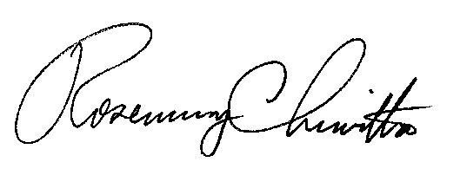
Sincerely,

Rosemary Chiavetta
Secretary

cc: Elaine McDonald, FUS
Kathleen Aunkst, Secretary’s Bureau

