PENNSYLVANIA
PUBLIC UTILITY COMMISSION
Harrisburg, PA 17105-3265

 | Public Meeting held November 10, 2011
Commissioners Present:
Robert F. Powelson, Chairman
John F. Coleman, Jr., Vice Chairman
Wayne E. Gardner
James H. Cawley
Pamela A. Witmer

License Application of EnerPenn USA, LLC for Approval to Offer, Render, Furnish or Supply Electricity or Electric Generation Services as a Supplier of Retail Electric Power |  | Docket No. A-2011-2248532

ORDER

BY THE COMMISSION:

On June 17, 2011, EnerPenn USA, LLC d/b/a Y.E.P., d/b/a YEP Energy (EnerPenn) filed an application seeking to become a licensed electric generation supplier (EGS) in the electric distribution company service territories throughout the Commonwealth of Pennsylvania. The application was filed pursuant to the Commission’s regulations at 52 Pa. Code §§54.31-54.43, which became effective on August 8, 1998, and which were established under Section 2809 of the Public Utility Code, 66 Pa. C.S. §2809.

§2809 provides in pertinent part that:
License Requirement.--No person or corporation, including municipal corporations which choose to provide service outside their municipal limits except to the extent provided prior to the effective date of this chapter, brokers and marketers, aggregators and other entities, shall engage in the business of an electric generation supplier in this Commonwealth unless the person or corporation holds a license issued by the Commission. 66 Pa. C.S. §2809.

An electric generation supplier is defined as:

A person or corporation, including municipal corporations which choose to provide service outside their municipal limits except to the extent provided prior to the effective date of this chapter, brokers and marketers, aggregators or any other entities, that sells to end-use customers electricity or related services utilizing the jurisdictional transmission and distribution facilities of an electric distribution company, or that purchases, brokers, arranges or markets electricity or related services to end-use customers utilizing the jurisdictional transmission and distribution facilities of an electric distribution company. 66 Pa. C.S. §2803.

EnerPenn is a foreign limited liability company, organized in the State of Texas as of April 6, 2011, and registered to do business in Pennsylvania as of April 21, 2011. EnerPenn proposes to act as a supplier of retail electric power to residential, small commercial (25 kw and under demand), large commercial (over 25 kw demand), industrial and governmental customers in the electric distribution company service territories throughout the Commonwealth of Pennsylvania.

Since EnerPenn proposes to provide electric generation supplier services to residential customers it is required to comply with, and be governed by, applicable Chapter 56 residential service regulations as set forth in the Commission Order Guidelines for Maintaining Customer Service at the Same Level of Quality Pursuant to 66 Pa. C.S. §2807(d), and Assuring Conformance with 52 Pa. Code Chapter 56 Pursuant to 66 Pa. C.S. §2809(e) and (f), at Docket No. M-00960890 F0011, Order entered July 11, 1997. Thus, we deem it appropriate to reiterate certain items with respect to Chapter 56 of our regulations. Chapter 56 (52 Pa Code Chapter 56) is applicable to residential accounts. An electric generation supplier cannot physically disconnect a residential customer from the electricity grid; therefore, the rules relating to residential service termination are not applicable to electric generation suppliers. An electric generation supplier may seek to terminate its generation service through an appropriate written notice to the customer and the distribution company. The residential customer can then attempt to repair their relationship with the supplier, seek a new supplier, or return to utility service at default service rates in accordance with the utility's obligations under Section 2807(e), 66 Pa. C.S. §2807(e). The customer would only be disconnected from the electricity grid pursuant to appropriate regulations if the customer failed to meet its obligations to the utility or the electric generation supplier that has been designated by the Commission as the provider of last resort.

Additionally, we specifically note that the licensee must comply with, and ensure that its employees, agents, representatives and independent contractors comply with the standards of conduct and disclosure for licensees set out in Commission regulations at 52 Pa. Code §54.43 that were enacted to protect consumers of this Commonwealth. These standards include, inter alia, the provision of timely and accurate information about the services offered by the licensee, the practice of nondiscrimination in service in regard to race, color, religion, national origin, marital status, etc., the safeguarding of a consumer’s personal information, and compliance with applicable state and federal consumer protection laws. Also, we take this opportunity to remind the licensee of its agreement to abide by, and to ensure that its employees, representatives, agents and independent contractors abide by all applicable federal and state laws, and Commission regulations, procedures and orders, including Emergency Orders, which may be issued verbally or in writing during any emergency situations that may unexpectedly develop from time to time in the course of doing business in Pennsylvania.
We also note that the licensee must comply with our decision in Docket No. M-2010-2157431, Motion adopted at the February 11, 2010, Public Meeting, regarding EGS membership in the PJM Interconnection (PJM). Specifically, our Motion directed that such EGS applicants must file with the Commission, within 120 days of receiving an EGS license, proof of membership in the PJM as a Load Serving Entity (LSE) or proof of a contractual arrangement with an existing PJM LSE that facilitates the applicant’s retail operations. Since EnerPenn is taking title to electricity, it is required to comply with this requirement.

EnerPenn has provided proofs of publication in Pennsylvania newspapers and proofs of service to the interested parties as required by the Commission.

Regarding the financial and technical requirements of the license application, EnerPenn submitted the audited 2009 and 2010 Balance Sheet, Statement of Operations, and the Statement of Cash Flows for Texpo Power, LP (Texpo). Texpo is an affiliate of EnerPenn which has the same or similar owners, and officers. Texpo best reflects the market strength of EnerPenn. EnerPenn has also supplied resume data for its chief officers. Sufficient information has been provided by EnerPenn to demonstrate its financial fitness in order to be licensed as a supplier of retail electric power in the service territories throughout the Commonwealth of Pennsylvania.

EnerPenn has provided a $250,000 surety bond as required by the license application.

As of November 1, 2011, no protests have been filed with the Commission.

In the course of staff review of the instant application EnerPenn disclosed two court proceedings that its affiliate was a party to in Texas: a consumer/regulatory action and a criminal/civil proceeding.
On January 4, 2011 the Public Utility Commission of Texas Docket No. 39046, issued an order which approved the Settlement Agreement and Report to the Commission regarding Commission Staff’s investigation of Texpo Power, LP for violations of PURA §§17.004 and 39.101 and Subchapter R of the substantive rules of the Commission. That order was the result of Audit 2010050005 for Texpo Power, LP which was part of an industry wide audit that requested documents and confirmation of compliance with Customer Protection Rules for retail electric service. Commission Staff recommended an administrative penalty of $19,000. Texpo remitted payment to the Texas Commission on March 2, 2011.

Texpo Power, LP, EnerPenn’s affiliate, was involved as a defendant in a proceeding, at Case No. 1-11-425, in the 382nd Judicial District of Rockwall County, TX. The case is Donald Scott Mackenzie v Texpo Power, L.P. d/b/a Y.E.P. On April 20, 2011, Donald Scott Mackenzie (Plaintiff) submitted a Petition and Request for Disclosure to the 382 Judicial District of Rockwall County Texas wherein the Plaintiff asserts that Texpo engaged in deceptive business practices, common law fraud and, breach of contract. On May 25, 2011, an Order for Abating Lawsuit (1-11-425) was filed by Texpo. On September 27, 2011, the case (1-11-425) was dismissed with prejudice to the Plaintiff.

Upon review of the information submitted by EnerPenn in support of its application we note that the conduct of EnerPenn’s affiliate in other states (particularly Texas) raises consumer protection concerns. However, we believe that if we grant EnerPenn an EGS license subject to similar conditions we imposed on Just Energy, it is unlikely that EnerPenn would replicate the problematic history of its affiliates in other jurisdictions. These extensive conditions go a long way toward addressing our concerns regarding consumer protection.

Based on the above we direct that the following conditions be applied:

- All marketing materials to be used, including contracts and customer facing materials will be provided to Commission staff for informal comment 5 days prior to use. Bureau of Consumer Services review/comment does not relieve the supplier of complying with the relevant regulations and does not constitute a waiver/exemption from possible Commission action.

- EnerPenn will provide a single point of contact and escalation contacts for Commission staff for resolution of consumer inquiries and/or complaints received by the Commission's Bureau of Consumer Services ("BCS") and will respond to all consumer inquiries and complaints in accordance with Appendix 1 and any other BCS requirements, including providing all information regarding the customer and complaint as requested by Commission staff, including a copy of the contract and any audio recordings of the verification call. EnerPenn will also provide the Commission with the resolution of the complaint by the Company.

- Any early termination or exit fee imposed by EnerPenn will not exceed $50.00 per contract;

- EnerPenn will operate under the commitments outlined in Appendix 1.

- EnerPenn will use the disclosure statement developed in cooperation with the Commission’s BCS.

- EnerPenn shall file a status report with the Commission describing its compliance with the Public Utility Code, Commission Orders and Regulations, and the conditions set forth herein. The status report shall also include updated information regarding lawsuits, investigations, and state commission proceedings involving its affiliates in other jurisdictions.

We direct that the licensee be released from these conditions at the end of an eighteen-month probationary period, if it has:

a. Operated in good faith and compliance with the Conditions set forth and applicable Laws;

b. Maintained a Complaint Ratio of less than 2% of sales over the 18- month period;

c. Maintained the customer service level commitments based on the 18-month period (averaged across the period);

d. Obtained concurrence from Commission staff with the release from the aforementioned Conditions.

Based on the foregoing, we will grant the application of EnerPenn USA, LLC d/b/a Y.E.P., d/b/a YEP Energy; subject to the conditions, consistent with the Opinion and Order THEREFORE,

IT IS ORDERED:

1. That the application of EnerPenn USA, LLC d/b/a Y.E.P., d/b/a YEP Energy is hereby approved, consistent with this Order.

2. That a license be issued authorizing EnerPenn USA, LLC d/b/a Y.E.P., d/b/a YEP Energy to begin to offer, render, furnish or supply electric generation supplier services to residential, small commercial (25 kw and under demand), large commercial (over 25 kw demand), industrial and governmental customers in the service territories throughout the Commonwealth of Pennsylvania, subject to the following conditions, which will apply for a probationary period of eighteen months from the date EnerPenn USA, LLC d/b/a Y.E.P., d/b/a YEP Energy begins offering service in Pennsylvania. To the maximum extent possible, these conditions shall be construed to be consistent with the Commission’s regulations. In the event of a conflict the following conditions shall control:
- All EnerPenn USA, LLC d/b/a Y.E.P., d/b/a YEP Energy marketing materials to be used, including contracts and customer facing materials will be provided to Commission staff for informal comment 5 days prior to use. Bureau of Consumer Services review/comment does not relieve the supplier of complying with the relevant regulations and does not constitute a waiver/exemption form possible Commission action.

- EnerPenn USA, LLC d/b/a Y.E.P., d/b/a YEP Energy will provide a single point of contact and escalation contacts for Commission staff for resolution of consumer inquiries and/or complaints received by the Commission's Bureau of Consumer Services ("BCS") and will respond to all consumer inquiries and complaints in accordance with Appendix 1 and any other BCS requirements, including providing all information regarding the customer and complaint as requested by Commission staff, including a copy of the contract and any audio recordings of the verification call. EnerPenn will also provide the Commission with the resolution of the complaint by the Company.

- Any early termination or exit fee imposed by EnerPenn USA, LLC d/b/a Y.E.P., d/b/a YEP Energy will not exceed $50.00 per contract;

- EnerPenn USA, LLC d/b/a Y.E.P., d/b/a YEP Energy will operate under the commitments outlined in Appendix 1.

- EnerPenn USA, LLC d/b/a Y.E.P., d/b/a YEP Energy will use the disclosure statement developed in cooperation with the Commission’s BCS.

- Not less than sixty days before the expiration of the probationary period, EnerPenn USA, LLC d/b/a Y.E.P., d/b/a YEP Energy shall file a status report with the Commission describing its compliance with the Public Utility Code, Commission Orders and Regulations, and the conditions set forth herein. The status report shall also include updated information regarding lawsuits, investigations, and state commission proceedings involving its affiliates in other jurisdictions. A copy of this status report shall be provided to Paul Diskin in the Commission’s Bureau of Technical Utility Services and David Mick in the Commission’s Bureau of Consumer Services.

3. That the Commission’s Bureau of Consumer Services shall monitor EnerPenn USA, LLC d/b/a Y.E.P., d/b/a YEP Energy’s compliance with the conditions set forth in this Order.

4. Upon receipt of the status report directed in Paragraph 2. above, the Bureau of Technical Utility Services, with assistance from the Bureau of Consumer Services and the Law Bureau, shall prepare a Staff recommendation regarding appropriate license conditions after the expiration of the eighteen month probationary period. The Commission shall consider the recommendation at a subsequent Public Meeting. In making their recommendation, Commission staff shall consider all relevant factors, including whether EnerPenn USA, LLC d/b/a Y.E.P., d/b/a YEP Energy:

a. Operated in good faith and compliance with the Conditions set forth in Paragraph 2 and applicable Laws;

b. Maintained a Complaint Ratio of less than 2% of sales over the 18-month probationary period; and

c. Maintained the customer service level commitments based on the 18-month probationary period (averaged across the period).

5. That a copy of this Order be served on the Department of Revenue, Bureau of Corporation Taxes.

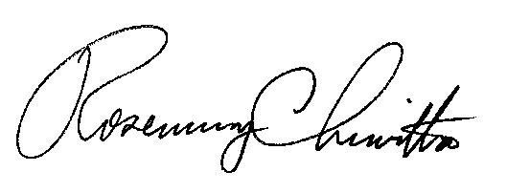
BY THE COMMISSION,

Rosemary Chiavetta
Secretary

(SEAL)

ORDER ADOPTED: November 10, 2011

ORDER ENTERED: November 14, 2011

Appendix 1:

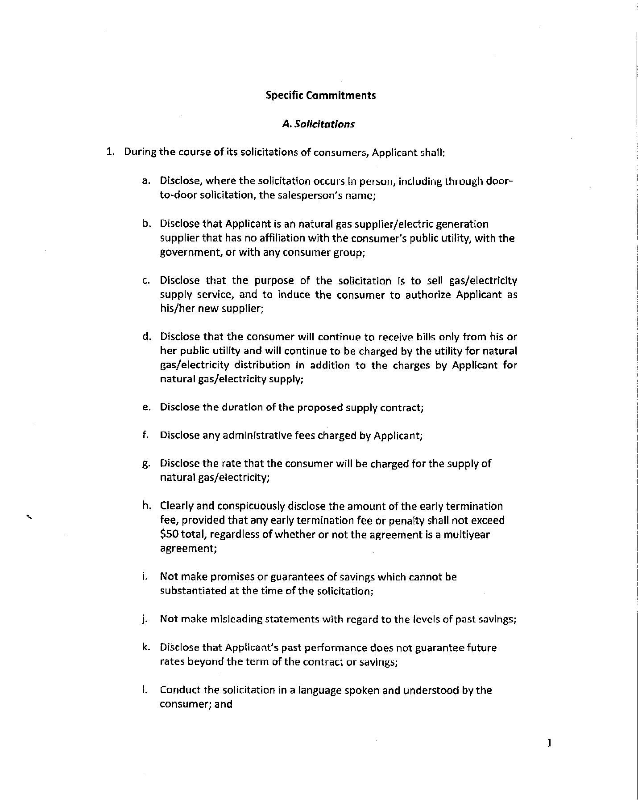
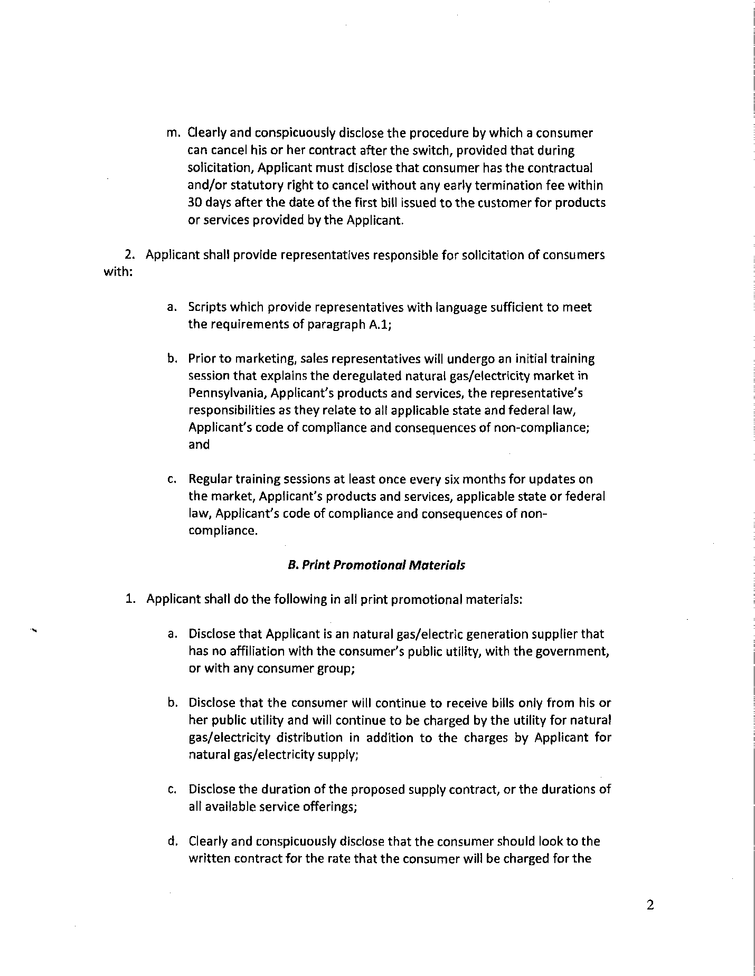
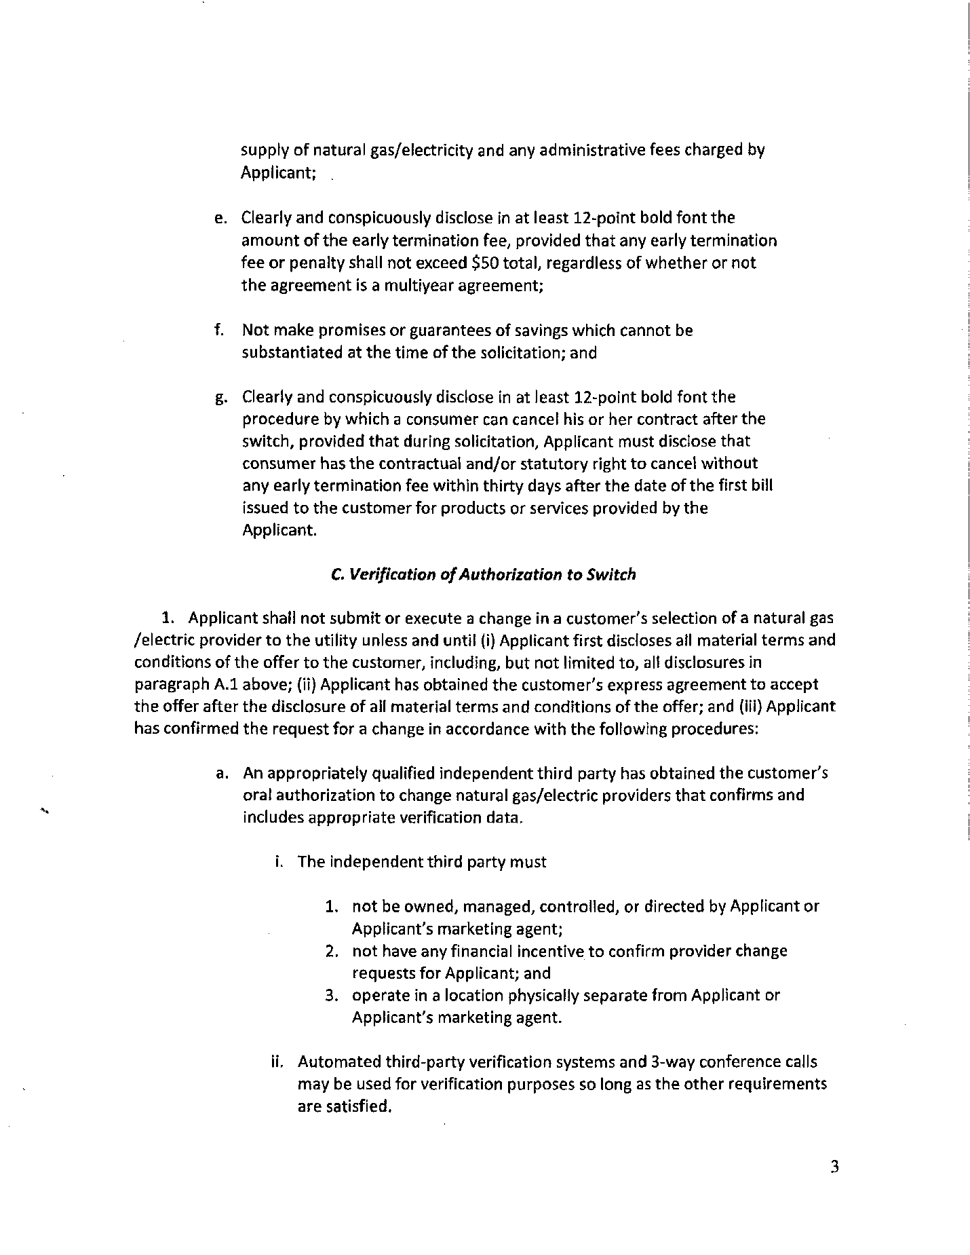
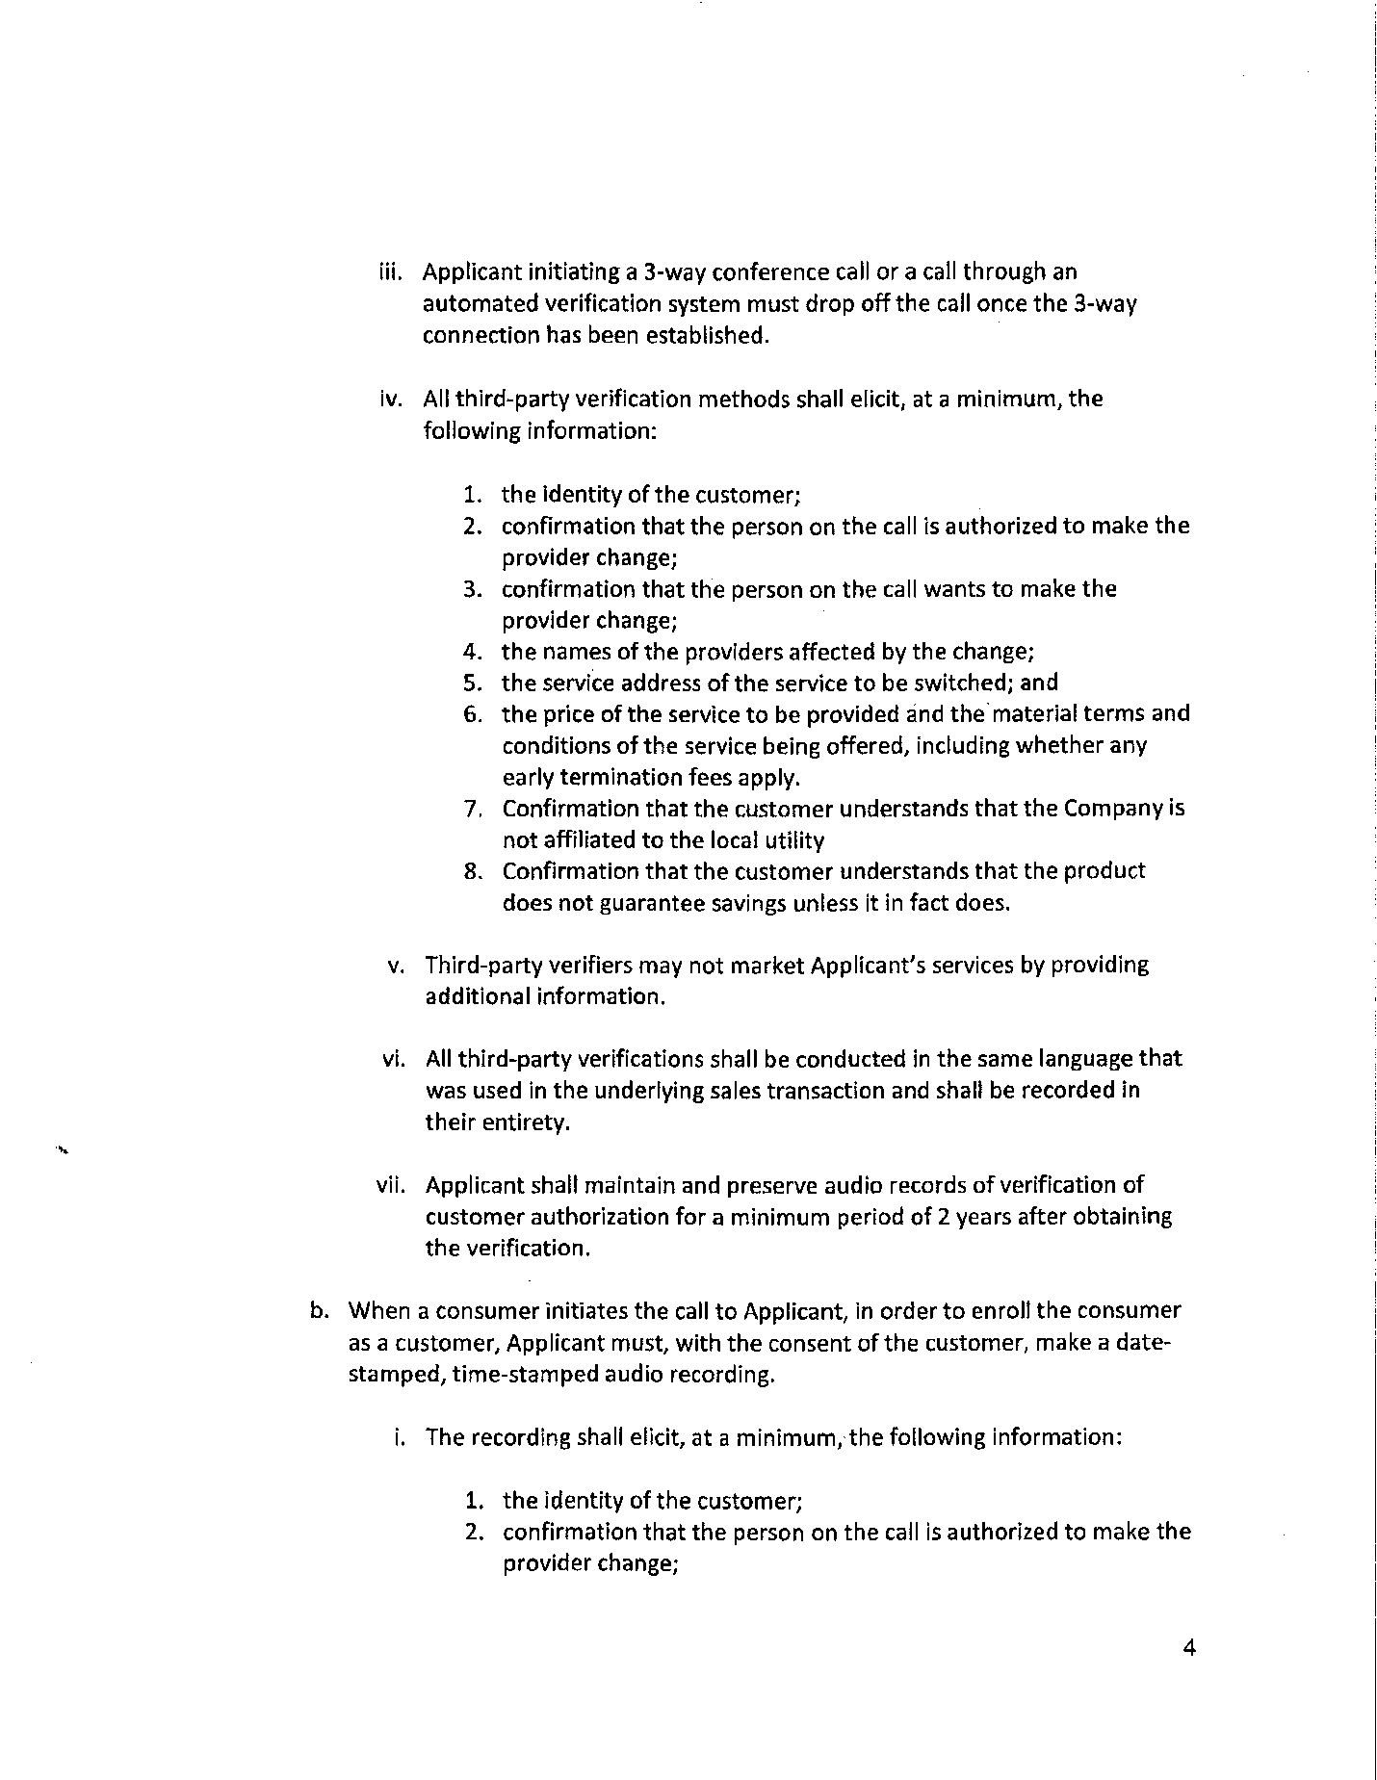
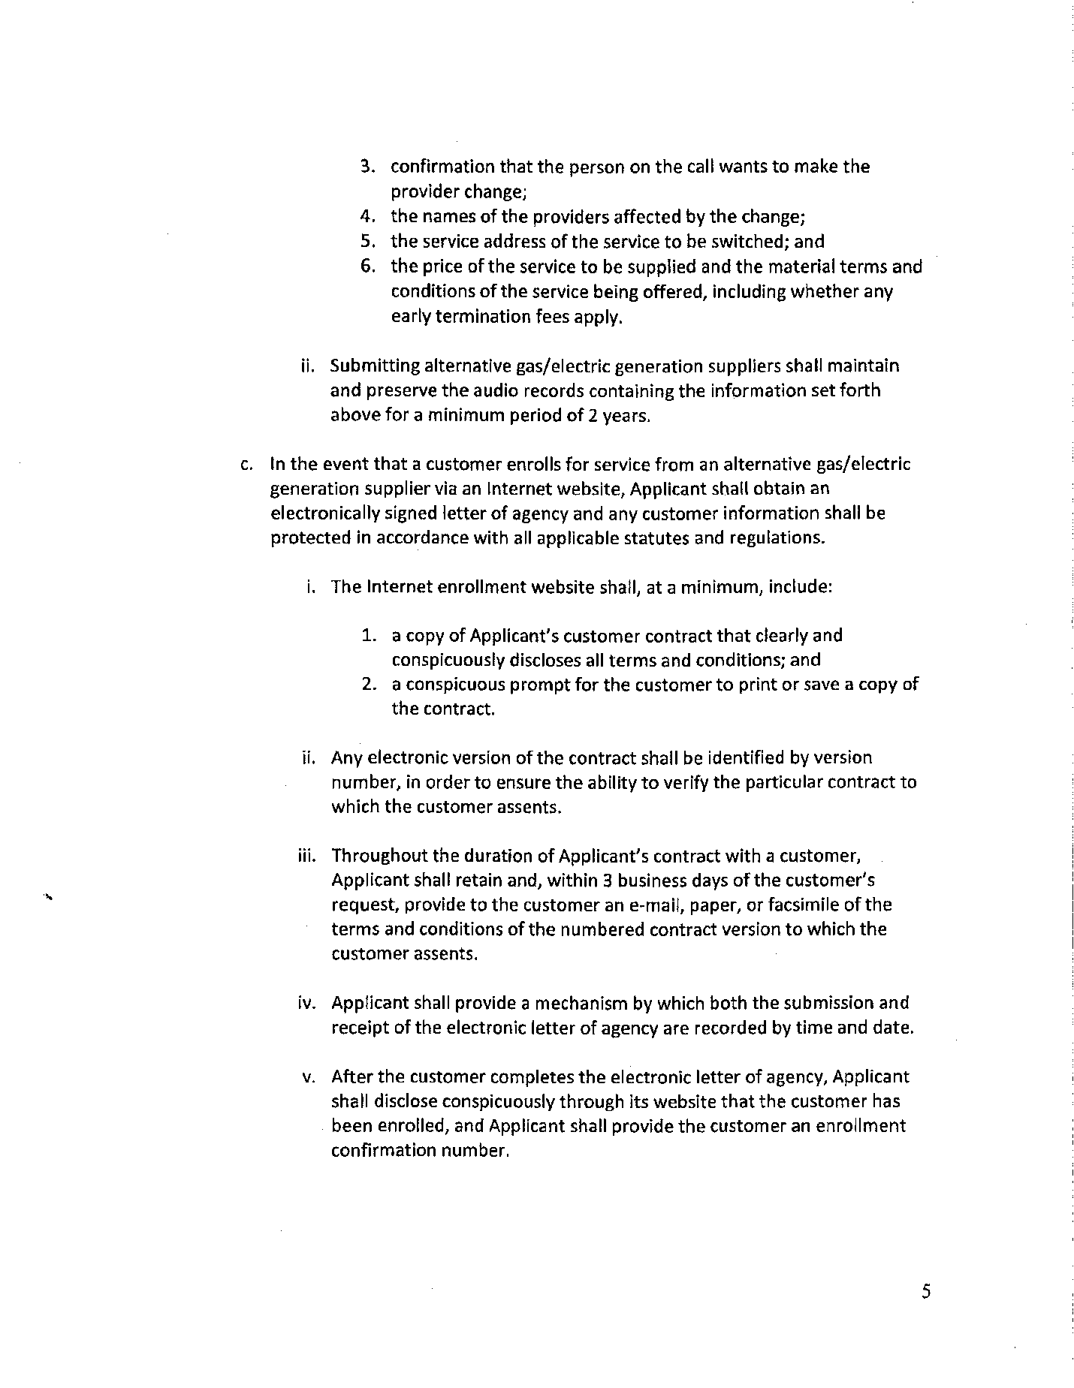

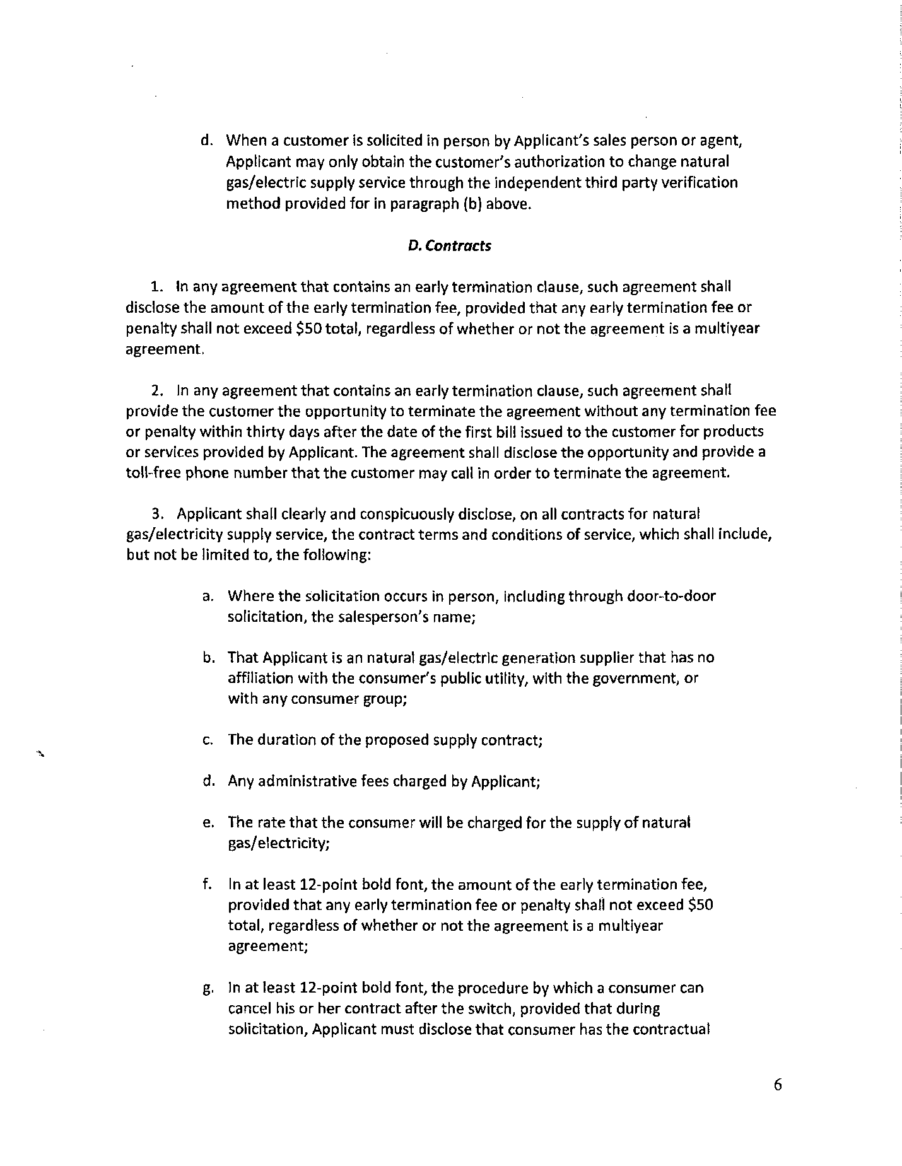

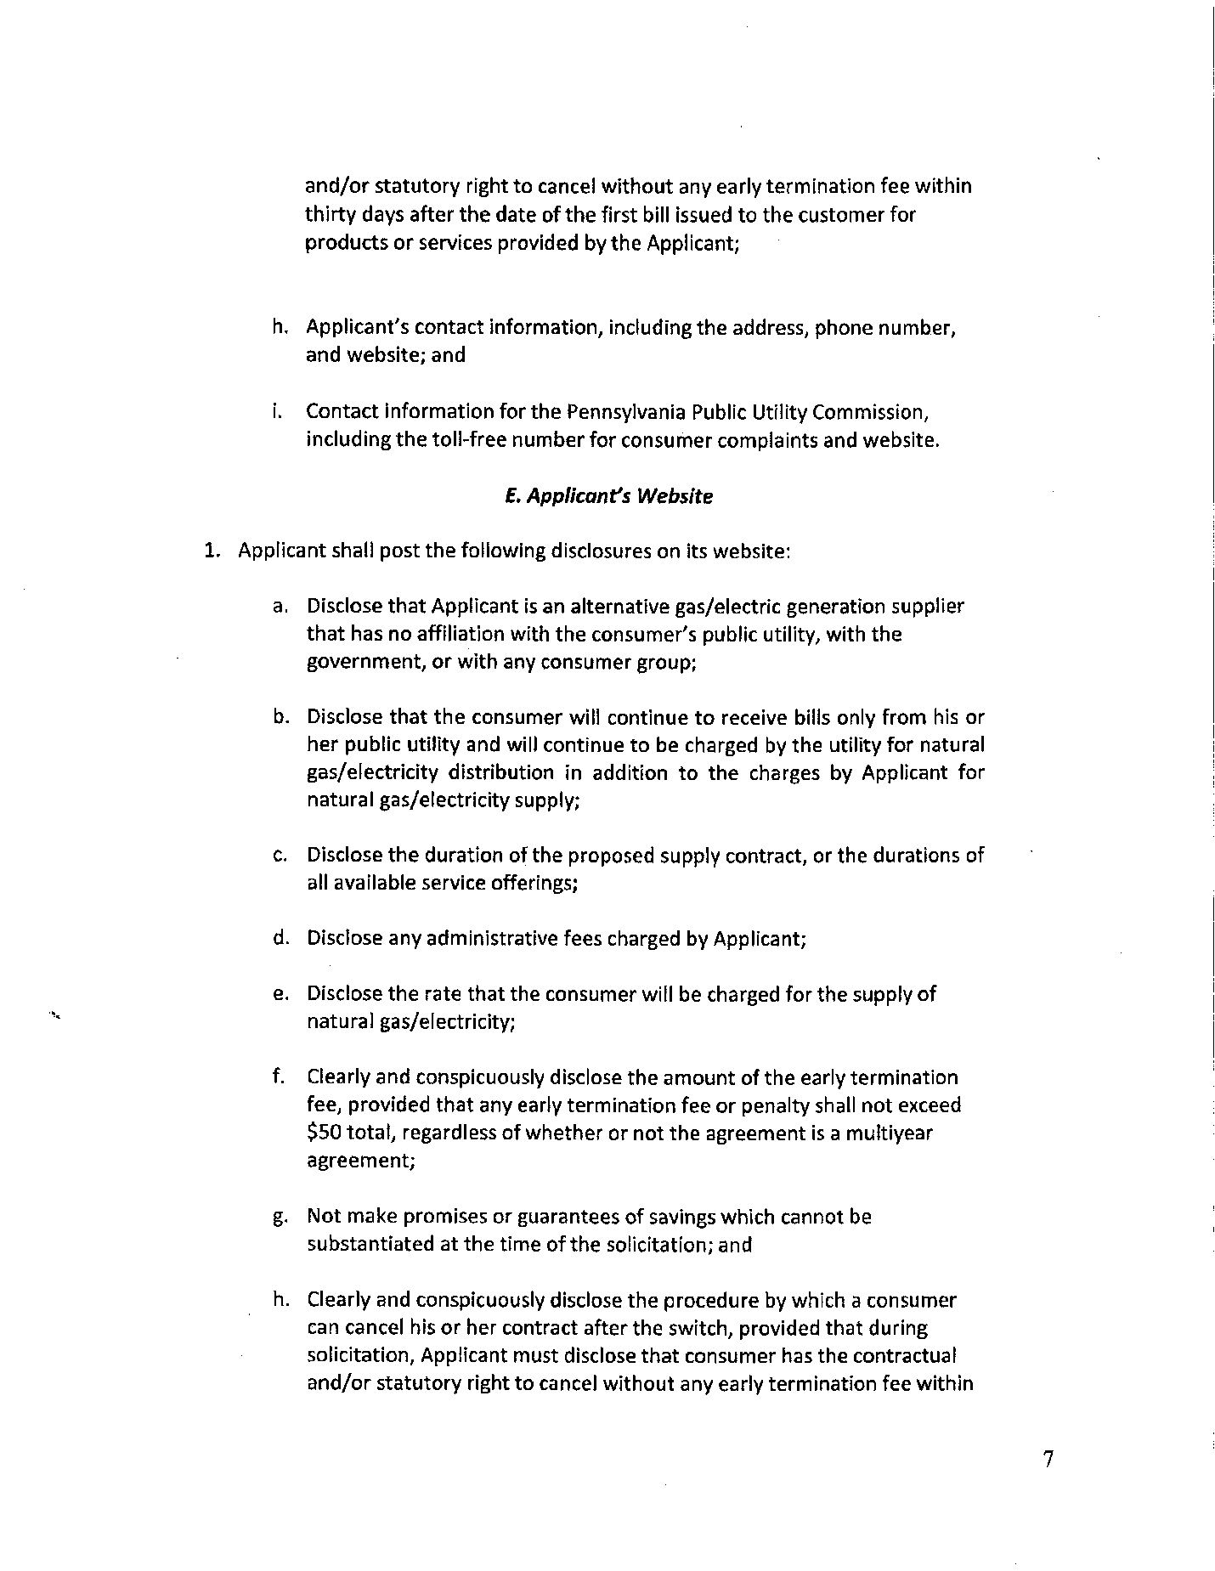

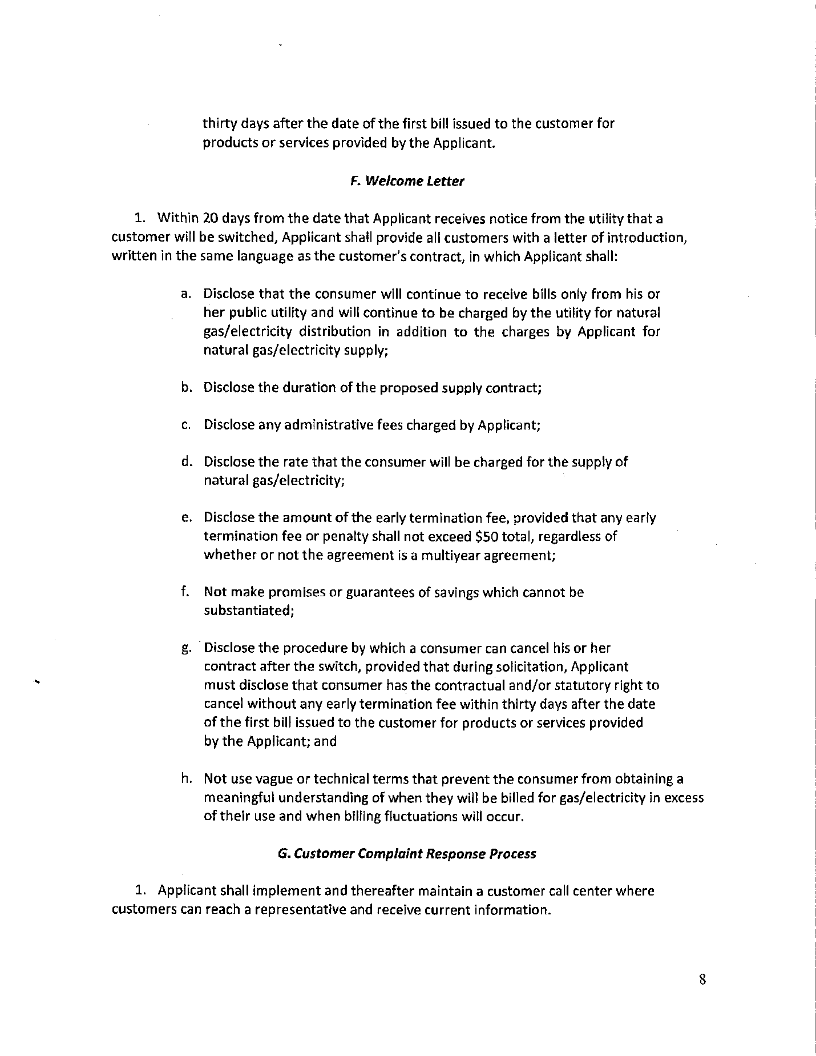

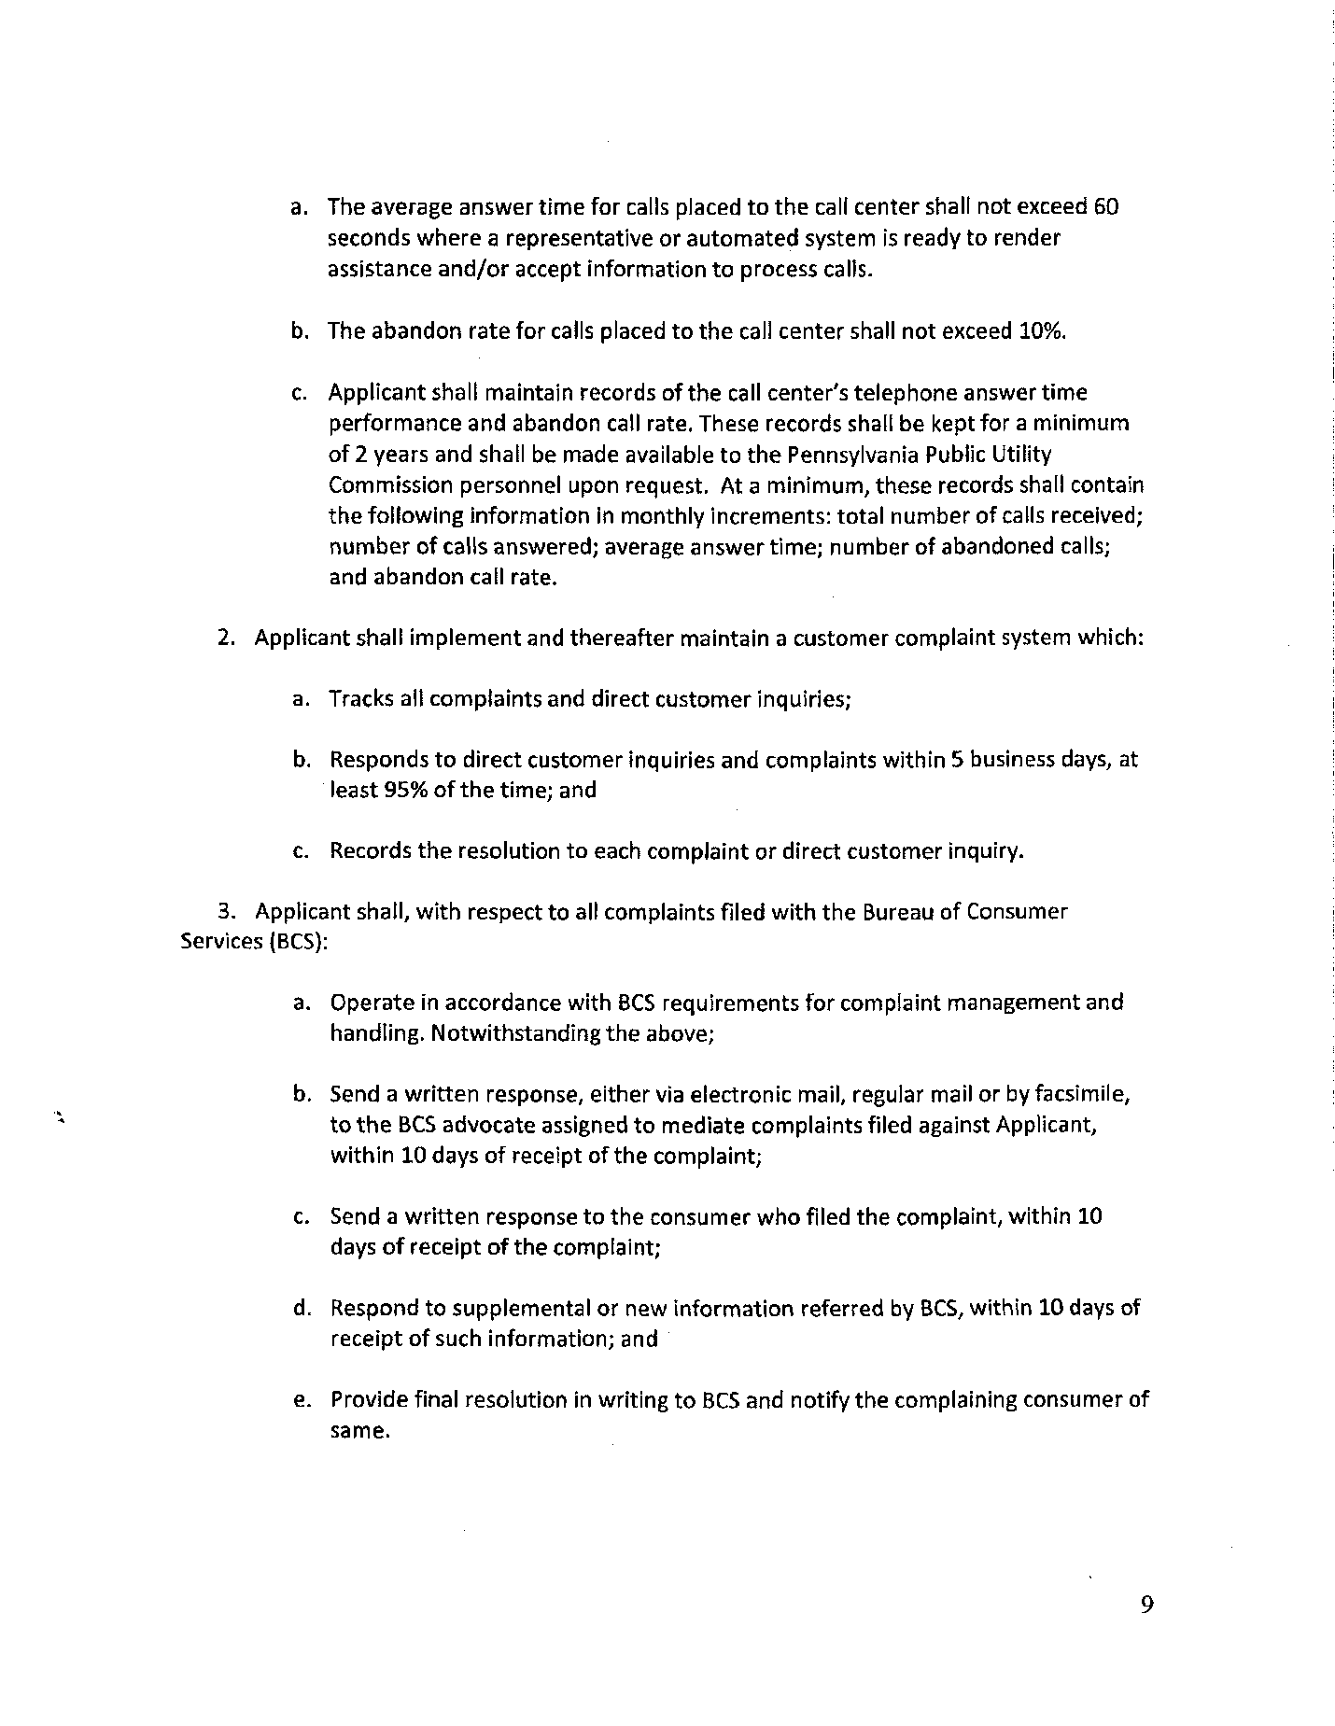

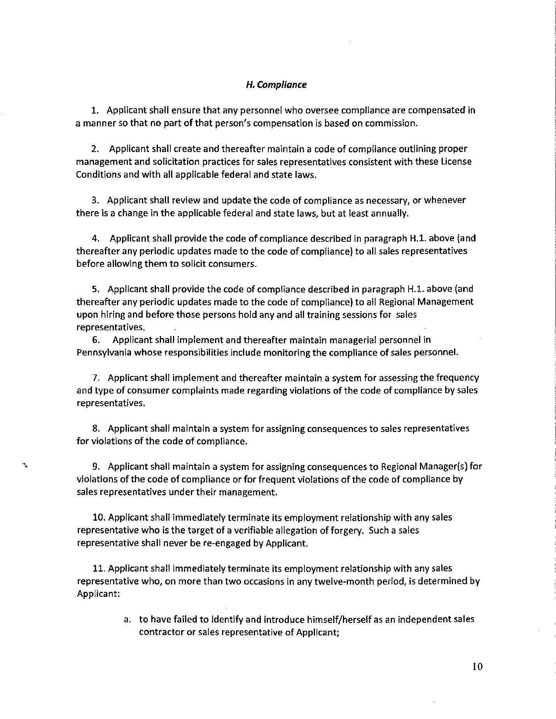

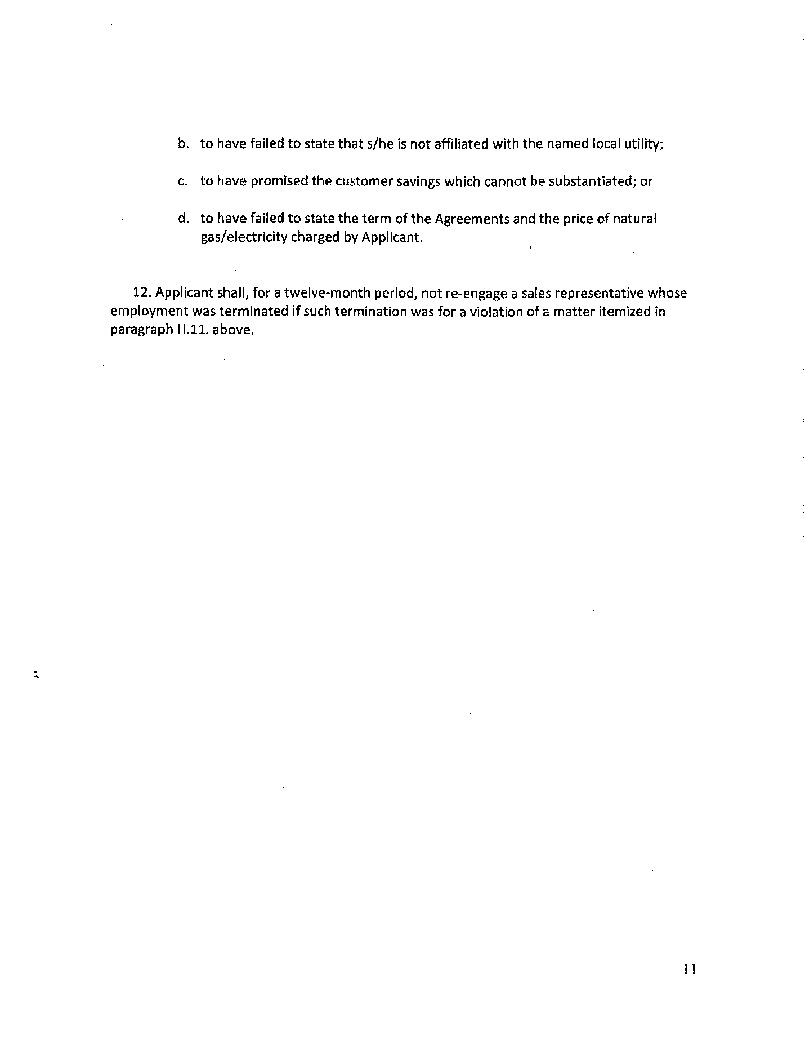

Public Utility Regulatory Act, TEX. UTIL. CODE ANN. §§ 11.01-66.016 (Vernon 2007 & Supp 2010)( PURA)
Docket No. A-2009-2097544, order entered December 23, 2009.

