PENNSYLVANIA
PUBLIC UTILITY COMMISSION
Harrisburg, PA 17105-3265
 |  | Public Meeting held December 1, 2011
Commissioners Present:
Robert F. Powelson, Chairman
John F. Coleman, Jr., Vice Chairman
Wayne E. Gardner
James H. Cawley
Pamela A. Witmer

Amendment to Electric Generation Supplier License of Sperian Energy Corp. |  |  | Docket Number:  A-2011-2250633
ORDER

BY THE COMMISSION:

On July 7, 2011, Sperian Energy Corp. (Sperian) filed an application seeking to become a licensed electric generation supplier (EGS) in the service territories of PECO Energy Company and PPL Electric Utilities, Inc. within the Commonwealth of Pennsylvania, serving residential and small commercial (25 kW and under) customers. By Order Entered August 26, 2011, the Commission approved a license at Docket No. A-2011-2250633, authorizing Sperian to begin to offer the services described above.

On September 16, 2011, Sperian filed a request to amend its electric generation supplier license to serve large commercial (over 25 kW), industrial, and governmental customers as a supplier, in addition to residential and small commercial (25 kW and under) customers, and to expand territories served to include all of the service territories throughout the Commonwealth of Pennsylvania. This proposed amendment is filed in accordance with the requirements of Section 2809 of the Public Utility Code, 66 Pa. C.S. § 2809.

Sperian has provided proofs of publication in all Pennsylvania newspapers, and proof of service of the amendment request to the interested parties, as required by the Commission.

With its amendment request, Sperian also proposes the addition of door-to-door sales, and will be using Third Party Verification procedures. The Commission directs Sperian to inform its independent consultants, which arrange for the sale of Sperian’s energy products to end-users, that they will be required to be licensed as an EGS if they arrange for the sale of energy products to end-users from another supplier, in addition to Sperian.

As of November 17, 2011, there have been no complaints filed against Sperian.

Upon full consideration of all matters of record, we find that approval of this request is necessary and proper for the service, accommodation and convenience of the public; THEREFORE,

IT IS ORDERED:

1. That the request of Sperian Energy Corp. to amend its electric generation supplier license to serve large commercial (over 25 kW), industrial, and governmental customers as a supplier, in addition to residential and small commercial (25 kW and under) customers, and to expand territories served to include all of the service territories throughout the Commonwealth of Pennsylvania is hereby approved, consistent with this Order.

2. That a license be issued authorizing Sperian Energy Corp. to begin to offer, render, furnish or supply electric generation supplier services as a supplier to residential, small commercial (25 kW and under), large commercial (over 25 kW), industrial, and governmental customers in the electric distribution service territories throughout the Commonwealth of Pennsylvania.

3. That this proceeding at Docket No. A-2011-2250633 be closed.

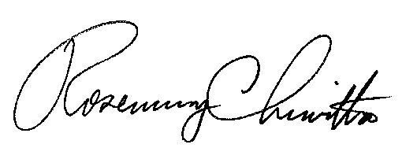
BY THE COMMISSION,

Rosemary Chiavetta
Secretary

(SEAL)

ORDER ADOPTED: December 1, 2011

ORDER ENTERED: December 1, 2011

