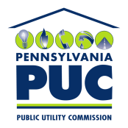 | COMMONWEALTH OF PENNSYLVANIA  PENNSYLVANIA PUBLIC UTILITY COMMISSION  P.O. BOX 3265, HARRISBURG, PA 17105-3265 | IN REPLY PLEASE REFER TO OUR FILE  M-2009-2123948

December 13, 2011

Re: Duquesne Light Company Petition for Approval of Smart Meter Procurement and Installation Plan, Docket No. M-2009-2123948 (Request for Extension of Filing Date for the Submittal of Duquesne's Final Proposed Smart Meter Plan)

TO ALL PARTIES OF RECORD:

On November 18, 2011, Duquesne Light Company (Duquesne) filed a Status Update and Request for Extension of Filing Date for the submittal of Duquesne’s final proposed Smart Meter Plan. By way of background, Duquesne filed its original Smart Meter Plan on August 14, 2009, which was approved with modifications by Commission Order entered on May 11, 2010. That Order provided for a thirty-month grace period for Duquesne to develop and obtain Commission approval for a comprehensive Smart Meter Plan. The Commission granted the Company’s request to file, no later than December 31, 2011, a final design of Duquesne’s proposed Smart Meter Program containing full cost information and a final implementation schedule.

In the instant Request for Extension of Filing Date, Duquesne is requesting an additional six months, or until June 30, 2012, to file its Final Proposed Smart Meter Plan due to its continued review, which it believes is necessary to finalize the evaluations and make final determinations on several key smart meter issues, including the magnitude of the costs and the long-term impact these decisions will have on its customers and itself. Duquesne avers that the six month extension will not affect its ability or timing to comply with Act 129 or Commission Orders.

The deadline to file Answers to Duquesne’s instant Request for Extension of Filing Date was on December 8, 2011. Only the Office of Consumer Advocate filed an Answer thereto and does not oppose Duquesne’s six-month extension request. No other responses have been received by the Commission.

Based on our review of Duquesne’s Request for Extension of Filing Date and the fact that no Parties object to the extension date, we are of the opinion that Duquesne’s request appears to be reasonable and consistent with the public interest. As such, we hereby grant Duquesne’s request to extend the filing date of its final proposed Smart Meter Plan until June 30, 2012. It is noted, however, that the granting of this extension only applies to the filing date for the final Smart Meter Plan and does not represent an extension of the existing grace period or an extension for the deployment of smart meters.

Should you have any questions regarding this matter, please contact Mr. Robert Carran, Office of Special Assistants, at (717) 783-1001.

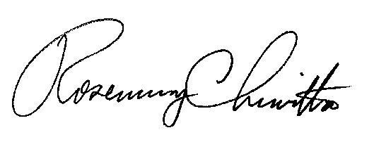
Very truly yours,

Rosemary Chiavetta
Secretary

