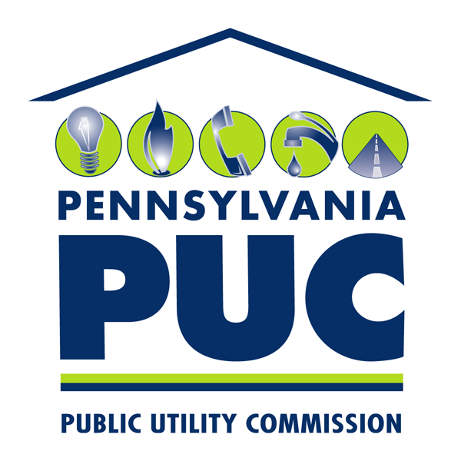 | COMMONWEALTH OF PENNSYLVANIA  PENNSYLVANIA PUBLIC UTILITY COMMISSION  P.O. BOX 3265, HARRISBURG, PA 17105-3265 | IN REPLY PLEASE REFER TO OUR FILE

January 11, 2012

Samuel Farruggio
Farruggio’s Bristol & Philadelphia Auto Express, Inc.
1419 Radcliffe Street
Bristol, PA 19007

Re: Pennsylvania Public Utility Commission v. Farruggio’s Bristol & Philadelphia Auto Express, Inc., Docket No. C-2010-2194273

Dear Respondent:

Please be advised since no objections were filed to the withdrawal of the complaint pursuant to 52 Pa Code § 5.94, this case shall be marked closed.

Sincerely,

Rosemary Chiavetta
Secretary

cc: Lawrence F. Barth, Assistant Counsel

