PENNSYLVANIA
PUBLIC UTILITY COMMISSION
Harrisburg, PA 17105-3265
 |  | Public Meeting held January 12, 2012
Commissioners Present:
Robert F. Powelson, Chairman
John F. Coleman, Jr., Vice Chairman
Wayne E. Gardner
James H. Cawley
Pamela A. Witmer
Application of Agway Energy Services, LLC to Amend its Natural Gas Supplier License |  |  |  | A-125125
ORDER

BY THE COMMISSION:

On October 18, 2011, Agway Energy Services, LLC (Agway) filed an application to amend its natural gas supplier license to add the additional natural gas distribution company (NGDC) service territory of National Fuel Gas Distribution Corp.

Agway, by Order entered May 7, 2004, is currently licensed by the Commission to offer, render, furnish or supply natural gas supply services in the Commonwealth of Pennsylvania to residential and small commercial (less than 6,000 MCF annually) customers in the NGDC service territories of Columbia Gas of Pennsylvania, Inc. and The Peoples Natural Gas Co., LLC.

Agway has provided proof of publication in the Pennsylvania newspaper of general circulation serving the geographical territory affected by the application and proofs of service to the interested parties as required by the Commission.

Section 2208(c)(1), 66 Pa. C.S. § 2208(c)(1), provides that a natural gas supplier license shall not be issued unless the applicant furnishes a bond or other security in a form and amount to ensure its financial responsibility. The criteria used to establish the form and amount of the bond or other security is set forth in the NGDC’s tariff. The amount and form of the bond or other security may also be mutually agreed to between the NGDC and the natural gas supplier. Section 2208 also provides that should the parties fail to achieve an agreement, then the form and amount of bond or other financial security “shall be determined by criteria approved by the Commission.” Agway has provided documentation to evidence its compliance with the Section 2208(c) bonding requirement for the additional NGDC in whose service territory it proposes to expand its operations.

As of January 3, 2012, no protests have been filed. Additionally, no formal complaints have been filed against Agway, and there has been a minimal amount of informal complaints filed, all having been resolved.

Upon full consideration of all matters of record, we find that approval of these applications is necessary and proper for the service, accommodation and convenience of the public; THEREFORE,

IT IS ORDERED:

1. That the application of Agway Energy Services, LLC is hereby approved, consistent with this Order.

2. That a license be issued authorizing Agway Energy Services, LLC to begin to offer, render, furnish or supply natural gas supply services to residential and small commercial customers (less than 6,000 MCF annually) in the additional natural gas distribution company service territory of National Fuel Gas Distribution Corp.

3. That this proceeding at Docket No. A-125125 be closed.

BY THE COMMISSION,
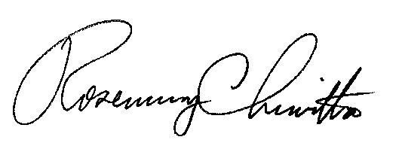

Rosemary Chiavetta
Secretary

(SEAL)

ORDER ADOPTED: January 12, 2012

ORDER ENTERED: January 12, 2012

