PENNSYLVANIA
PUBLIC UTILITY COMMISSION
Harrisburg, PA 17105-3265

Public Meeting held January 27, 2012

Commissioners Present:

Robert F. Powelson, Chairman
John F. Coleman, Jr., Vice Chairman, Statement
Wayne E. Gardner, Joint Statement
James H. Cawley, Joint Statement
Pamela A. Witmer

Pennsylvania Public Utility Commission,  Law Bureau Prosecutory Staff  v.  Equitable Gas Company, LLC | M-2011-2185982

OPINION AND ORDER

BY THE COMMISSION:

Before the Pennsylvania Public Utility Commission (Commission) for consideration and disposition is a proposed Settlement Agreement (Settlement) filed on December 2, 2011, by the Commission’s Law Bureau Prosecutory Staff (Prosecutory Staff) and Equitable Gas Company, LLC (Equitable) (collectively, the Parties), with respect to an informal investigation conducted by the Prosecutory Staff. The Parties submit that the proposed Settlement is in the public interest and is consistent with the Commission’s Policy Statement at 52 Pa. Code § 69.1201, Factors and standards for evaluating litigated and settled proceedings involving violations of the Public Utility Code and Commission regulations—statement of policy (Policy Statement). Joint Statement in Support of Settlement at 4-6.

The proposed Settlement is conditioned on the Commission’s approval without modification, addition, or deletion of any of its terms or conditions. If the Commission does not approve the Settlement or any of the terms or conditions set forth therein without modification, addition, or deletion, then either Party may elect to withdraw from the Settlement. Settlement at 13, ¶ 23.

History of the Case

By letter dated August 6, 2010, the Prosecutory Staff informed Equitable that it was initiating an informal investigation regarding the transfer of intellectual property to EQT IP Ventures, LLC (EQT IP Ventures) and affiliated interest transactions with EQT IP Ventures. Specifically, EQT IP Ventures was formed in 2001. Subsequently, Equitable Resources, Inc. (ERI) and its operating subsidiaries transferred certain intangible/intellectual property, including the trade names and trade marks relating to ERI's regulated Equitable Gas Company Division, to EQT IP Ventures in a tax free transaction. EQT IP Ventures received royalty payments in exchange for the services it provided in connection with the intangible/intellectual property and the right to use that property retained by ERI and its operating subsidiaries.

The informal investigation was based on information obtained in the Commission's Bureau of Audits’ Stratified Management and Operations Audit. The audit was conducted by an outside consultant, and it covered the time period from October 2001, when EQT IP Ventures was formed, to the present. During the time period which the investigation covered, the Commission's Bureau of Audits (Audits) had conducted a Management Audit of Equitable that was concluded in 2003
(2003 Management Audit) and a related Management Efficiency Investigation that was concluded in February 2007. Both of those audits resulted in recommendations that Equitable update its affiliated interest agreements to reflect all affiliate transactions. Equitable did not include EQT IP Ventures in any of its affiliated interest filings in response to the 2003 Management Audit or the related Management Efficiency Investigation.

Pursuant to a Management Audit that was conducted in 2010
(2010 Management Audit), an outside consultant recommended that Equitable develop an affiliated interest agreement regarding the EQT IP Ventures and Equitable relationship and submit it to the Commission for approval (Recommendation VII-11).
On June 7, 2011, in response to Recommendation VII-11, Equitable filed, without prejudice to its positions advanced in this proceeding, an updated affiliated interest agreement that included EQT IP Ventures. The Commission’s TUS is currently reviewing the pending affiliated interest filing at Docket No. G-2011-2246777.

Background

The proposed Settlement is attached to this Opinion and Order, and it is a full and final resolution of the informal investigation at this Docket. Had this matter been litigated, the Prosecutory Staff would have alleged the following: (1) that Equitable transferred intellectual property used or useful in the public service to EQT IP Ventures without Commission approval in violation of Section 1102(a)(3) of the Public Utility Code (Code), 66 Pa. C.S. § 1102(a)(3); (2) that Equitable entered into an agreement with EQT IP Ventures, an affiliate, for the payment of royalty amounts by Equitable in exchange for the services provided by EQT IP Ventures and the right to use intellectual property without Commission approval in violation of Section 2102(a) of the Code,
66 Pa. C.S. § 2102(a); and (3) that Equitable failed to furnish information to the Commission regarding its transactions with EQT IP Ventures at various times since 2001 in violation of Section 505 of the Code, 66 Pa. C.S. § 505. Settlement at 7, ¶ 13(a)-(c).

Although Equitable fully cooperated with the investigation, had this matter been litigated, Equitable would have denied that it violated any section of the Code or of the Commission’s Regulations and Orders. Settlement at 8, ¶ 16. Equitable would have responded to the Prosecutory Staff’s allegations, inter alia, as follows: (1) that Equitable informed Audits of the existence of an arrangement with an Equitable affiliate involving intellectual property, and Audits reported this information in the 2003 Management Audit; (2) that because the subject intellectual property had no book value and was not included as part of Equitable’s rate base for ratemaking purposes, Equitable was not required to obtain approval for the transfer of the property under Section 1102(a)(3) of the Code; and (3) that Section 2102(a) of the Code was not intended to apply to the transactions between Equitable and EQT IP Ventures, particularly because payments of royalties are from shareholder funds that are beyond the Commission’s jurisdiction. Settlement at 8-11, ¶ 16(a), (b), (c), (e).

Terms of the Settlement

Pursuant to the proposed Settlement, Equitable will pay the Commission a civil settlement amount of $40,000 and make an $85,000 contribution to its Hardship Repair

Fund. Equitable will not claim or include any portion of these monetary amounts for recovery in future ratemaking proceedings. Settlement at 12, ¶¶ 19, 20. In order to facilitate the timely review and disposition of Equitable’s pending affiliated interest filing at Docket No. G-2011-2246777, Equitable has agreed that it will not object to the Commission’s Law Bureau providing legal advice to TUS in its review of the filing, provided that the advice pertains only to the filing at that docket and that Equitable has no further liability for matters that occurred prior to the Commission’s Order at that docket.
Id. at 12, ¶ 21.

The Settlement resolves all matters raised and which could have been raised by the Prosecutory Staff in the investigation, as well as any potential issues or liability associated with Equitable’s transactions with EQT IP Ventures prior to the date of the Commission’s Order at Docket No. G-2011-2246777. Settlement at 13, ¶ 22. The provisions of the Settlement may not be used or construed by any person as an admission of any fact or liability by Equitable. Moreover, the Agreement does not constitute any admission against, or prejudice to, any position that any party may adopt during any subsequent administrative or court proceeding. Id. at 14, ¶ 24.

Discussion

Pursuant to our Regulations at 52 Pa. Code § 5.231, it is the Commission’s policy to promote settlements. The Commission must, however, review proposed settlements to determine whether the terms are in the public interest. Pa. PUC v. Philadelphia Gas Works, Docket No. M-00031768 (Order entered January 7, 2004);
Pa. PUC v. CS Water and Sewer Assoc., 74 Pa. P.U.C. 767 (1991); Pa. PUC v. Philadelphia Electric Co., 60 Pa. P.U.C. 1 (1985).

Conclusion

Before issuing a decision on the merits of the proposed Settlement, and consistent with the requirement of 52 Pa. Code § 3.113(b)(3), we are providing an opportunity for interested parties to file comments regarding the proposed Settlement; THEREFORE,

IT IS ORDERED:

1. That this Opinion and Order, together with the attached Settlement Agreement and the Joint Statement in Support thereof, shall be issued for comments by any interested party.

2. That a copy of this Opinion and Order, together with the attached Settlement Agreement and the Joint Statement in Support thereof, shall be served on the Office of Consumer Advocate and the Office of Small Business Advocate.

3. That comments regarding the proposed Settlement Agreement and the Statements in Support thereof, will be considered timely if filed within twenty (20) days of the date of entry of this Opinion and Order.
4. That, subsequent to the Commission’s review of comments filed in this proceeding, a final Opinion and Order will be issued.
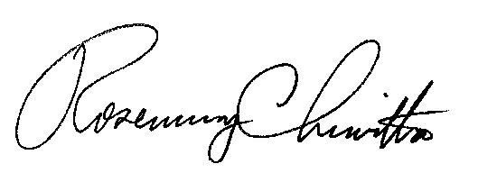
BY THE COMMISSION,

Rosemary Chiavetta
Secretary

(SEAL)

ORDER ADOPTED: January 27, 2012

ORDER ENTERED: January 27, 2012

ATTACHMENT

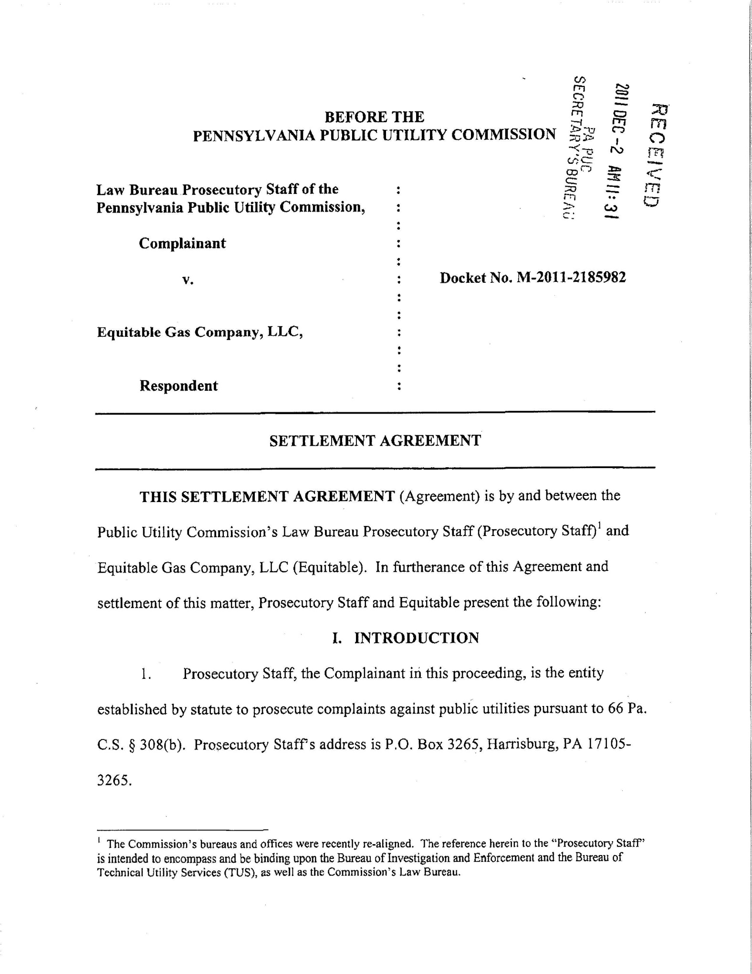
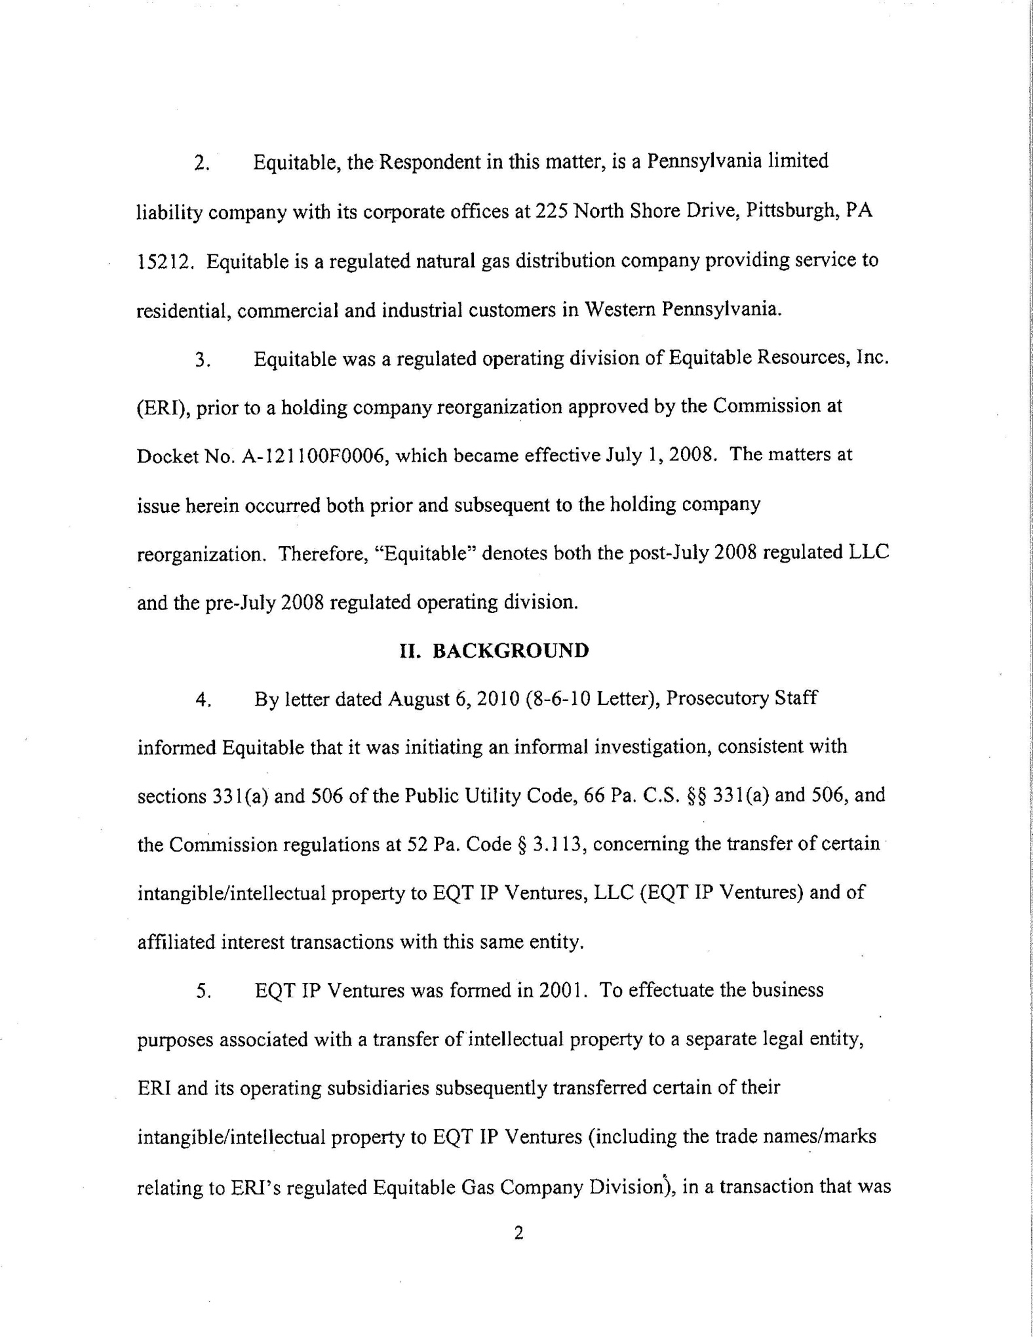
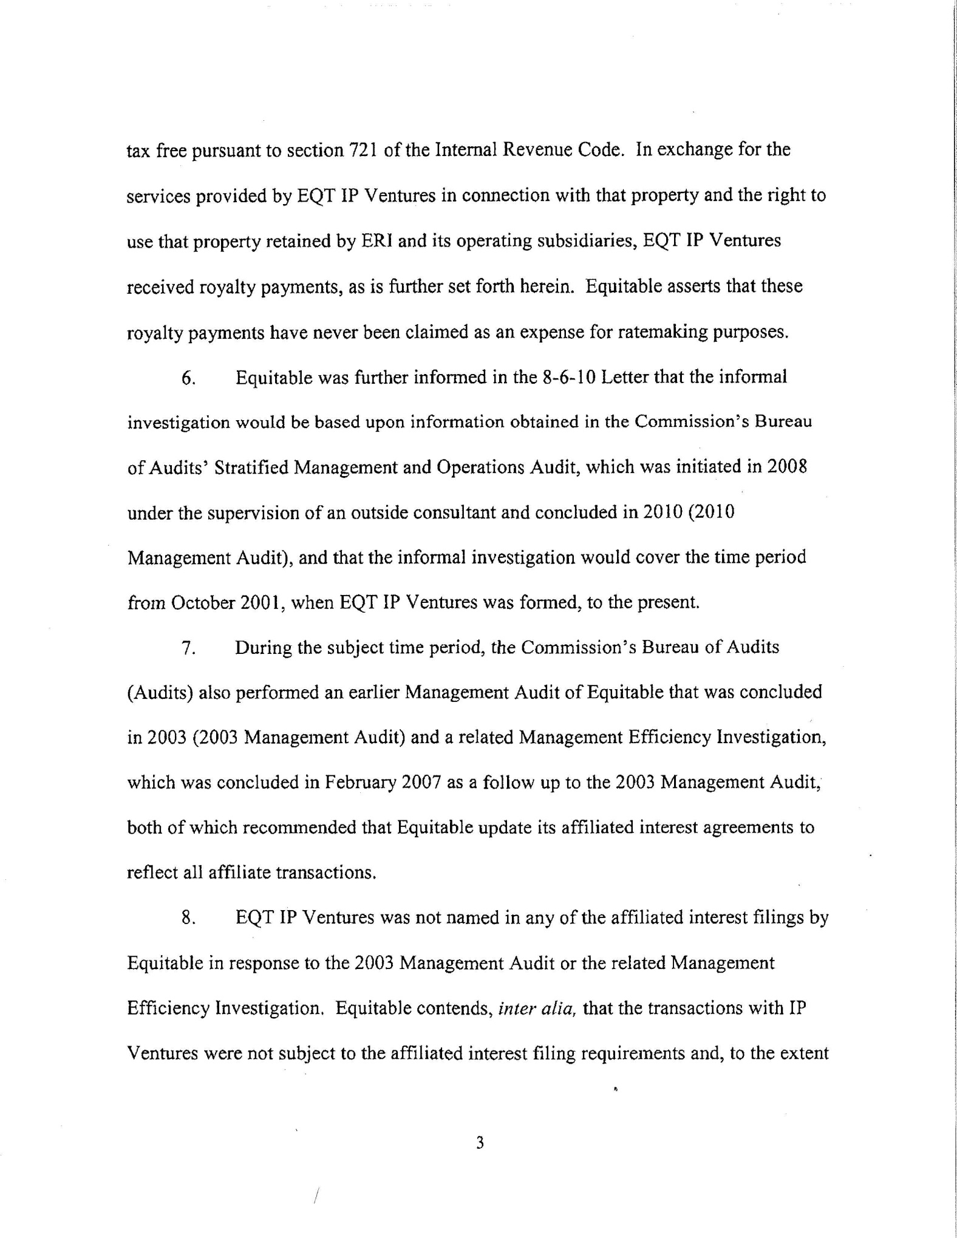
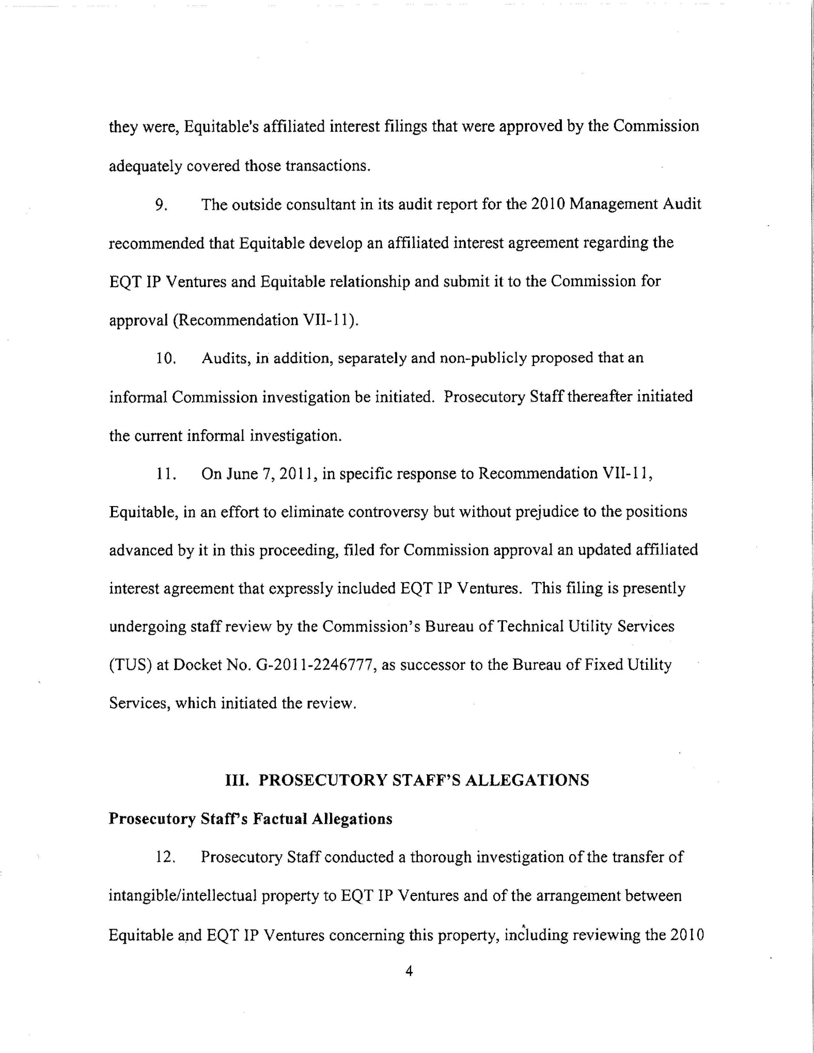
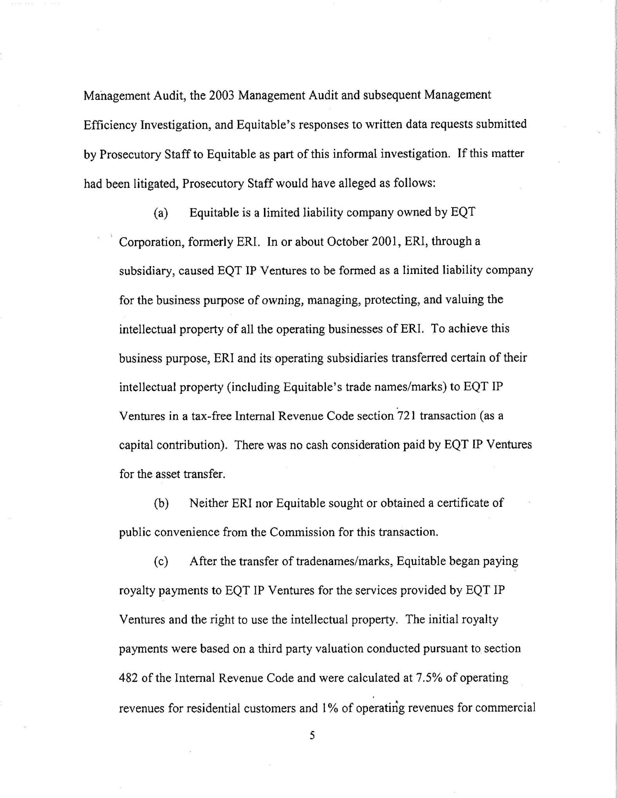
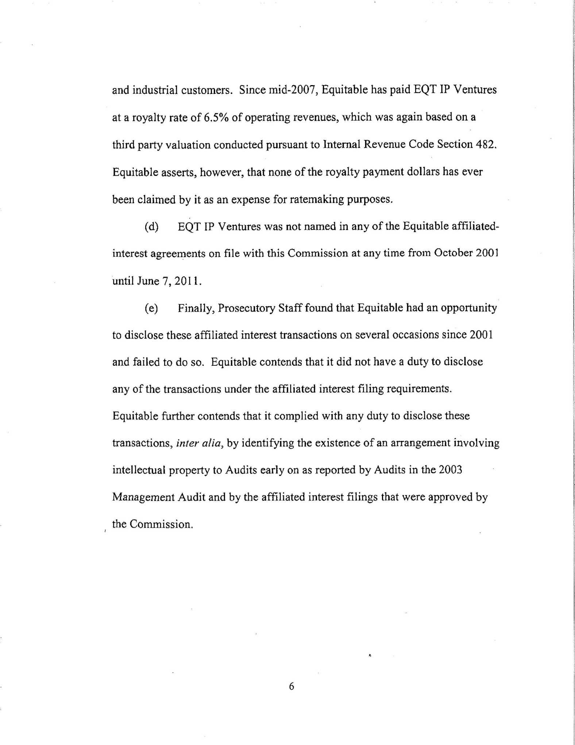
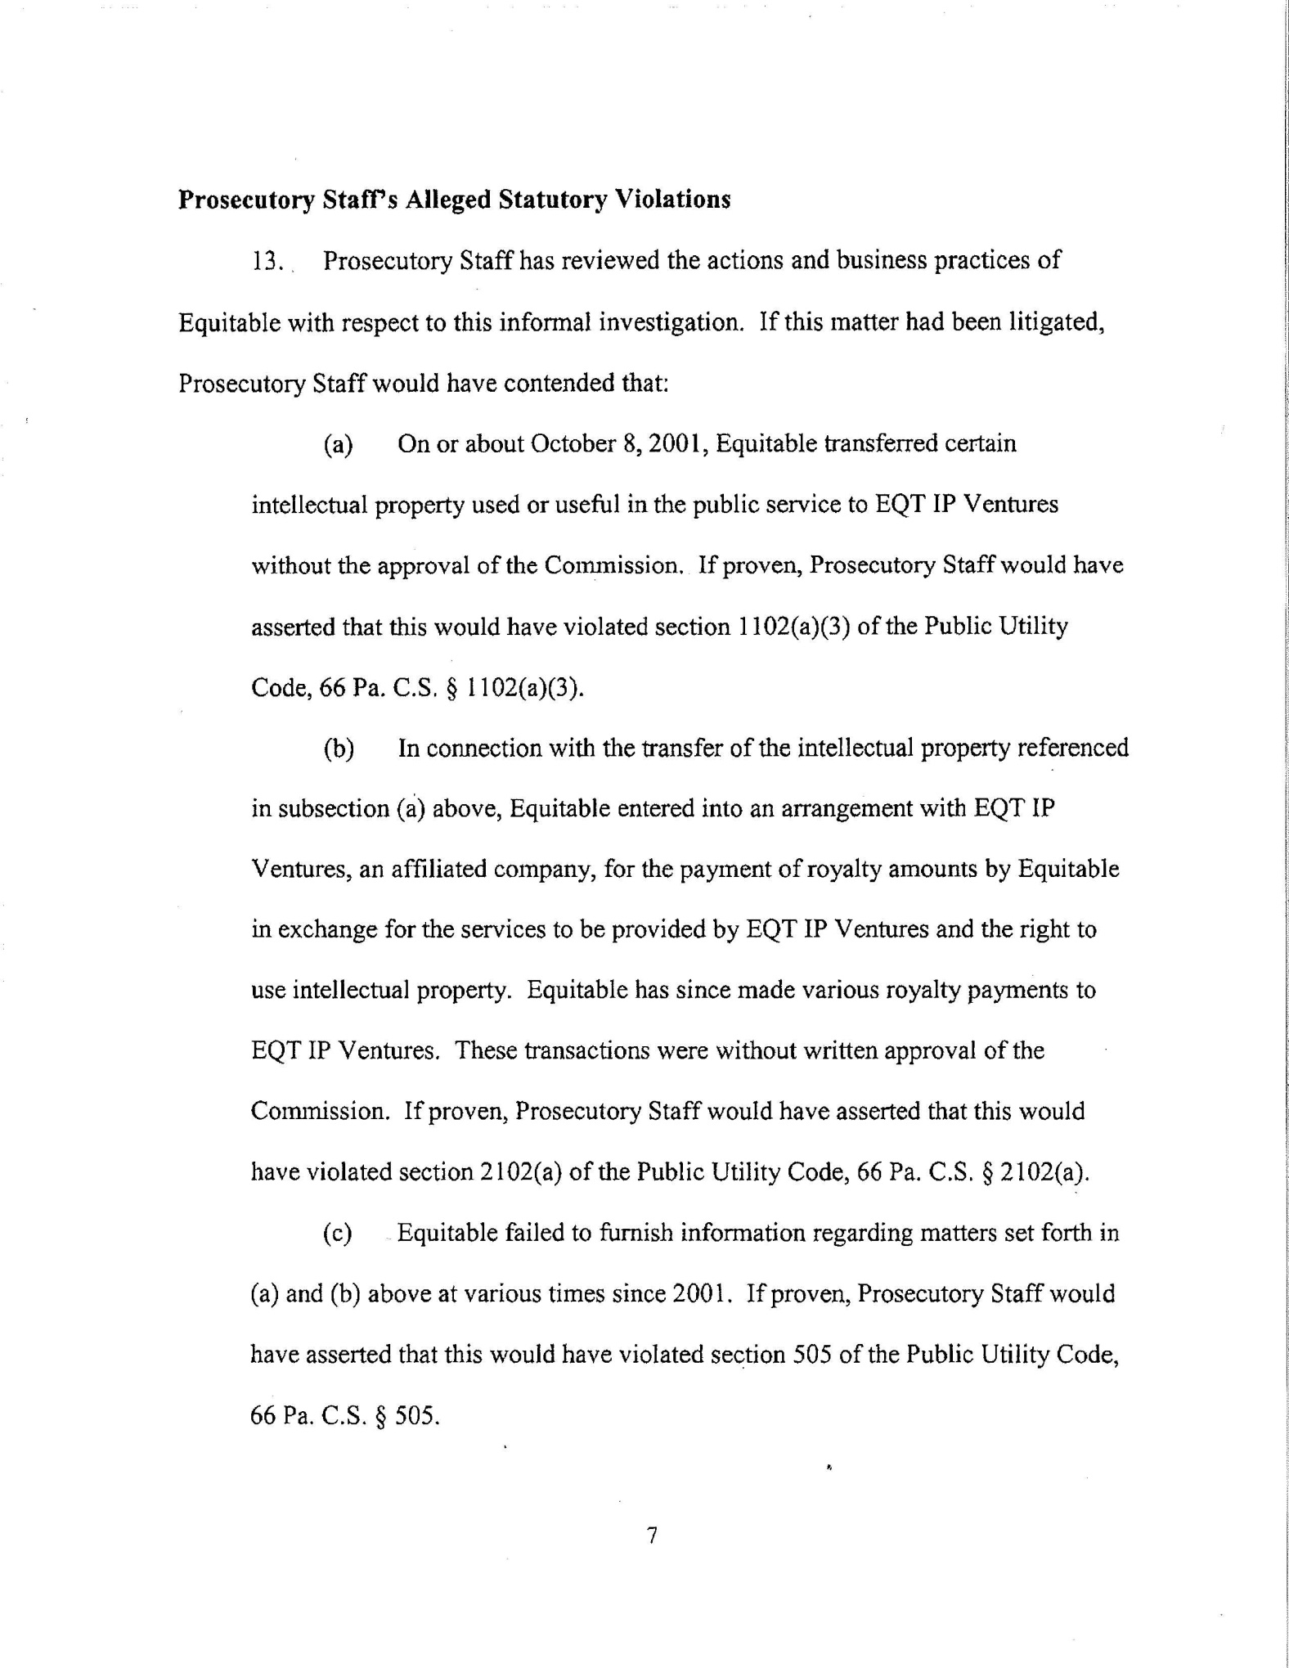
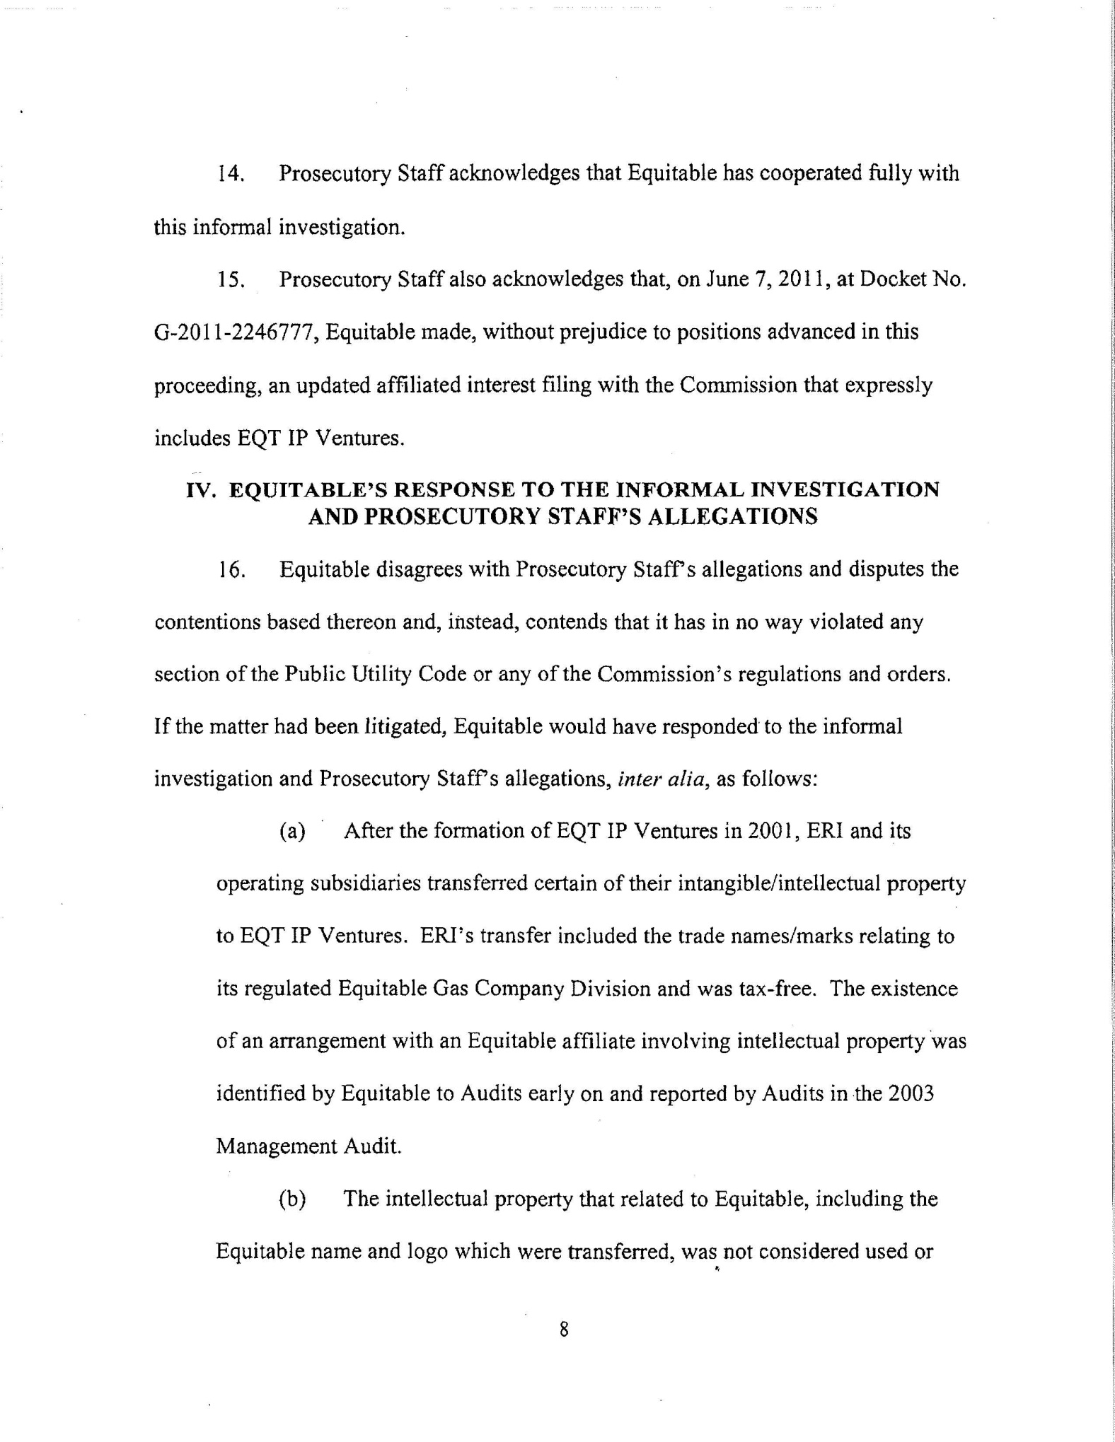
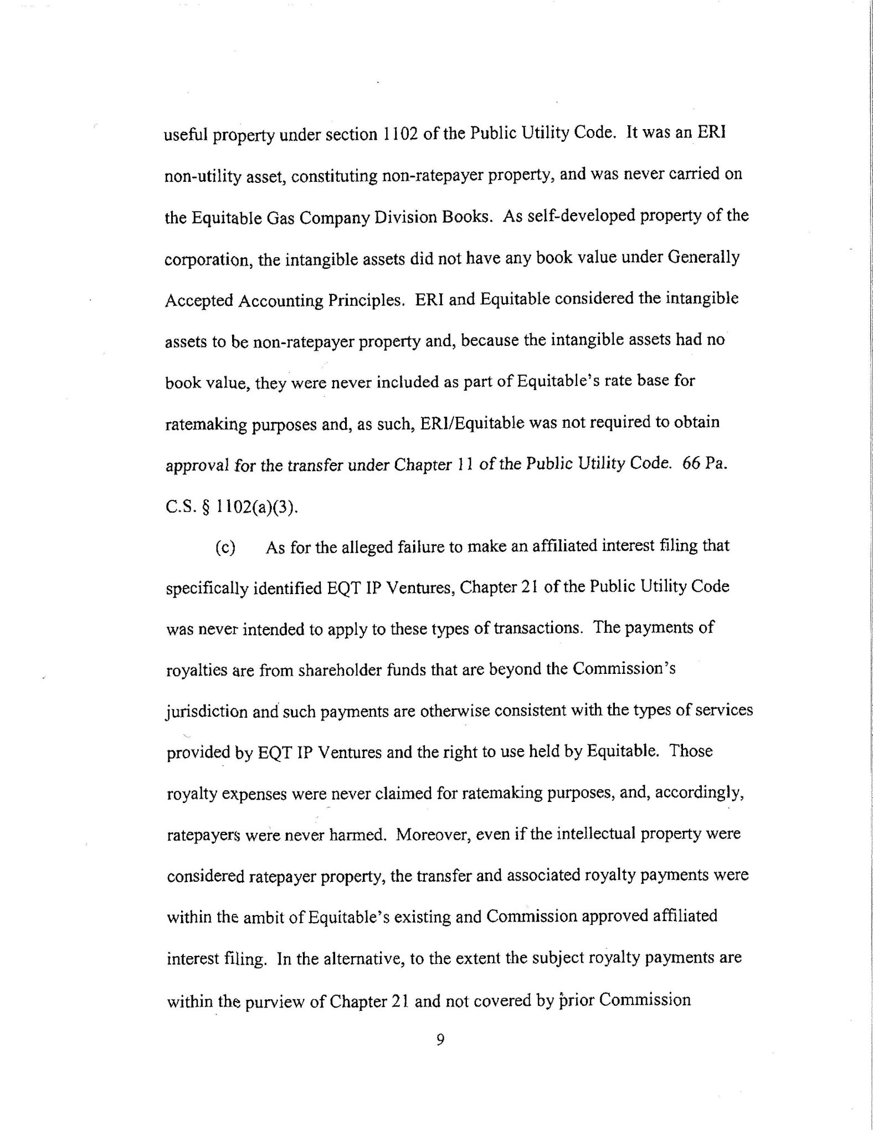
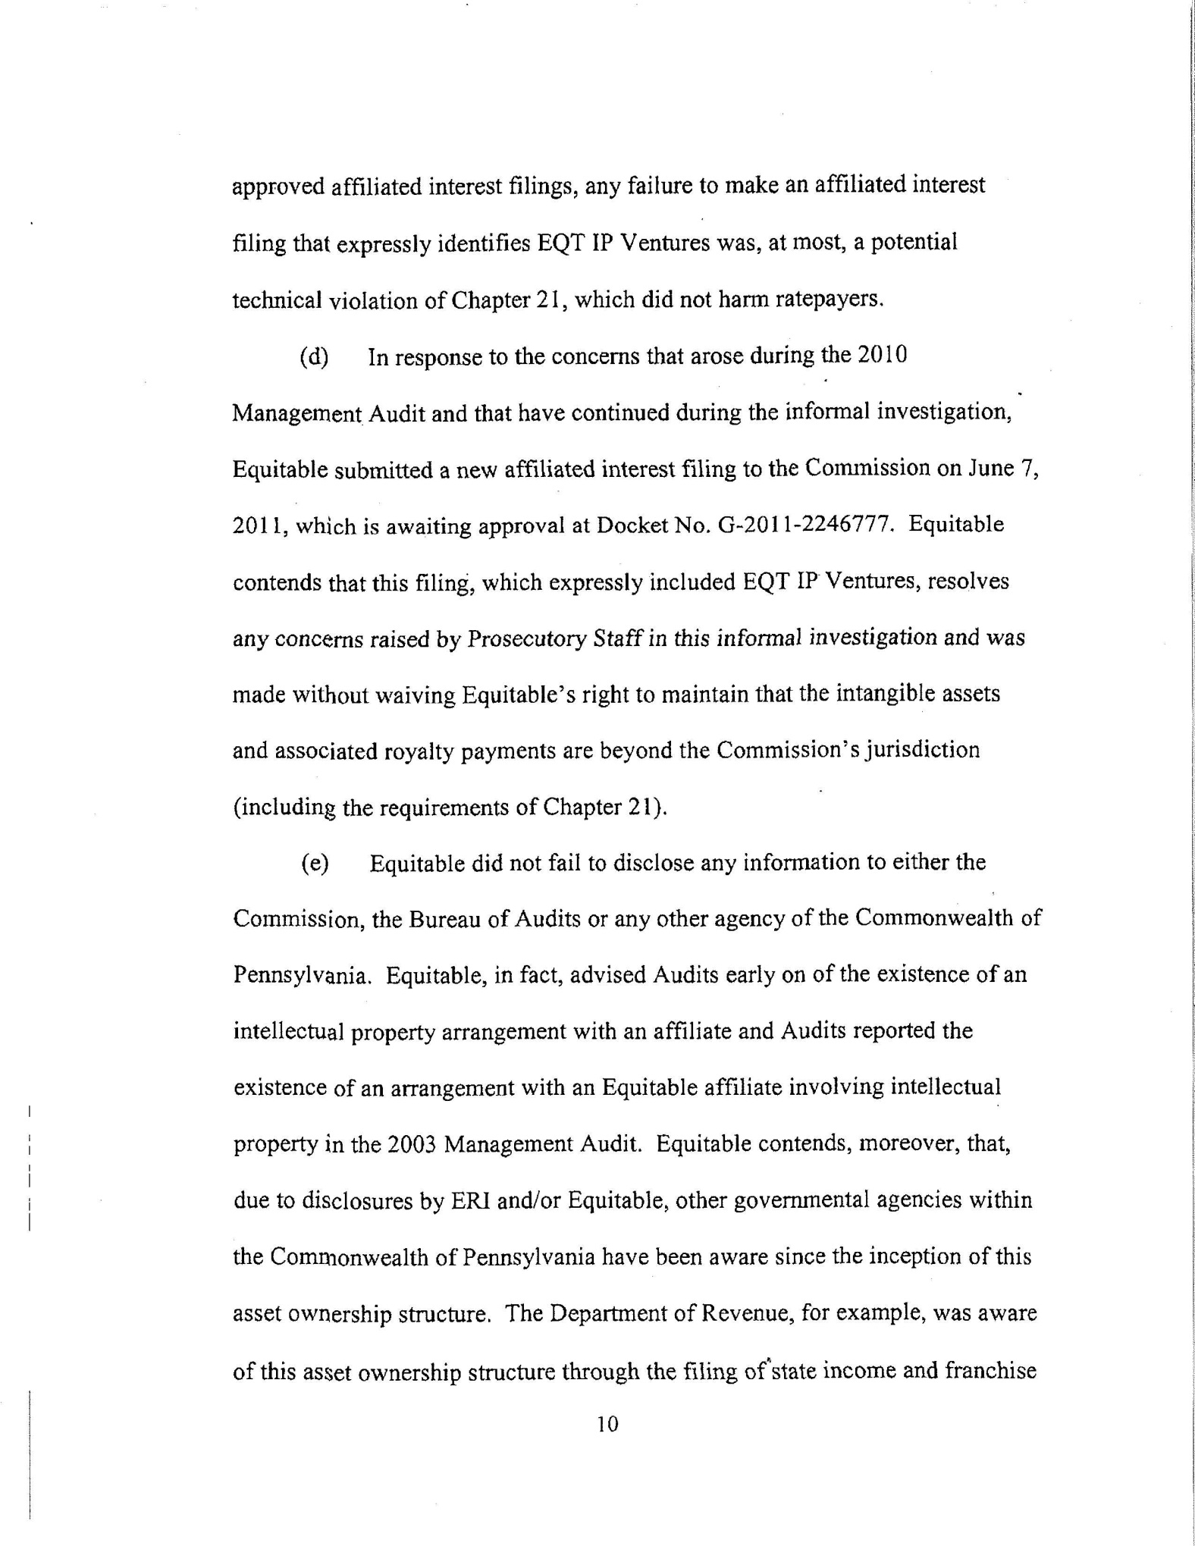
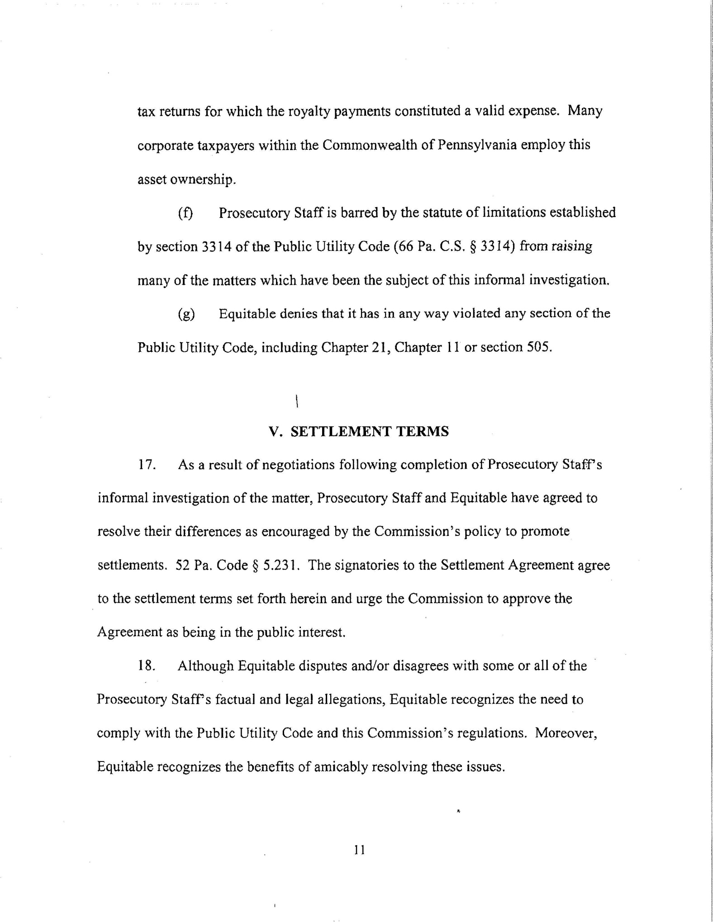
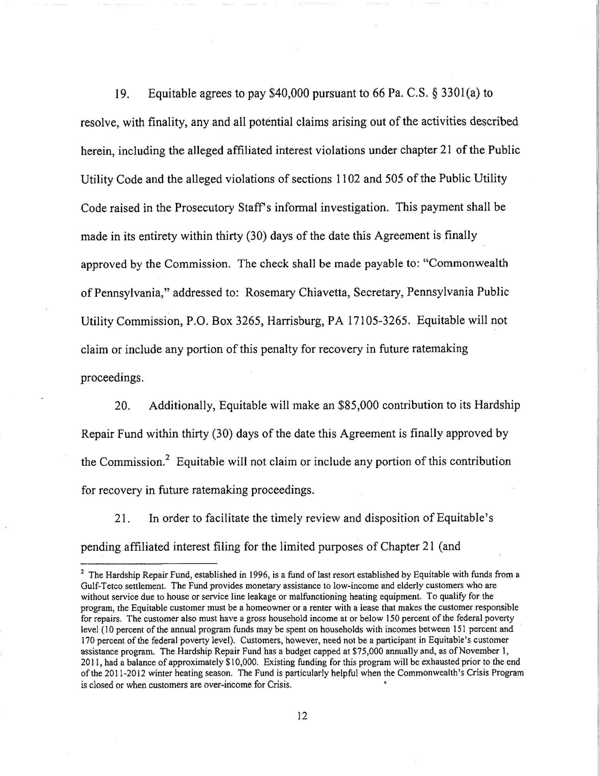
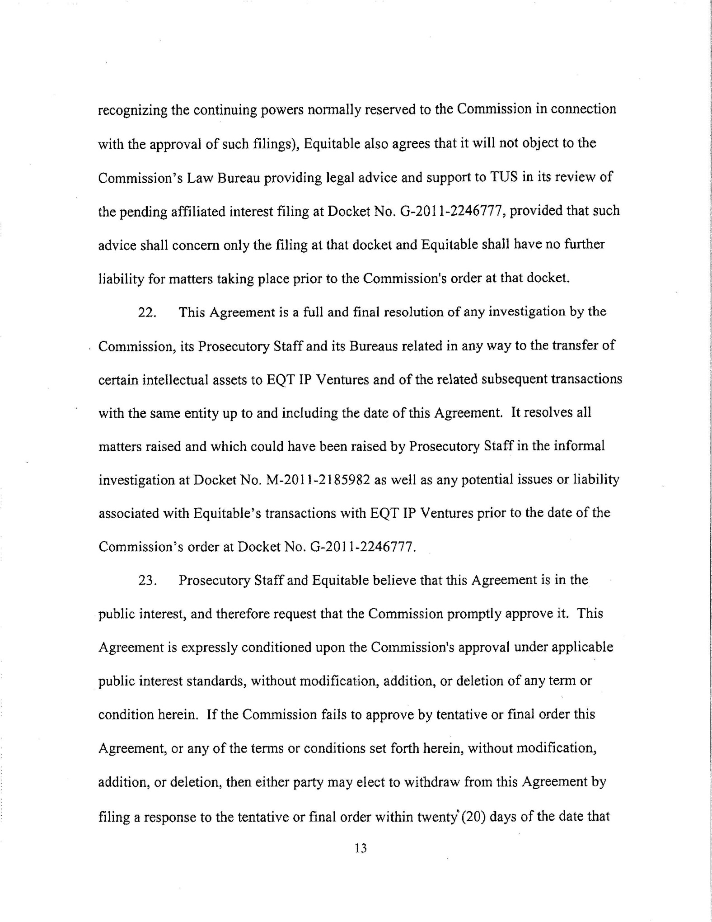
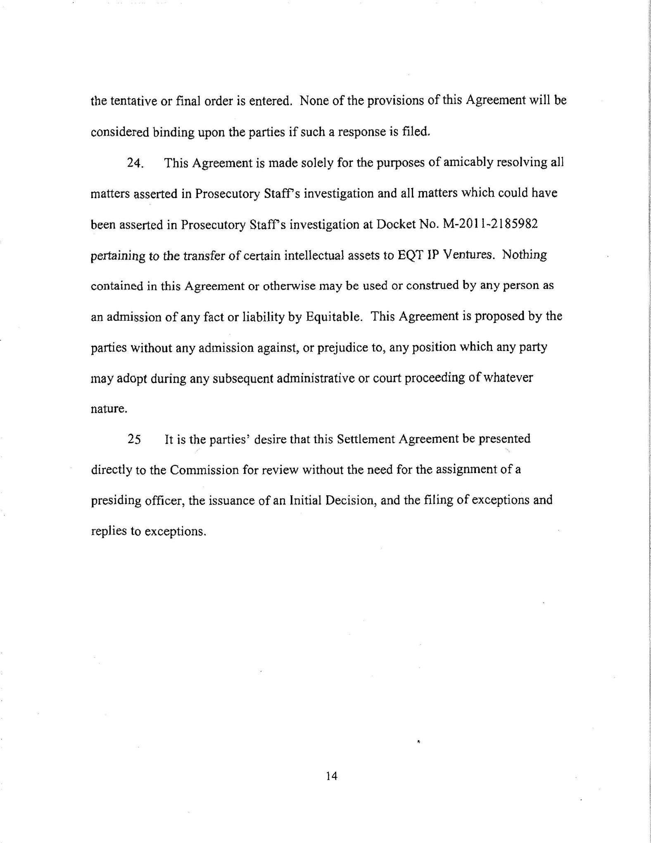
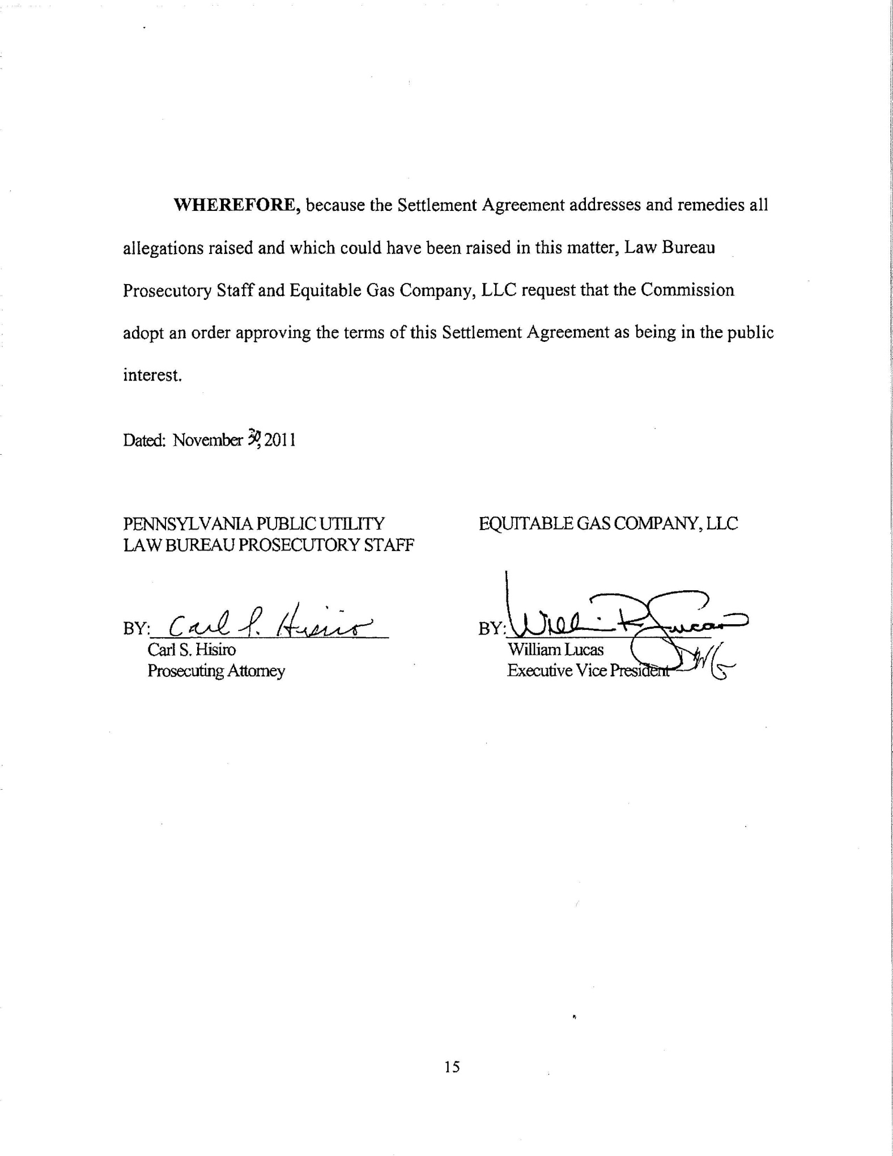
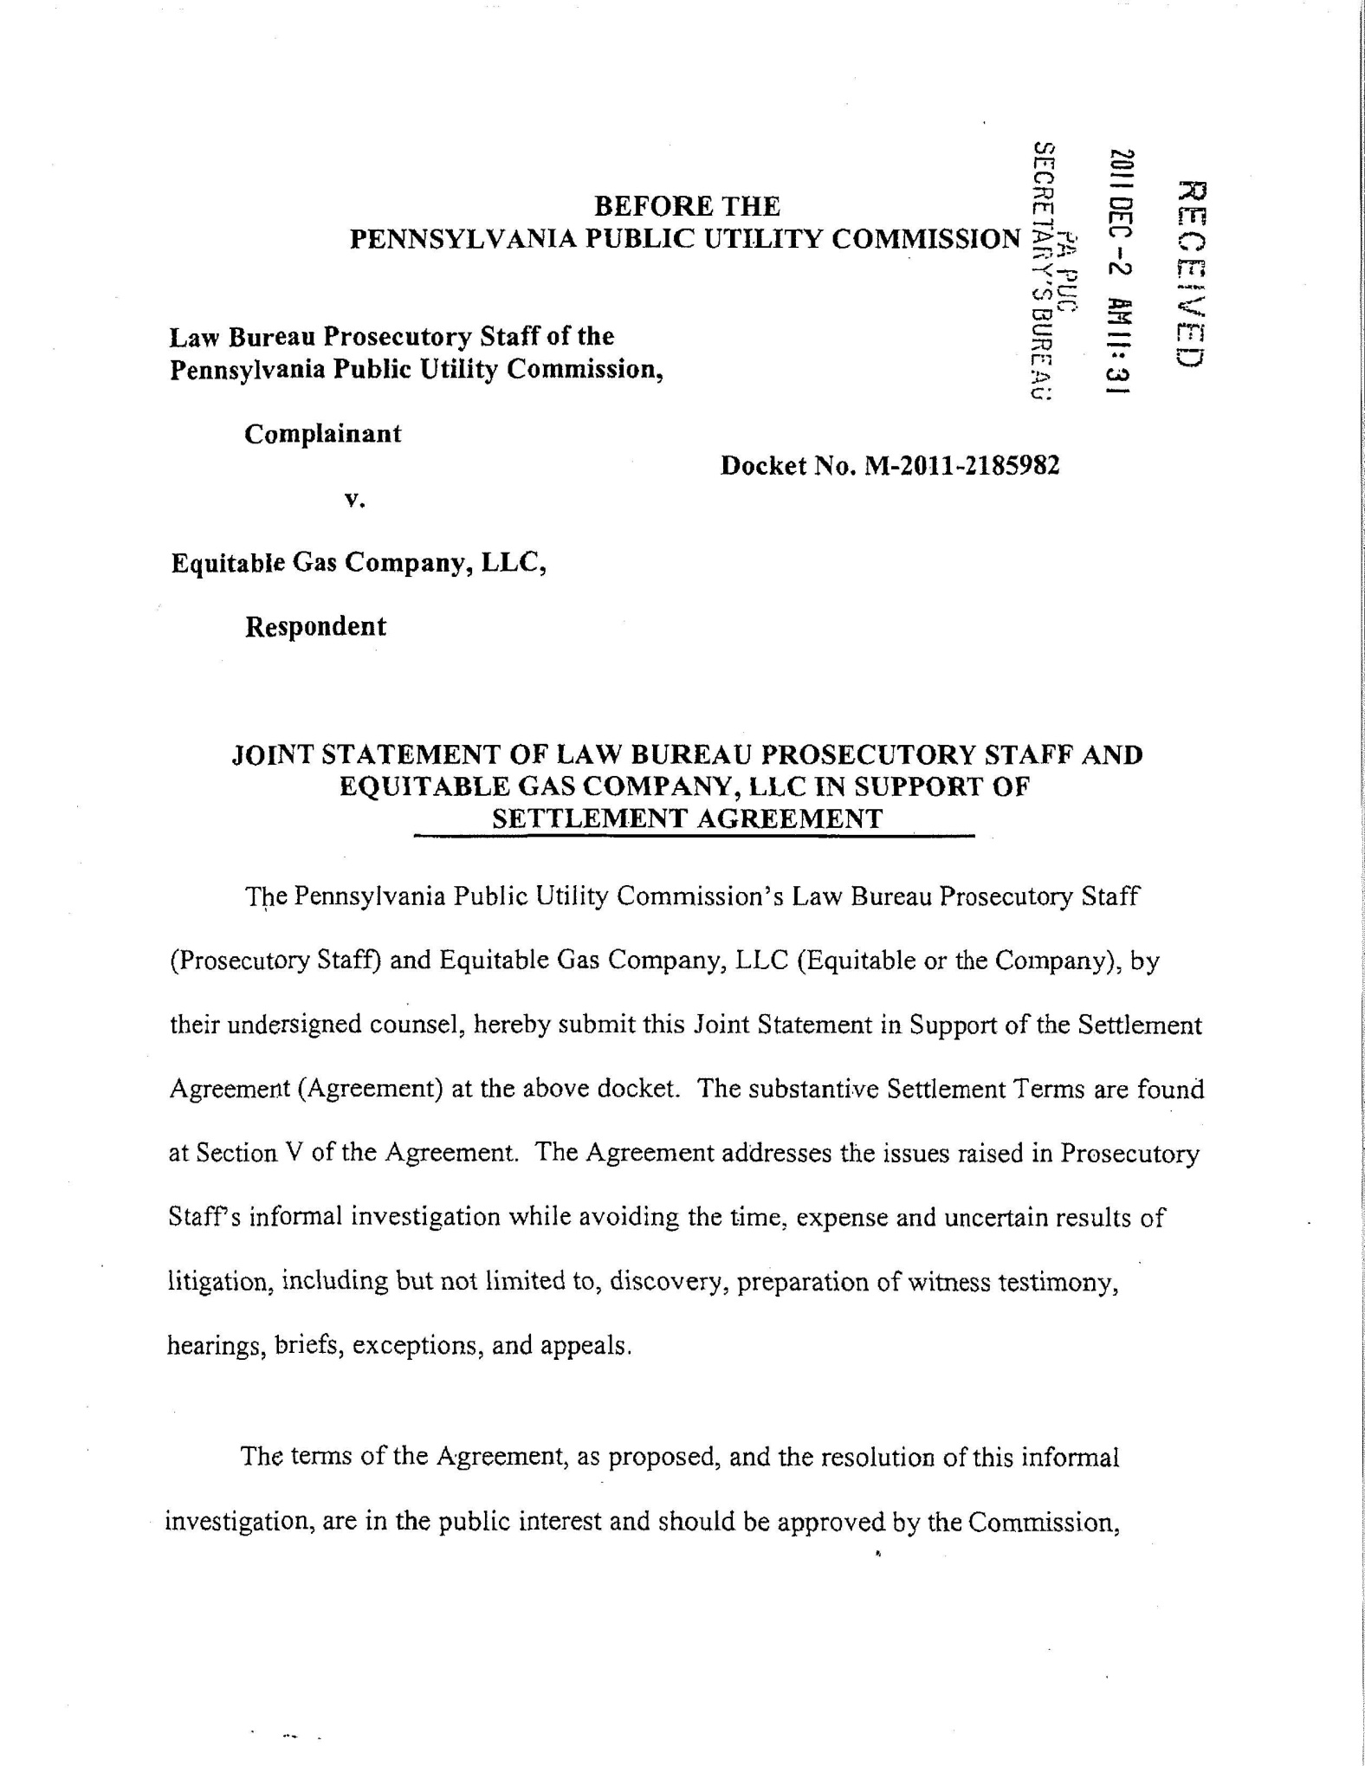
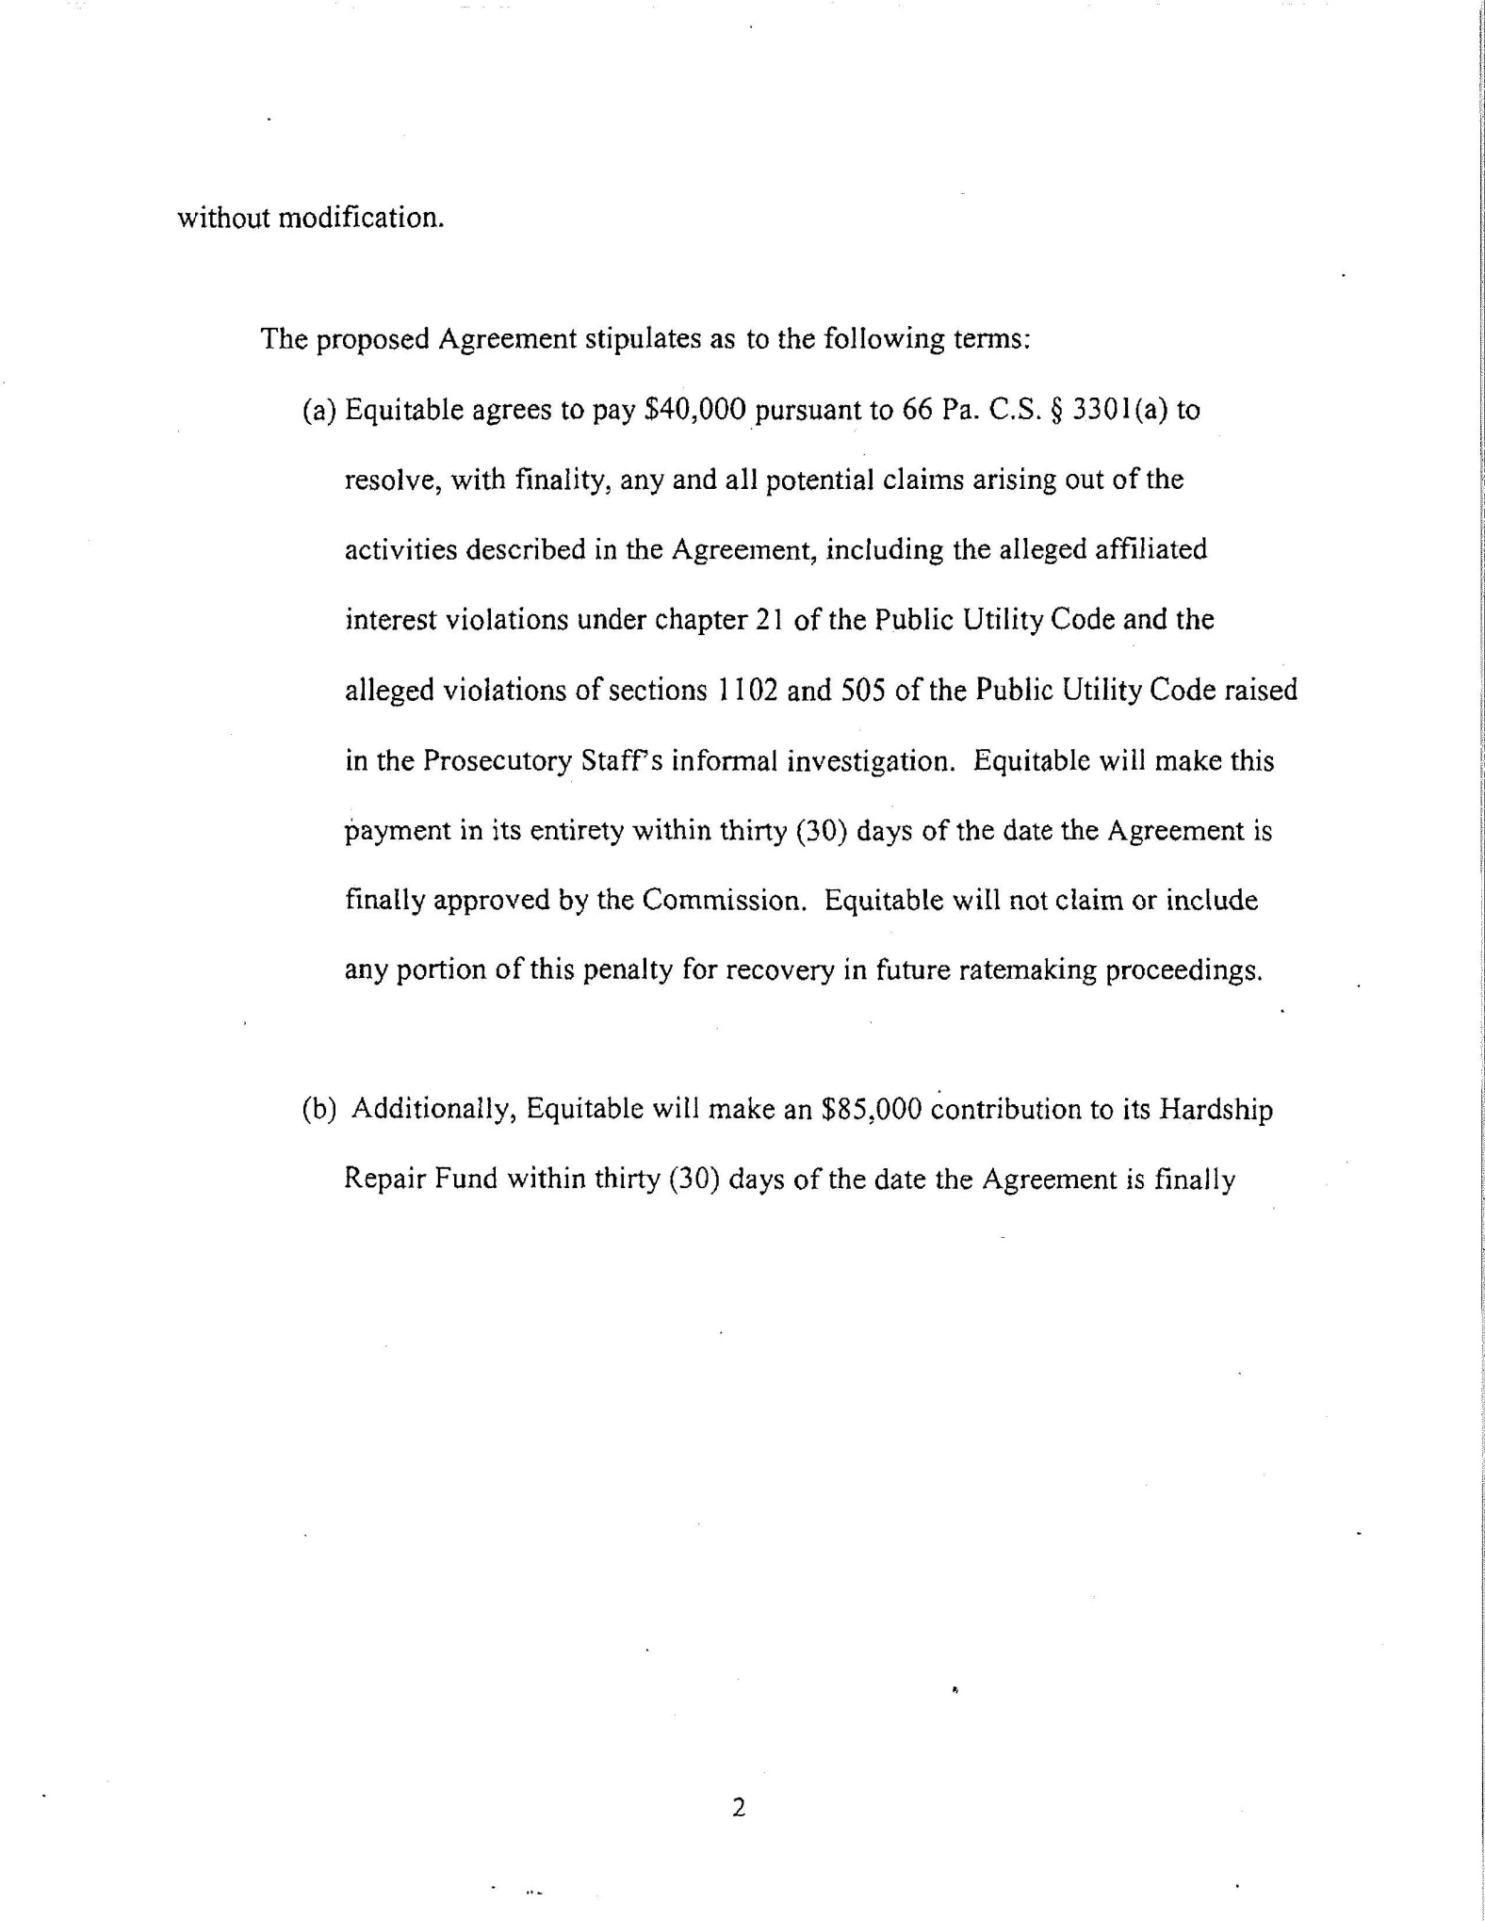
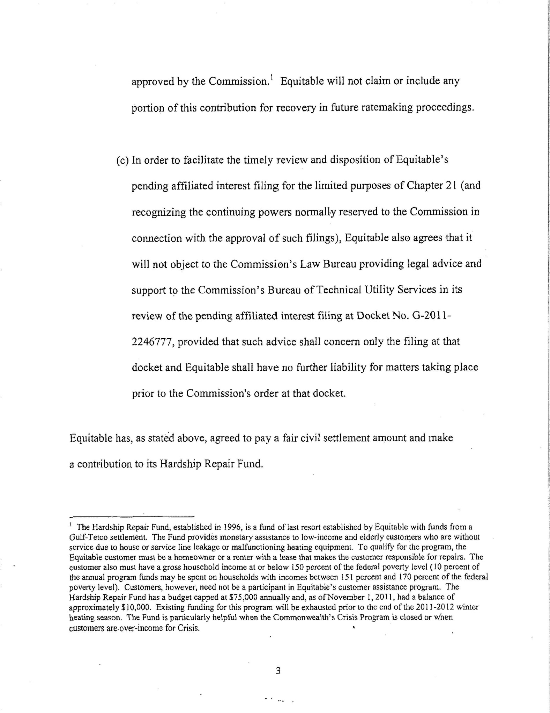
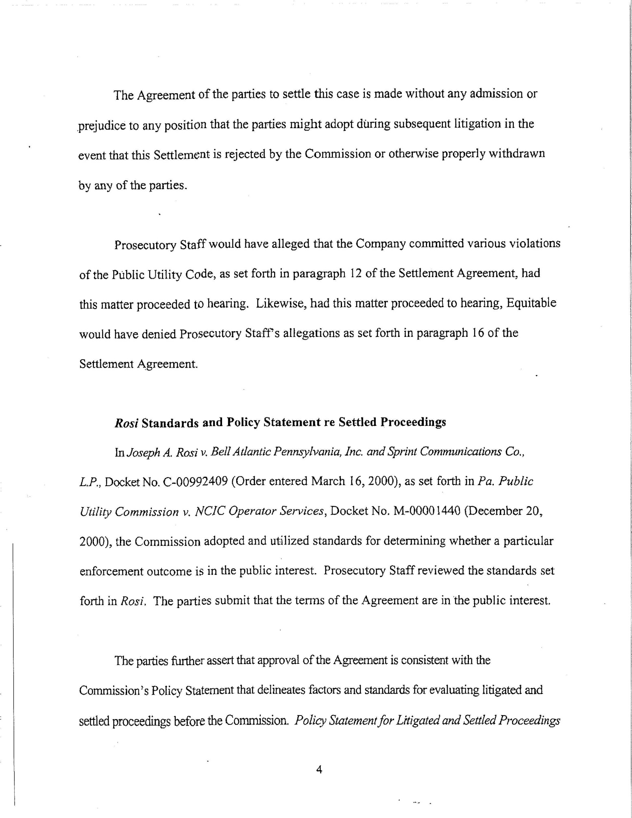
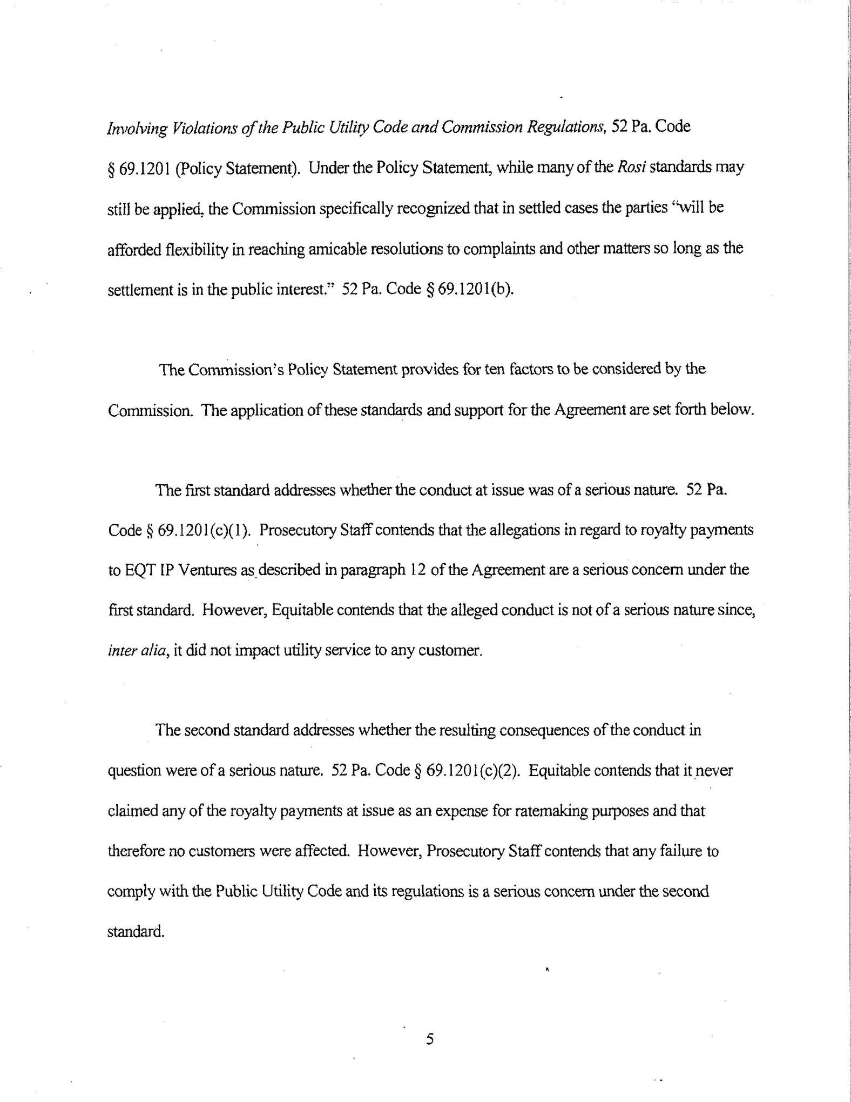
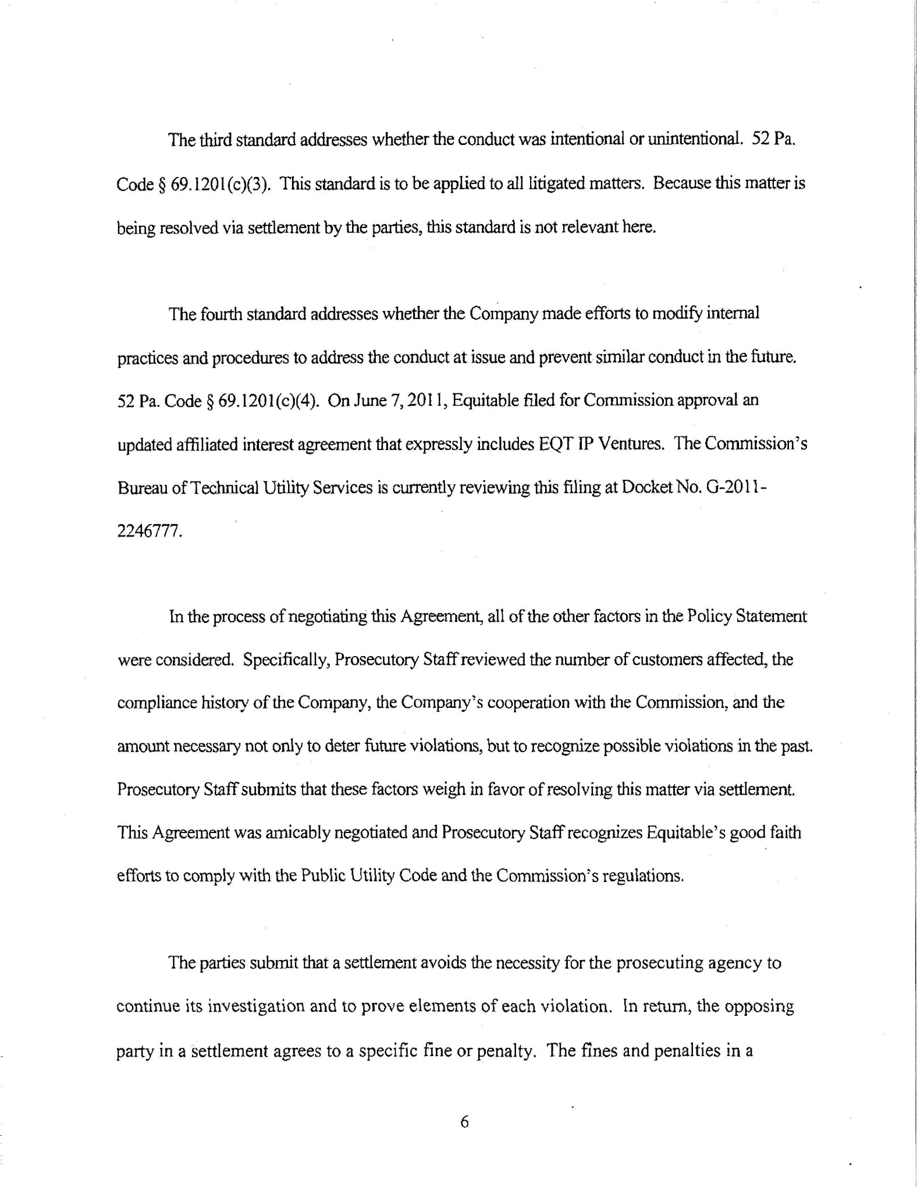
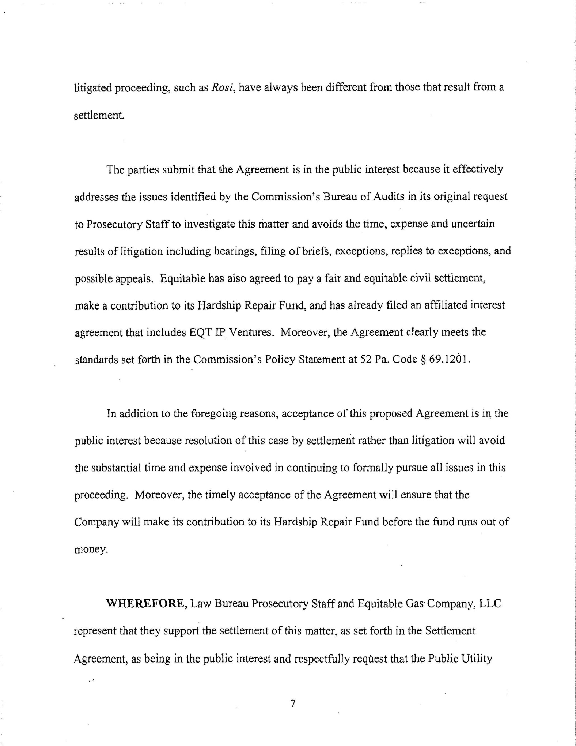
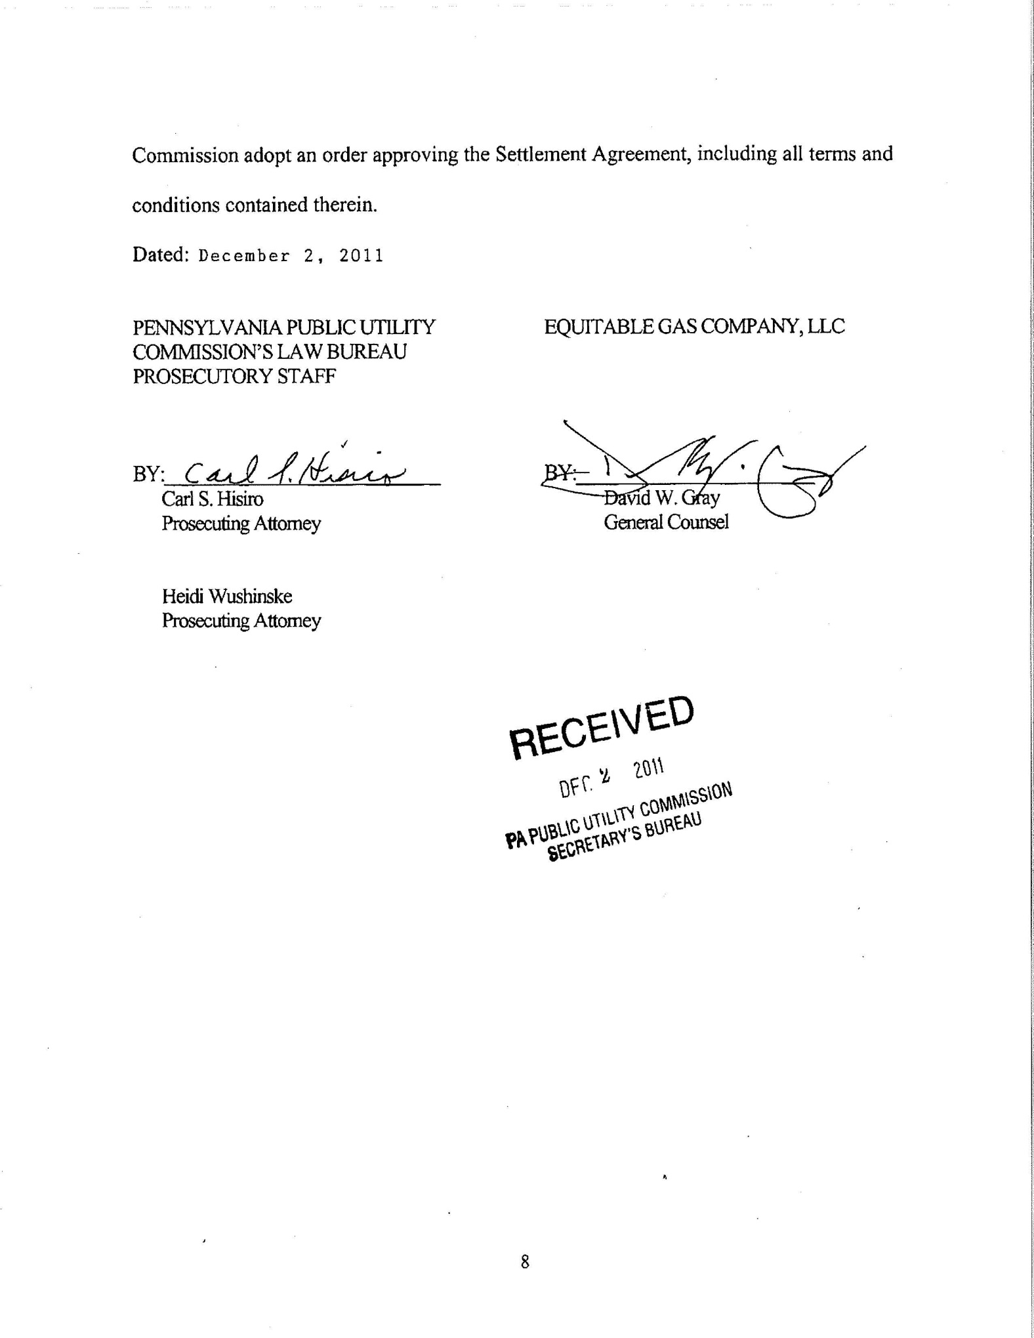

The reference herein to the “Prosecutory Staff” is intended to include and be binding on the Bureau of Investigation and Enforcement and the Bureau of Technical Utility Services (TUS), as well as the Commission’s Law Bureau.
Equitable was a regulated operating division of ERI prior to a holding company reorganization approved by the Commission at Docket No. A-121100F0006, which became effective on July 1, 2008. The investigation at this Docket covered matters that occurred before and after the holding company reorganization. As such, “Equitable” refers to both the post-July 2008 regulated LLC and the pre-July 2008 regulated operating division.
The Hardship Repair Fund is a fund of last resort that was established by Equitable in 1996 with funds from a Gulf-Tetco settlement. The Fund provides monetary assistance to low-income and elderly customers who are without service due to house or service line leakage or malfunctioning heating equipment. To qualify for the program, a customer must be a homeowner or a renter with a lease that makes the customer responsible for repairs. The customer also must have a gross household income at or below 150 percent of the federal poverty level (10 percent of the annual program funds may be spent on households with incomes between 151 percent and 170 percent of the federal poverty level). Customers need not be participants in Equitable's customer assistance program. The Hardship Repair Fund has a budget capped at $75,000 annually and, as of November 1, 2011, it had a balance of approximately $10,000. Existing funding for this program will be exhausted prior to the end of the 2011-2012 winter heating season. The Fund is particularly helpful when the Commonwealth's Crisis Program is closed or when customers are over-income for Crisis. Settlement at 12, n. 2.

