 | COMMONWEALTH OF PENNSYLVANIA  PENNSYLVANIA PUBLIC UTILITY COMMISSION  P.O. BOX 3265, HARRISBURG, PA 17105-3265 | IN REPLY PLEASE REFER TO OUR FILE

March 9, 2012
Docket No. L-00060182

DAVID P ZAMBITO ESQ
POST & SCHELL
17 NORTH SECOND STREET
12TH FLOOR
HARRISBURG PA 17101-1601

Re: Peoples Natural Gas, LLC -- Supplement No. 12 to Tariff Gas-Pa. P.U.C. No. 44 (Implementation of the Pennsylvania Public Utility Commission’s Revised Final Rulemaking Order to Amend Chapter 56 Standards and Billing Practices for Residential Service)

Dear Mr. Zambito:

On December 30, 2011, Peoples Natural Gas Company, LLC (Company) filed Supplement No. 12 to Tariff Gas-Pa. P.U.C. No. 44 to become effective on February 28, 2012. Supplement No. 12 implements the Pennsylvania Public Utility Commission’s Revised Final Rulemaking Order to amend Chapter 56 standards and billing practices for residential utility service.

Commission Staff has reviewed the tariff revisions and found that suspension or further investigation does not appear warranted at this time. Therefore, in accordance with 52 Pa. Code, Supplement No. 12 to Tariff Gas-Pa. P.U.C. No. 44 is effective by operation of law according to the effective dates contained on each page of the supplement. However, this does not constitute a determination that the revisions are just, lawful and reasonable, but only that suspension or further investigation does not appear warranted at this time, and is without prejudice to any formal complaints timely filed against said tariff revision.

If you have any questions in this matter, please contact J. Elaine McDonald, Bureau of Technical Utility Services, at 717-787-1869 or jmcdonald@pa.gov.

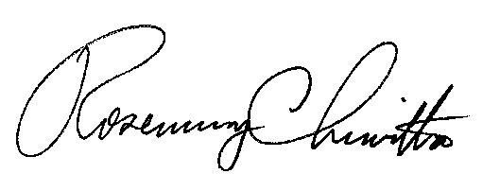
Sincerely

Rosemary Chiavetta
Secretary

cc: J. Elaine McDonald, Bureau of Technical Utility Services

