 | COMMONWEALTH OF PENNSYLVANIA  PENNSYLVANIA PUBLIC UTILITY COMMISSION  P.O. BOX 3265, HARRISBURG, PA 17105-3265 | IN REPLY PLEASE REFER TO OUR FILE

April 10, 2012
Docket No. L-00060182

GARY A JACK
ASSISTANT GENERAL COUNSEL
DUQUESNE LIGHT COMPANY
411 SEVENTH AVENUE
16TH FLOOR
PITTSBURGH PA 19512

Re: Proposed Supplement No. 56 to Tariff Electric-Pa. P.U.C. No. 24

Dear Mr. Webster:

On January 23, 2012, Duquesne Light Company (Company) filed Supplement No. 56 to Tariff Electric-Pa. P.U.C. No. 24 to become effective on March 23, 2012. Supplement No. 56 reflects tariff changes to comply with the Rulemaking to Amend the Provisions of 52 Pa. Code, Chapter 56 at the above docket.

Commission Staff has reviewed the tariff revisions and found that suspension or further investigation does not appear warranted at this time. Therefore, in accordance with 52 Pa. Code, Supplement No. 56 to Tariff Electric-Pa. P.U.C. No. 24 is effective by operation of law according to the effective dates contained on each page of the supplement. However, this does not constitute a determination that the revisions are just, lawful and reasonable, but only that suspension or further investigation does not appear warranted at this time, and is without prejudice to any formal complaints timely filed against said tariff revision.

If you have any questions in this matter, please contact J. Elaine McDonald, Bureau of Technical Utility Services, at 717-787-1869 or jmcdonald@pa.gov.

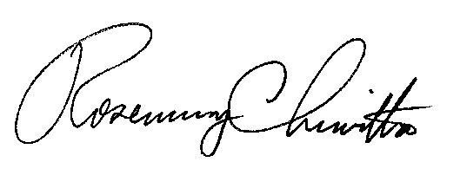
Sincerely

Rosemary Chiavetta
Secretary

cc: J. Elaine McDonald, Bureau of Technical Utility Services

