PENNSYLVANIA
PUBLIC UTILITY COMMISSION
Harrisburg, PA 17105-3265
 |  | Public Meeting held April 12, 2012
Commissioners Present:
Robert F. Powelson, Chairman
John F. Coleman, Jr., Vice Chairman
Wayne E. Gardner
James H. Cawley
Pamela A. Witmer
Application of EnergyMark, LLC to Amend its Natural Gas Supplier License |  |  |  | A-2009-2150184
ORDER

BY THE COMMISSION:

On February 16, 2012, EnergyMark, LLC (EnergyMark) filed an application to amend its natural gas supplier license to add residential customers in the natural gas distribution company (NGDC) service territory of National Fuel Gas Distribution Corporation (NFG).

EnergyMark, by Order entered April 15, 2010, is currently licensed by the Commission to offer, render, furnish or supply natural gas supply services as a supplier and broker/marketer in the Commonwealth of Pennsylvania to small commercial (less than 6,000 Mcf annually), large commercial (6,000 Mcf or more annually), industrial and governmental customers in the NGDC service territory of NFG.

EnergyMark has provided proofs of publication in Pennsylvania newspapers of general circulation serving the geographical territories affected by the applications and proofs of service to the interested parties as required by the Commission.

Section 2208(c)(1), 66 Pa. C.S. § 2208(c)(1), provides that a natural gas supplier license shall not be issued unless the applicant furnishes a bond or other security in a form and amount to ensure its financial responsibility. The criteria used to establish the form and amount of the bond or other security is set forth in the NGDC’s tariff. The amount and form of the bond or other security may also be mutually agreed to between the NGDC and the natural gas supplier. Section 2208 also provides that should the parties fail to achieve an agreement, then the form and amount of bond or other financial security “shall be determined by criteria approved by the Commission.” EnergyMark has provided documentation to evidence its compliance with the Section 2208(c) bonding requirement for the NGDC in whose service territories it proposes to expand its operations.

As of April 3, 2012, no protests have been filed, however, EnergyMark did have a number of informal consumer complaints filed with the Commission. All of the complaints were filed prior to May, 2011, and all have been resolved satisfactorily by the company.

Upon full consideration of all matters of record, we find that approval of these applications is necessary and proper for the service, accommodation and convenience of the public; THEREFORE,

IT IS ORDERED:

1. That the application of EnergyMark, LLC is hereby approved, consistent with this Order.

2. That a license be issued authorizing EnergyMark, LLC to begin to offer, render, furnish or supply natural gas supply services to residential customers in the natural gas distribution company service territory of National Fuel Gas Distribution Corporation.

3. That this proceeding at Docket No. A-2009-2150184 be closed.

BY THE COMMISSION,
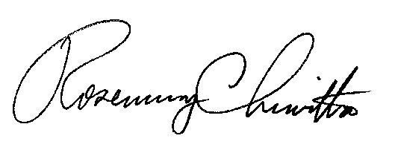

Rosemary Chiavetta
Secretary

(SEAL)

ORDER ADOPTED: April 12, 2012

ORDER ENTERED: April 12, 2012

