COMMONWEALTH OF PENNSYLVANIA
PENNSYLVANIA PUBLIC UTILITY COMMISSION
P. O. BOX 3265, HARRISBURG PA 17105-3265
IN REPLY PLEASE
REFER TO OUR FILE
717-772-7777
May 2, 2012
Docket No. A-2012-2300584

George Hamaty
Columbia Gas Transmission LLC
1700 Maccorkle Avenue, SE
Charleston, WV 25314

Dear Mr. Hamaty:

This letter acknowledges the receipt of your company’s application for registration as a pipeline operator under Act 127 of 2011, the Gas and Hazardous Liquids Pipelines Act (Pipeline Act) in the Commonwealth of Pennsylvania. The docket number assigned to your application is A-2012-2300584. Please refer to this number in all future correspondence with the Public Utility Commission (PUC).

Please note that the PUC will not be issuing an assessment invoice for Fiscal Year 2011-2012, as previously indicated in the PUC Secretarial Letter of January 12, 2012. However, the PUC will issue an assessment invoice to your company for Fiscal Year 2012-2013 in the near future.

Should you have any questions pertaining to your registration, please contact our Bureau of Technical Utility Services at 717-783-5242.

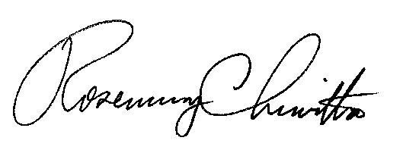
Sincerely,

Rosemary Chiavetta
Secretary

