PENNSYLVANIA
PUBLIC UTILITY COMMISSION
Harrisburg, PA 17105-3265

Application of Bradley A. Kleffel, t/a Kleffel’s : A-2010-2202568
Moving & Delivery Service :

FINAL ORDER

In accordance with the provisions of Section 332(h) of the Public Utility Code, 66 Pa. C.S. §332(h), the decision of Administrative Law Judge Angela T. Jones dated March 15, 2012, has become final without further Commission action;

THEREFORE,

IT IS ORDERED:

- That the application filed by Bradley A. Kleffel t/a Kleffel’s Moving and Delivery Service (“Applicant” or “Kleffel”) for approval to expand the service territory to transport household goods in use in the counties of Lehigh, Schuylkill, Lebanon, Lancaster, Carbon and Montgomery at Docket No. A-2010-2202568 is denied.

- That the Secretary’s Bureau mark this matter closed.

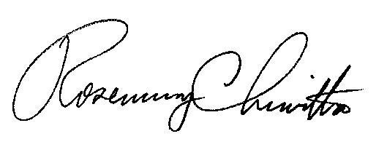
BY THE COMMISSION,

Rosemary Chiavetta
Secretary

(SEAL)

ORDER ENTERED: May 10, 2012

