PENNSYLVANIA
PUBLIC UTILITY COMMISSION
Harrisburg, PA 17105-3265

Public Meeting held May 10, 2012

Commissioners Present:

Robert F. Powelson, Chairman
John F. Coleman, Jr., Vice Chairman, Statement
Wayne E. Gardner
James H. Cawley
Pamela A. Witmer

Pennsylvania Public Utility Commission,  Law Bureau Prosecutory Staff  v.  Equitable Gas Company, LLC | M-2011-2185982

OPINION AND ORDER

BY THE COMMISSION:

Before the Pennsylvania Public Utility Commission (Commission) for consideration and disposition is a proposed Settlement Agreement (Settlement) filed on December 2, 2011, by the Commission’s Law Bureau Prosecutory Staff (Prosecutory Staff) and Equitable Gas Company, LLC (Equitable) (collectively, the Parties). The Settlement was proposed to resolve an informal investigation conducted by the Prosecutory Staff. The Parties submit that the proposed Settlement is in the public interest and is consistent with the Commission’s Policy Statement at 52 Pa. Code § 69.1201, Factors and standards for evaluating litigated and settled proceedings involving violations of the Public Utility Code and Commission regulations—statement of policy (Policy Statement). Joint Statement in Support of Settlement (Parties’ Joint Statement) at 4-6.

The proposed Settlement is conditioned on the Commission’s approval without modification, addition, or deletion of any of its terms or conditions. If the Commission does not approve the Settlement or any of the terms or conditions set forth therein without modification, addition, or deletion, then either Party may elect to withdraw from the Settlement. Settlement at 13.

Background

Equitable is a Pennsylvania limited liability company owned by EQT Corporation, formerly Equitable Resources, Inc. (ERI). Equitable is a regulated natural gas distribution company providing service to residential, commercial and industrial customers in western Pennsylvania. On or about October 2001, ERI, through a subsidiary, caused EQT IP Ventures, LLC. (EQT IP Ventures) to be formed as a limited liability company for the business purpose of owning, managing, protecting, and valuing the intellectual property of all the operating business of ERI. Subsequently, ERI and its operating subsidiaries transferred certain intangible/intellectual property, including trade names and trademarks, to EQT IP Ventures as a tax-free capital contribution. There was no contribution paid by EQT IP Ventures for the asset transfer. Settlement at 2 and 5.

In exchange for the services provided by EQT IP Ventures in connection with the right to use of those assets, ERI and its subsidiaries made royalty payments to EQT IP Ventures. Settlement at 3. The Settlement states that the initial royalty payments were based on a third-party valuation conducted pursuant to Section 482 of the Internal Revenue Code and were calculated at 7.5 percent of operating revenues for residential customers and one percent of operating revenues for commercial and industrial customers. Since “mid-2007,” Equitable has paid EQT IP Ventures a royalty rate of 6.5 percent for all revenue based on another third-party evaluation. Equitable notes that none of the royalty payments have been claimed as an expense for ratemaking purposes. Settlement at 5-6.

History of the Case

By letter dated August 6, 2010, the Prosecutory Staff informed Equitable that it was initiating an informal investigation regarding the transfer of intellectual property to EQT IP Ventures and affiliated interest transactions with EQT IP Ventures. The informal investigation was initiated as a result of information obtained from a Stratified Management and Operations Audit (SM&O Audit) performed for the Commission's Bureau of Audits (Bureau of Audits). The SM&O Audit was conducted by an outside consultant, and it covered the time period from October 2001, when EQT IP Ventures was formed, to the conclusion of the audit in 2010. Prior to the SM&O Audit, the Bureau of Audits had also conducted a Management Audit of Equitable that was concluded in 2003 (2003 Management Audit) and a related Management Efficiency Investigation that was concluded in February 2007. Both of those audits resulted in recommendations that Equitable update its affiliated interest agreements to reflect all affiliate transactions. Equitable did not include EQT IP Ventures in any of its affiliated interest filings in response to the 2003 Management Audit or the related Management Efficiency Investigation. Settlement at 2-3.

Pursuant to the SM&O Audit, the outside consultant recommended that Equitable develop an affiliated interest agreement regarding the EQT IP Ventures and Equitable’s relationship, and submit the affiliated interest agreement to the Commission for approval. On June 7, 2011, in response to the audit recommendation, Equitable filed, without prejudice to its positions advanced in this proceeding, an updated affiliated interest agreement that included EQT IP Ventures. The Commission’s Bureau of Technical Utility Services is currently reviewing the pending affiliated interest filing at Docket No. G-2011-2246777. Settlement at 3.

On December 2, 2011, the Prosecutory Staff and Equitable filed the proposed Settlement and the Joint Statement with the Commission. By Order entered January 27, 2012, at the above-captioned docket (January 2012 Order), the Commission issued the proposed Settlement and the Joint Statement for comments by any interested party. The Commission also directed that the Settlement and the Parties’ Joint Statement be served on the Office of Consumer Advocate (OCA) and the Office of Small Business Advocate. The January 2012 Order stated that any comments on the Settlement would be considered timely if they were filed within twenty days of the entry of the Order.

Concurrent with the adoption of the January 2012 Order at the Commission’s Public Meeting held January 27, 2012, Commissioners Wayne E. Gardner and James H. Cawley issued a Joint Statement (Commissioners’ Joint Statement). The Commissioners’ Joint Statement, inter alia, requested that Equitable, Prosecutory Staff and other interested parties comment on “any effect that the transfer to EQT IP might have had on rates related to revenue requirements asserted by Equitable in its 2008 base rate case [Docket No. R-2008-2029325] as well as any other issue.” (footnote omitted). Commissioners’ Joint Statement at 2.

Comments in response to the January 2012 Order and the Commissioners’ Joint Statement were filed by the Prosecutory Staff on February 13, 2012, and by Equitable and the OCA on February 16, 2012.

Alleged Violations and Equitable’s Response

Had this matter been litigated, the Prosecutory Staff would have alleged the following: (1) that Equitable transferred intellectual property used or useful in the public service to EQT IP Ventures without Commission approval in violation of Section 1102(a)(3) of the Public Utility Code (Code), 66 Pa. C.S. § 1102(a)(3); (2) that Equitable entered into an agreement with EQT IP Ventures, an affiliate, for the payment of royalty amounts by Equitable in exchange for the services provided by EQT IP Ventures and the right to use intellectual property without Commission approval in violation of Section 2102(a) of the Code, 66 Pa. C.S. § 2102(a); and (3) that Equitable failed to furnish information to the Commission regarding its transactions with EQT IP Ventures at various times since 2001, in violation of Section 505 of the Code, 66 Pa. C.S. § 505. Settlement at 7.

Although Equitable fully cooperated with the investigation, had this matter been litigated, Equitable would have denied that it violated any section of the Code or of the Commission’s Regulations and Orders. Settlement at 8. Equitable would have responded to the Prosecutory Staff’s allegations, inter alia, as follows: (1) that Equitable informed Audits of the existence of an arrangement with an Equitable affiliate involving intellectual property, and Audits reported this information in the 2003 Management Audit; (2) that because the subject intellectual property had no book value and was not included as part of Equitable’s rate base for ratemaking purposes, Equitable was not required to obtain approval for the transfer of the property under Section 1102(a)(3) of the Code; and (3) that Section 2102(a) of the Code was not intended to apply to the transactions between Equitable and EQT IP Ventures, particularly because payments of royalties are from shareholder funds that are beyond the Commission’s jurisdiction. Settlement at 8-11.

Terms of the Settlement

Pursuant to the proposed Settlement, Equitable will pay the Commission a civil settlement amount of $40,000 and make an $85,000 contribution to Equitable’s Hardship Repair Fund. Equitable will not claim or include any portion of these monetary amounts for recovery in future ratemaking proceedings. Settlement at 12. In order to facilitate the timely review and disposition of Equitable’s pending affiliated interest agreement filing at Docket No. G-2011-2246777, Equitable has agreed that it will not object to the Commission’s Law Bureau providing legal advice to TUS in its review of the filing, provided that the advice pertains only to the filing at that docket and that Equitable has no further liability for matters that occurred prior to the Commission’s Order at that docket. Id. at 12.

The Settlement resolves all matters raised and which could have been raised by the Prosecutory Staff in the investigation, as well as any potential issues or liability associated with Equitable’s transactions with EQT IP Ventures prior to the date of the Commission’s Order at Docket No. G-2011-2246777. Settlement at 13. The provisions of the Settlement may not be used or construed by any person as an admission of any fact or liability by Equitable. Moreover, the Agreement does not constitute any admission against, or prejudice to, any position that any party may adopt during any subsequent administrative or court proceeding. Id. at 14.

Discussion

The Informal Investigation was conducted pursuant to Sections 331(a) and 506 of the Code, 66 Pa. C.S. §§ 331(a) and 506, and Section 3.113 of the Commission’s Rules of Practice and Procedure, 52 Pa. Code § 3.113. After the Informal Investigation, and in accordance with 52 Pa. Code § 3.113(b)(3), LBPS and Equitable entered into discussions regarding settling this matter without the need for an on-the-record proceeding. Those discussions resulted in the instant proposed Settlement.

Pursuant to our Regulations at 52 Pa. Code § 5.231, it is the Commission’s policy to promote settlements. However, the Commission must review proposed settlements to determine whether the terms are in the public interest. Pa. PUC v. Philadelphia Gas Works, Docket No. M-00031768 (Order entered January 7, 2004);
Pa. PUC v. CS Water and Sewer Assoc., 74 Pa. P.U.C. 767 (1991); Pa. PUC v. Philadelphia Electric Co., 60 Pa. P.U.C. 1 (1985). Before addressing the merits of the proposed Settlement, and consistent with the requirement of 52 Pa. Code § 3.113(b)(3), the Commission provided an opportunity for interested parties to file comments regarding the proposed Settlement. As noted, supra, Comments were filed by Equitable, Prosecutory Staff and the OCA.

Comments in Response to the January 2012 Order

In its Comments in response to the January 2012 Order (Equitable Comments), Equitable addresses the issue raised in the Commissioners’ Joint Statement. Equitable notes that, as explained in the Settlement, the royalty payments made by Equitable to EQT IP Ventures were never claimed by Equitable as an expense for ratemaking purposes. Equitable submits that the Settlement also explained that the intellectual property that was transferred to EQT IP Ventures was never included as part of Equitable’s rate base for ratemaking purposes. Therefore, Equitable avers that the transfer of intellectual property had no impact on ratepayers. In addition, Equitable states that the 2008 rate case was resolved through a “black box” settlement after full investigation and discovery. Equitable Comments at 2-3.

In the Prosecutory Staff’s Response Comment to the January 2012 Order (Prosecutory Staff Comments), Prosecutory Staff states that it examined the entire rate case docket filings of Equitable’s 2008 base rate case and concluded that the transfer of intangible/intellectual property and the subsequent royalty payments did not have “any measurable impact” on Equitable’s future rates. Prosecutory Staff Comments at 2. In support of its conclusion, Prosecutory Staff submits that the licensing fee/royalty payments to Equitable IP Ventures were “below the line” payments made from shareholder funds, not ratepayer funds. Id. Further, Prosecutory Staff explains that there were no federal tax implications because Equitable files a consolidated tax return with its parent and affiliates. Prosecutory Staff also explains that any impact would have shown in the state corporate taxes. Prosecutory Staff avers that because Equitable had a negative state tax liability and a net operating loss carry forward for state tax purposes, there was no state tax liability in the 2008 rate proceeding. Id. at 3.

In its Comments, the OCA states that it was an active party to the 2008 base rate case. The OCA submits that information provided in the Settlement and the information reviewed by the OCA in conjunction with the 2008 rate case provides no basis to contest Equitable’s claims that the source of the royalty payments were shareholder funds and were never claimed for ratemaking purposes. The OCA concludes that the royalty payments had no impact on the revenue requirement awarded in that case and ratepayers were not adversely affected. The OCA requests that the final order issued in this proceeding make it clear that Equitable’s stated disposition of the property and royalty payments in question are not claimed in rate proceedings and will not impact rates in any manner in any future proceedings. Comments of the OCA at 3.

Disposition

The Commission has promulgated a Policy Statement at 52 Pa. Code § 69.1201 that sets forth ten factors that we may consider in evaluating whether a fine for violating a Commission order, regulation or statute is appropriate, as well as if a proposed settlement for a violation is reasonable and approval of the settlement agreement is in the public interest. We will consider each of those factors in turn.

The first factor is whether the conduct at issue is of a serious nature. 52 Pa. Code § 69.1201(c)(1). “When conduct of a serious nature is involved, such as willful fraud or misrepresentation, the conduct may warrant a higher penalty. When the conduct is less egregious, such as administrative filing or technical errors, it may warrant a lower penalty.” Id. Equitable contends that the alleged conduct is not of a serious nature because, inter alia, it did not impact utility service to any customer. Parties’ Joint Statement at 5.

The second factor we may consider is whether the resulting consequences of the conduct are of a serious nature. 52 Pa. Code § 69.1201(c)(2). Equitable contends that since it never claimed any of the royalty payments at issue as an expense for ratemaking purposes, no customers were affected. However, Prosecutory Staff contends that any failure to comply with the Public Utility Code and its regulation is a “serious concern” under the second standard. Parties’ Joint Statement at 5.

In considering the first and second factors contained in 52 Pa. Code § 69.1201(c)(1) and (2), we recognize that Equitable did disclose the arrangement involving EQT IP Ventures to the Bureau of Audits and that the royalties paid to EQT IP Ventures were never claimed for ratemaking purposes. However, we concur with the Prosecutory Staff that the failure to seek Commission approval for the transfer of intellectual property is a serious matter. We believe that the $40,000 civil penalty, the $85,000 contribution the Hardship Repair Fund and the other terms of the Settlement strike an appropriate balance to address these factors.

The third factor pertains to litigated cases only. 52 Pa. Code § 69.1201(c)(3). Because this matter is being resolved through a settlement by the parties, this standard is not relevant here.

The fourth factor we may consider is whether the regulated entity made efforts to modify internal practices and procedures to address the conduct at issue and prevent similar conduct in the future. 52 Pa. Code § 69.1201(c)(4). “In an effort to eliminate controversy but without prejudice to the positions advanced in this proceeding,” on June 7, 2011, Equitable filed an updated affiliated interest agreement that “expressly” included EQT IP Ventures. Settlement at 4. This affiliated interest filing is presently undergoing review by TUS. Notwithstanding the recommendations of TUS and any future action by the Commission, we find that the filing of the updated affiliated interest agreement by Equitable satisfies the criteria set forth in 52 Pa. Code § 69.1201(c)(4) for the purpose of adopting the Settlement.

The fifth factor we may consider is the number of customers affected and the duration of the violation. 52 Pa. Code § 69.1201(c)(5). As indicated, supra, Equitable contends that since it never claimed any of the royalty payments at issue as an expense for ratemaking purposes, no customers were affected.

We may also consider the compliance history of the regulated entity which committed the violation. 52 Pa. Code § 69.1201(c)(6). The SM&O Audit addressed Equitable’s affiliate relationships in the context of compliance with the Public Utility Code. Subject to the Commission’s ultimate disposition of the updated affiliated interest agreement filed by Equitable, we find that filing of the updated affiliated interest agreement addresses the relevant compliance history at this juncture.

Another factor we may consider is whether the regulated entity cooperated with the Commission’s investigation. 52 Pa. Code § 69.1201(c)(7). Prosecutory Staff acknowledged that Equitable cooperated fully with this investigation. Settlement at 8.

In addition, we may consider the amount of the civil penalty necessary to deter future violations as well as past Commission decisions in similar situations. 52 Pa. Code § 69.1201(c)(8) and (c)(9). Considering the proposed Settlement as a whole, we find the $40,000 civil penalty and the $85,000 contribution to Equitable’s Hardship Repair Fund are adequate.

The tenth factor permits us to consider other relevant factors. 52 Pa. Code § 69.1201(c)(10). No other relevant factors are present in this case.
Conclusion

It is the Commission’s policy to promote settlements. 52 Pa. Code § 5.231. The Comments submitted in response to the January 2012 Order together with the information submitted by the Parties to the Settlement have provided the Commission with sufficient information upon which to thoroughly consider the terms of the Settlement. The Settlement effectively addresses the issues which arose during the course of the informal investigation and avoids the expense of litigation and the possibility of appeals. Accordingly, we find that the proposed Settlement entered into between the Prosecutory Staff and Equitable is in the public interest and merits approval; THEREFORE,

IT IS ORDERED:

- That the Settlement Agreement entered into between the Law Bureau Prosecutory Staff and Equitable Gas Company, LLC, filed on December 2, 2011, is approved.

- That within thirty (30) days from the entry date of this Opinion and Order, Equitable Gas Company, LLC shall pay a civil penalty of $40,000 by check or money order made payable to:

Pennsylvania Public Utility Commission
P.O. Box 3265
Harrisburg, Pa. 17120

- That within thirty (30) days from the entry date of this Opinion and Order, Equitable Gas Company, LLC shall make an $85,000 contribution to its Hardship Repair Fund.

- That within forty (40) days from the entry date of this Opinion and Order, Equitable Gas Company, LLC shall file a notarized statement with the Secretary of the Commission confirming that the $85,000 contribution to its Hardship Repair Fund has been made.

- That Equitable Gas Company, LLC shall not claim or include any portion of the $40,000 civil penalty or $85,000 contribution to its Hardship Repair Fund for recovery in future rate making proceedings.

- That a copy of this Opinion and Order shall be served on the Office of Consumer Advocate, the Office of Small Business Advocate, and the Public Utility Commission’s Bureau of Administrative Services Fiscal Division.

- That upon payment of the $40,000 civil penalty and the confirmation of the $85,000 payment to the Hardship Repair Fund, the Secretary of the Commission shall mark this proceeding closed.

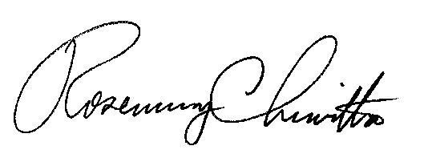
BY THE COMMISSION,

Rosemary Chiavetta
Secretary

(SEAL)

ORDER ADOPTED: May 10, 2012

ORDER ENTERED: May 10, 2012

ATTACHMENT

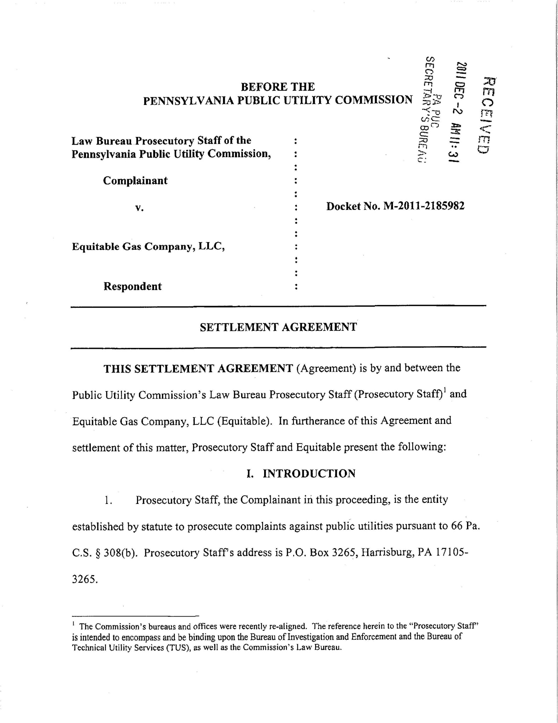
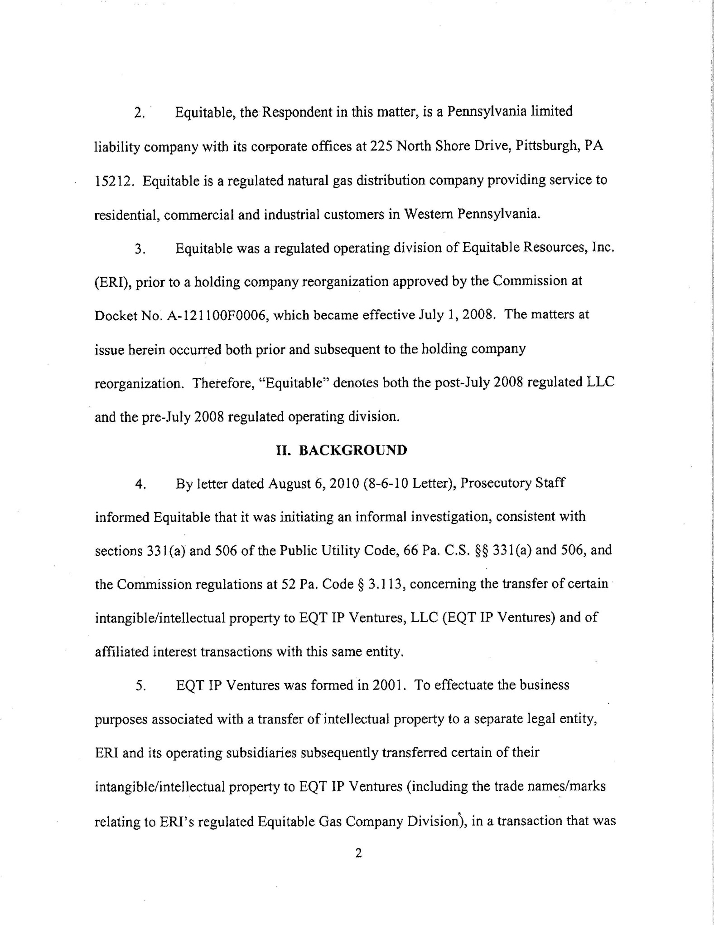
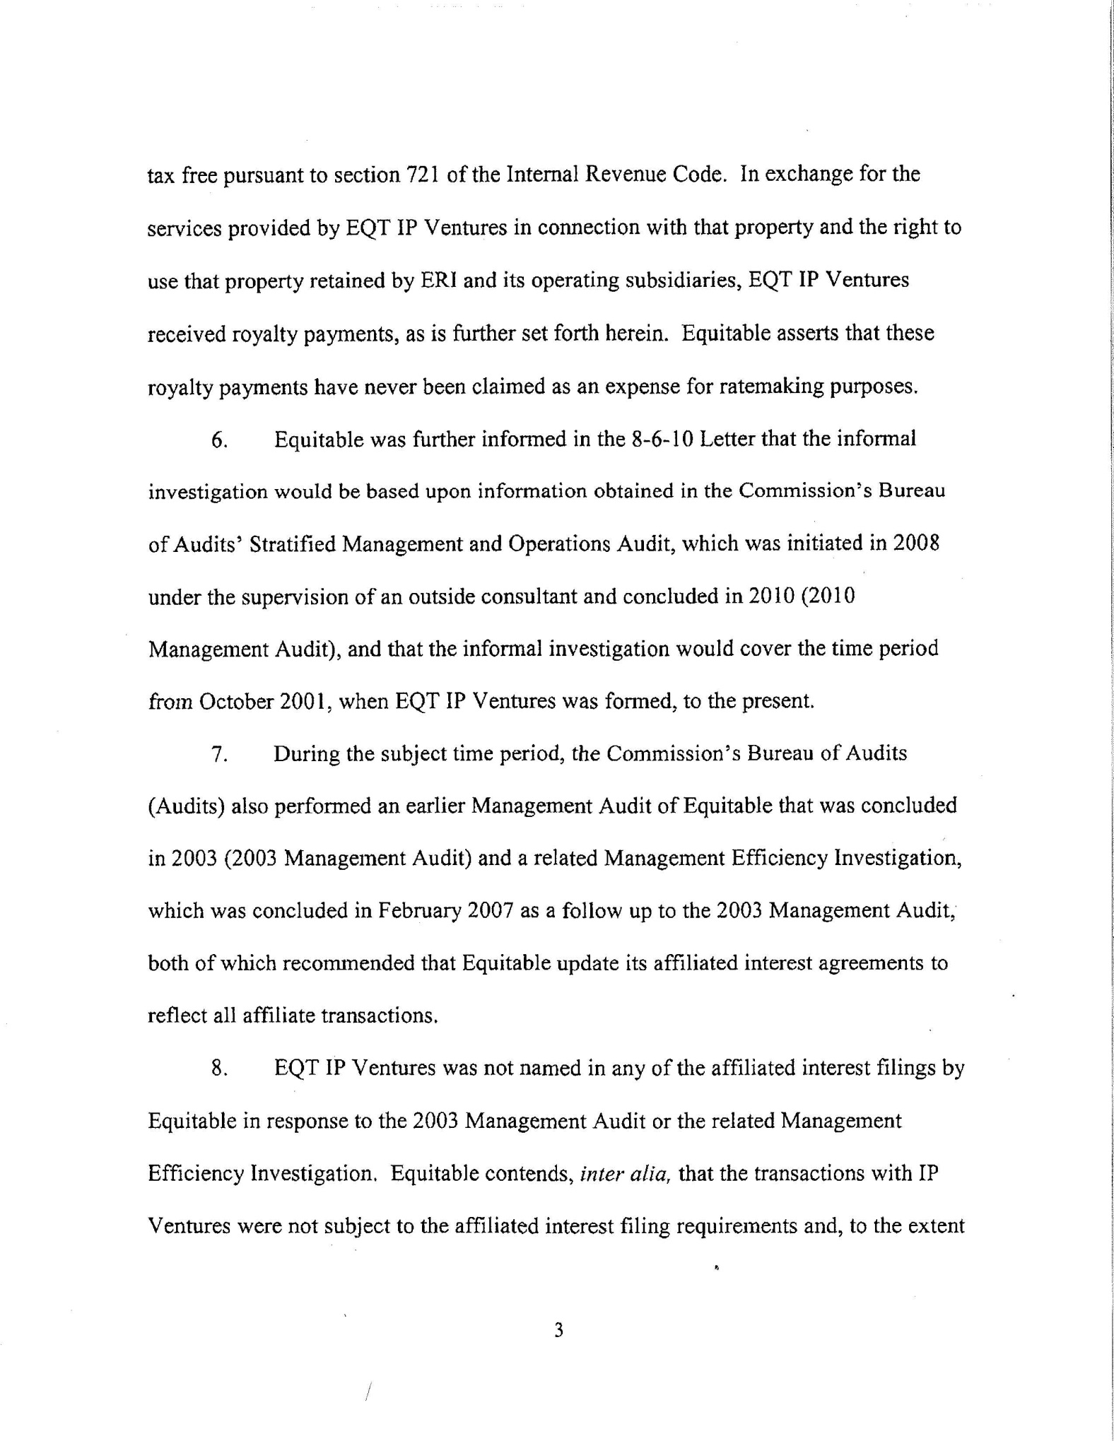
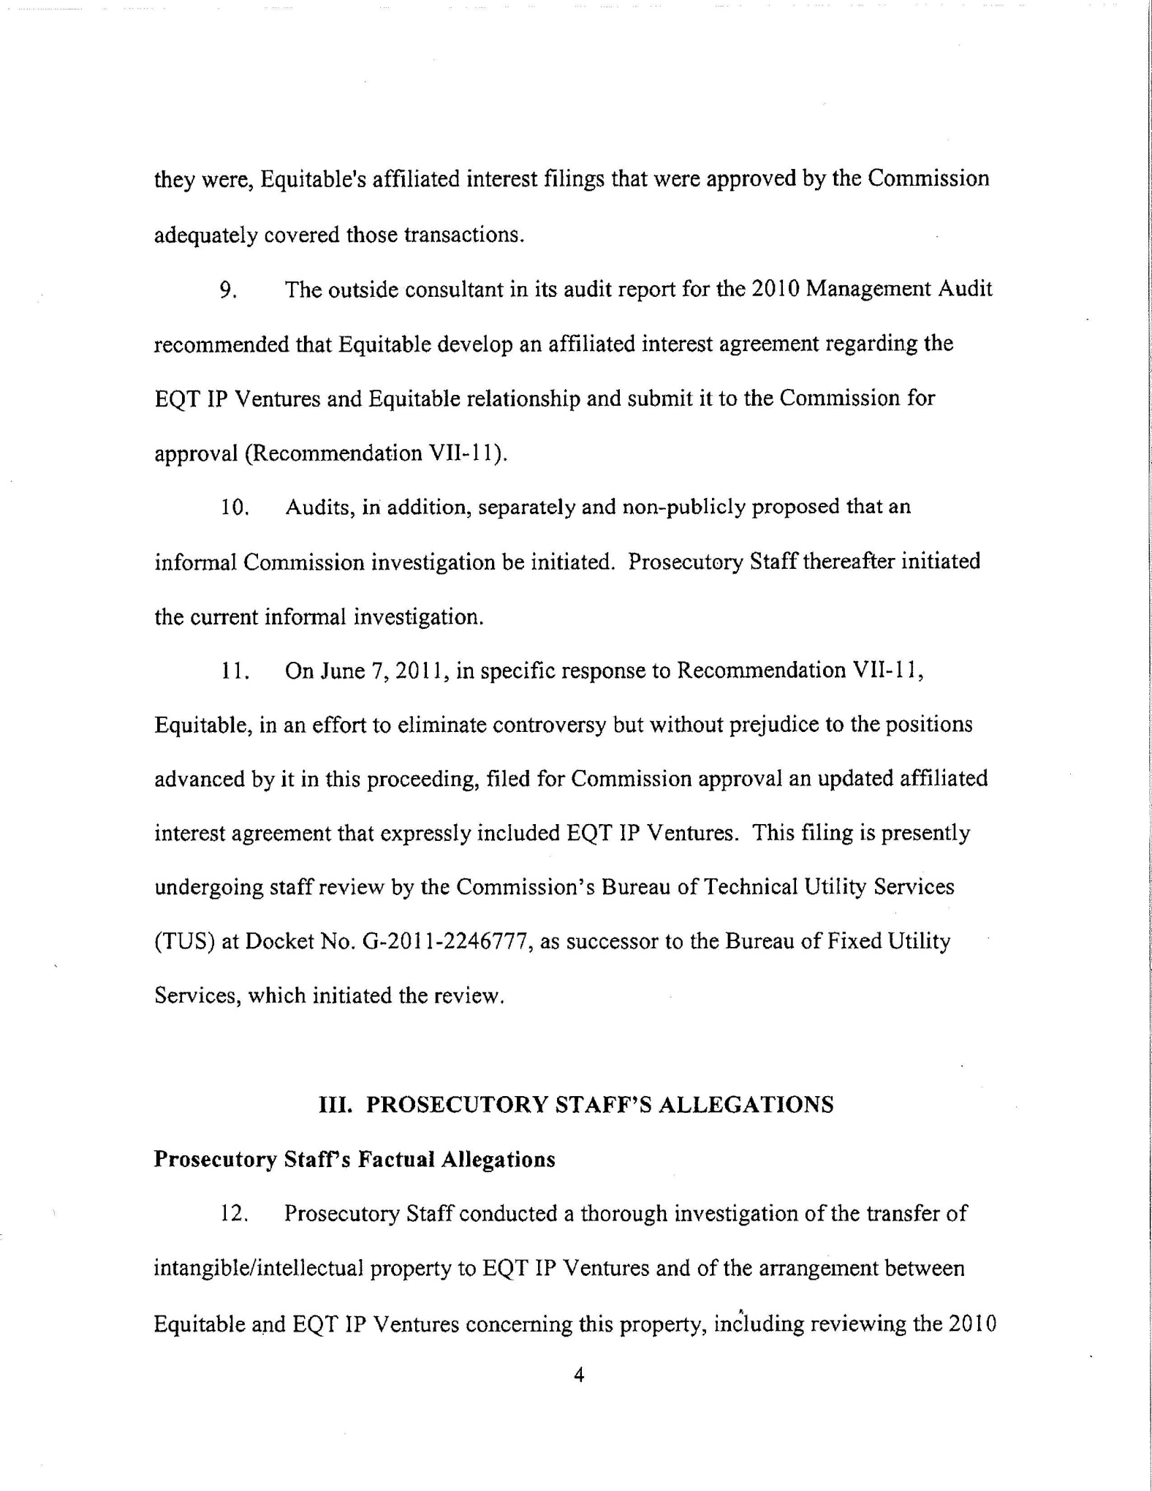
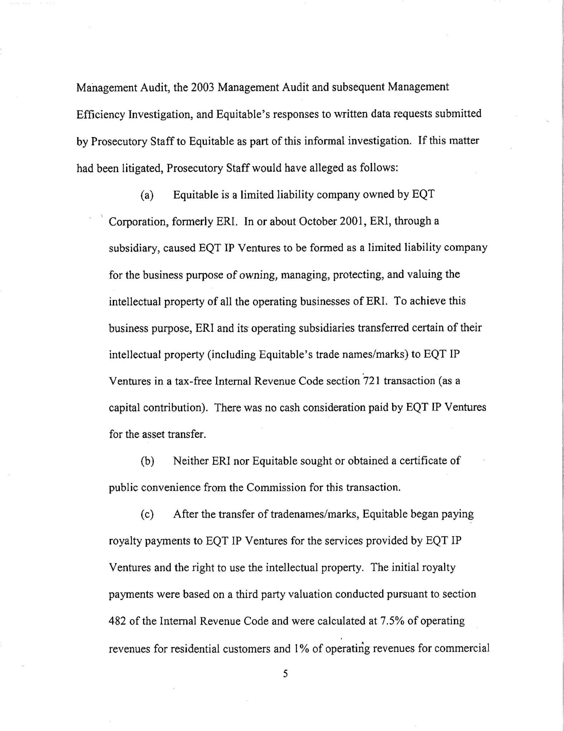
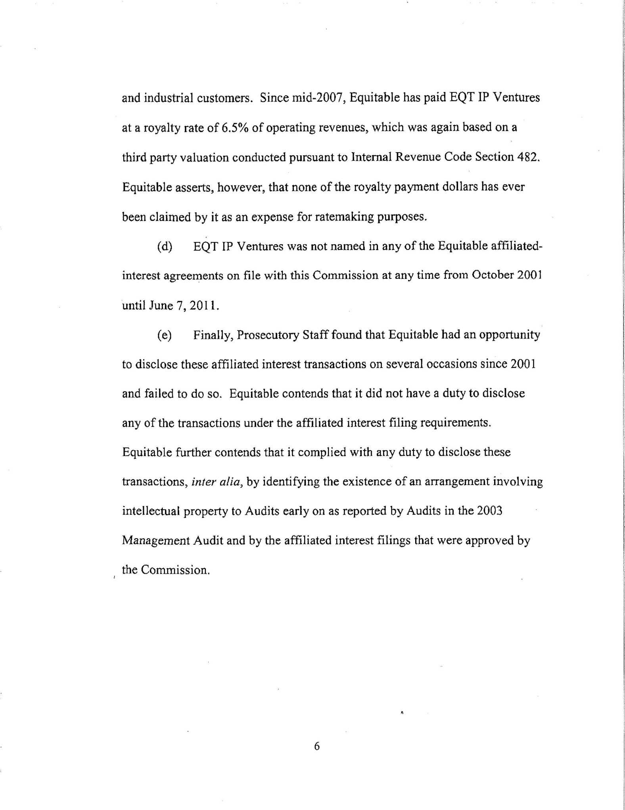
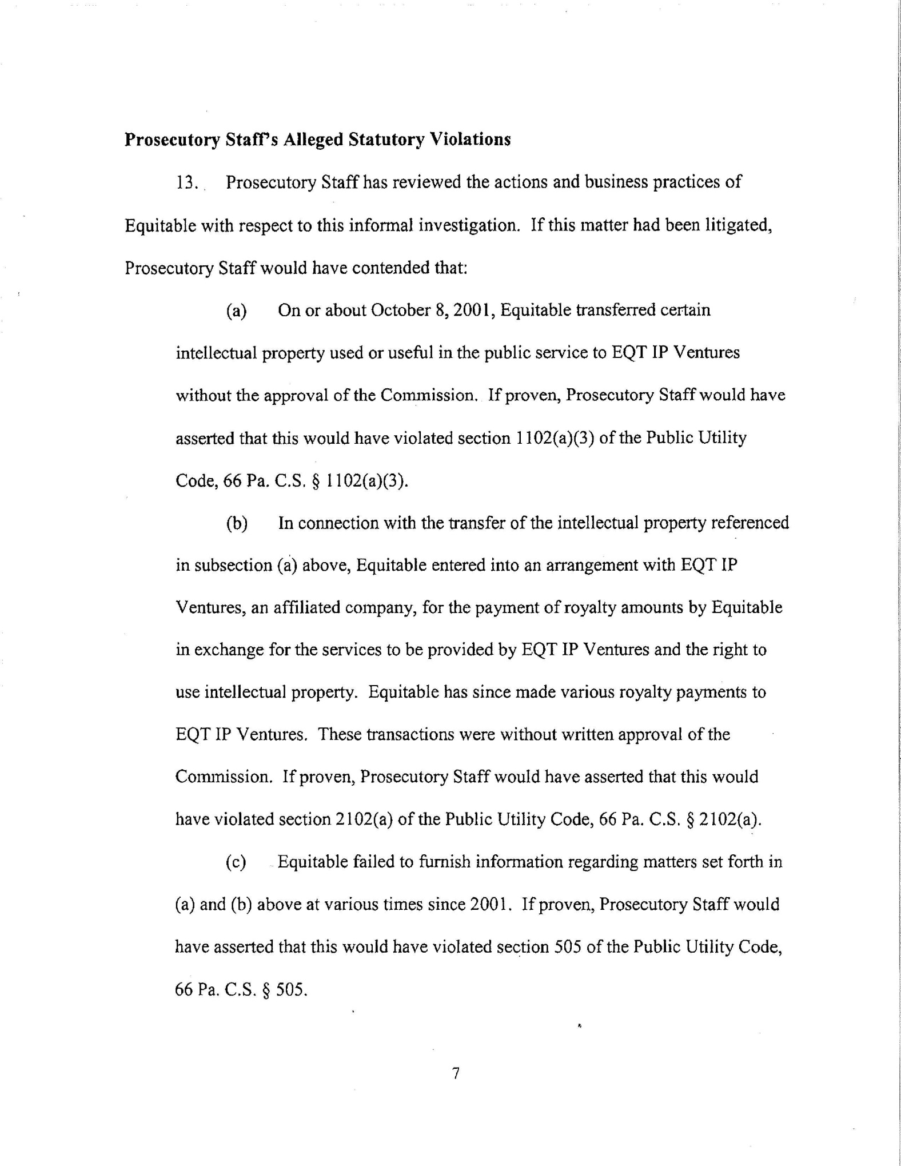
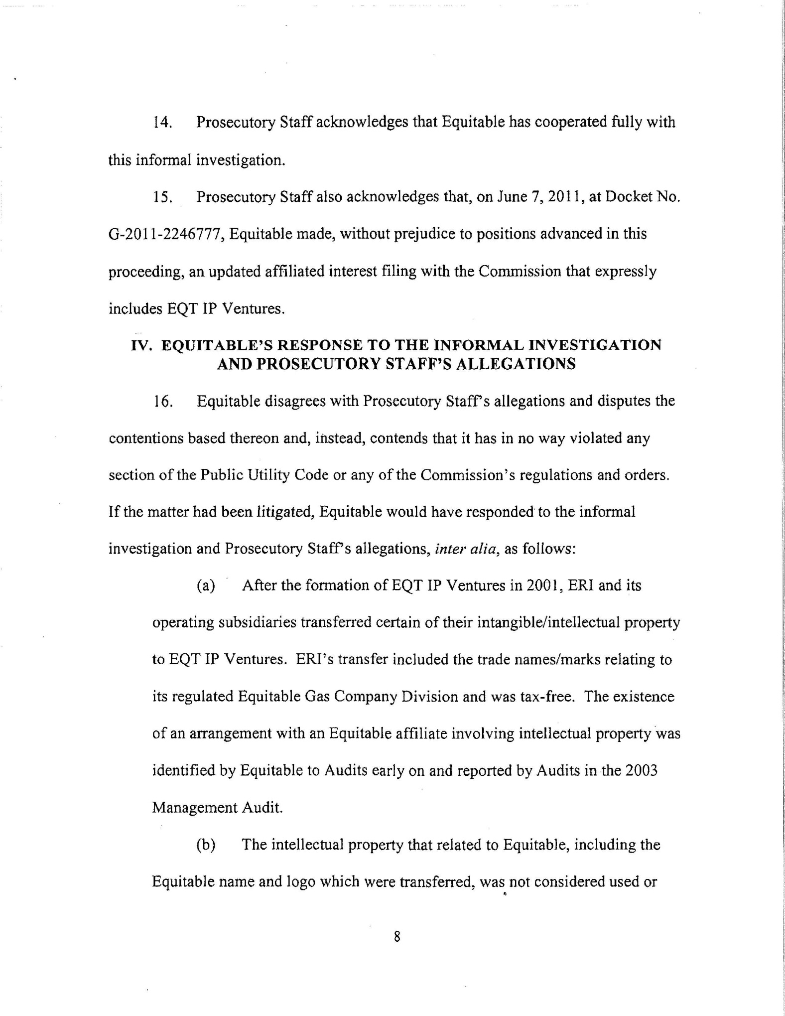
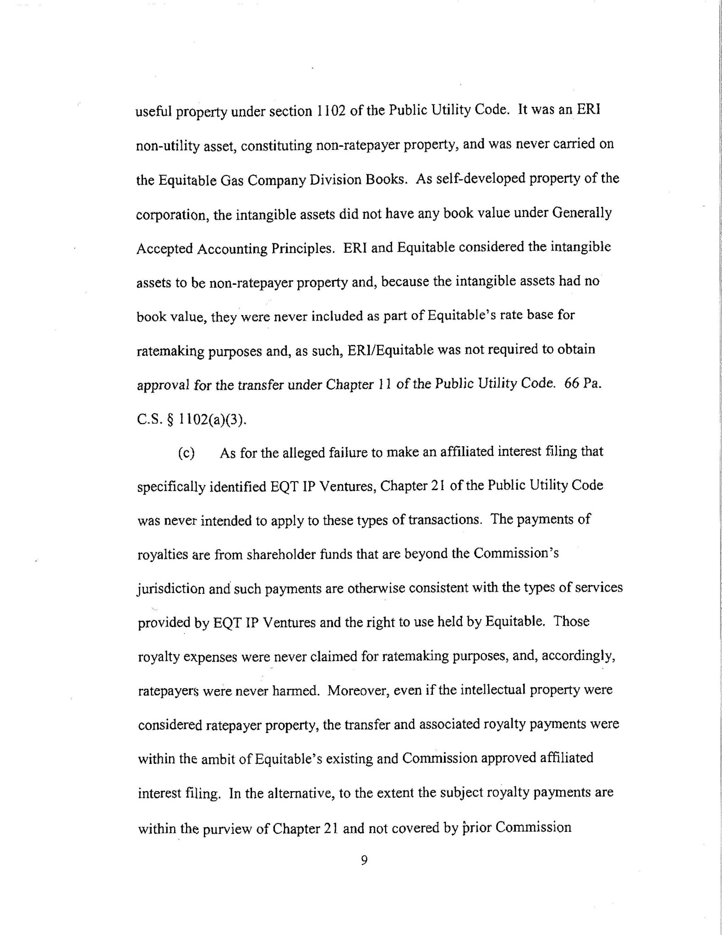
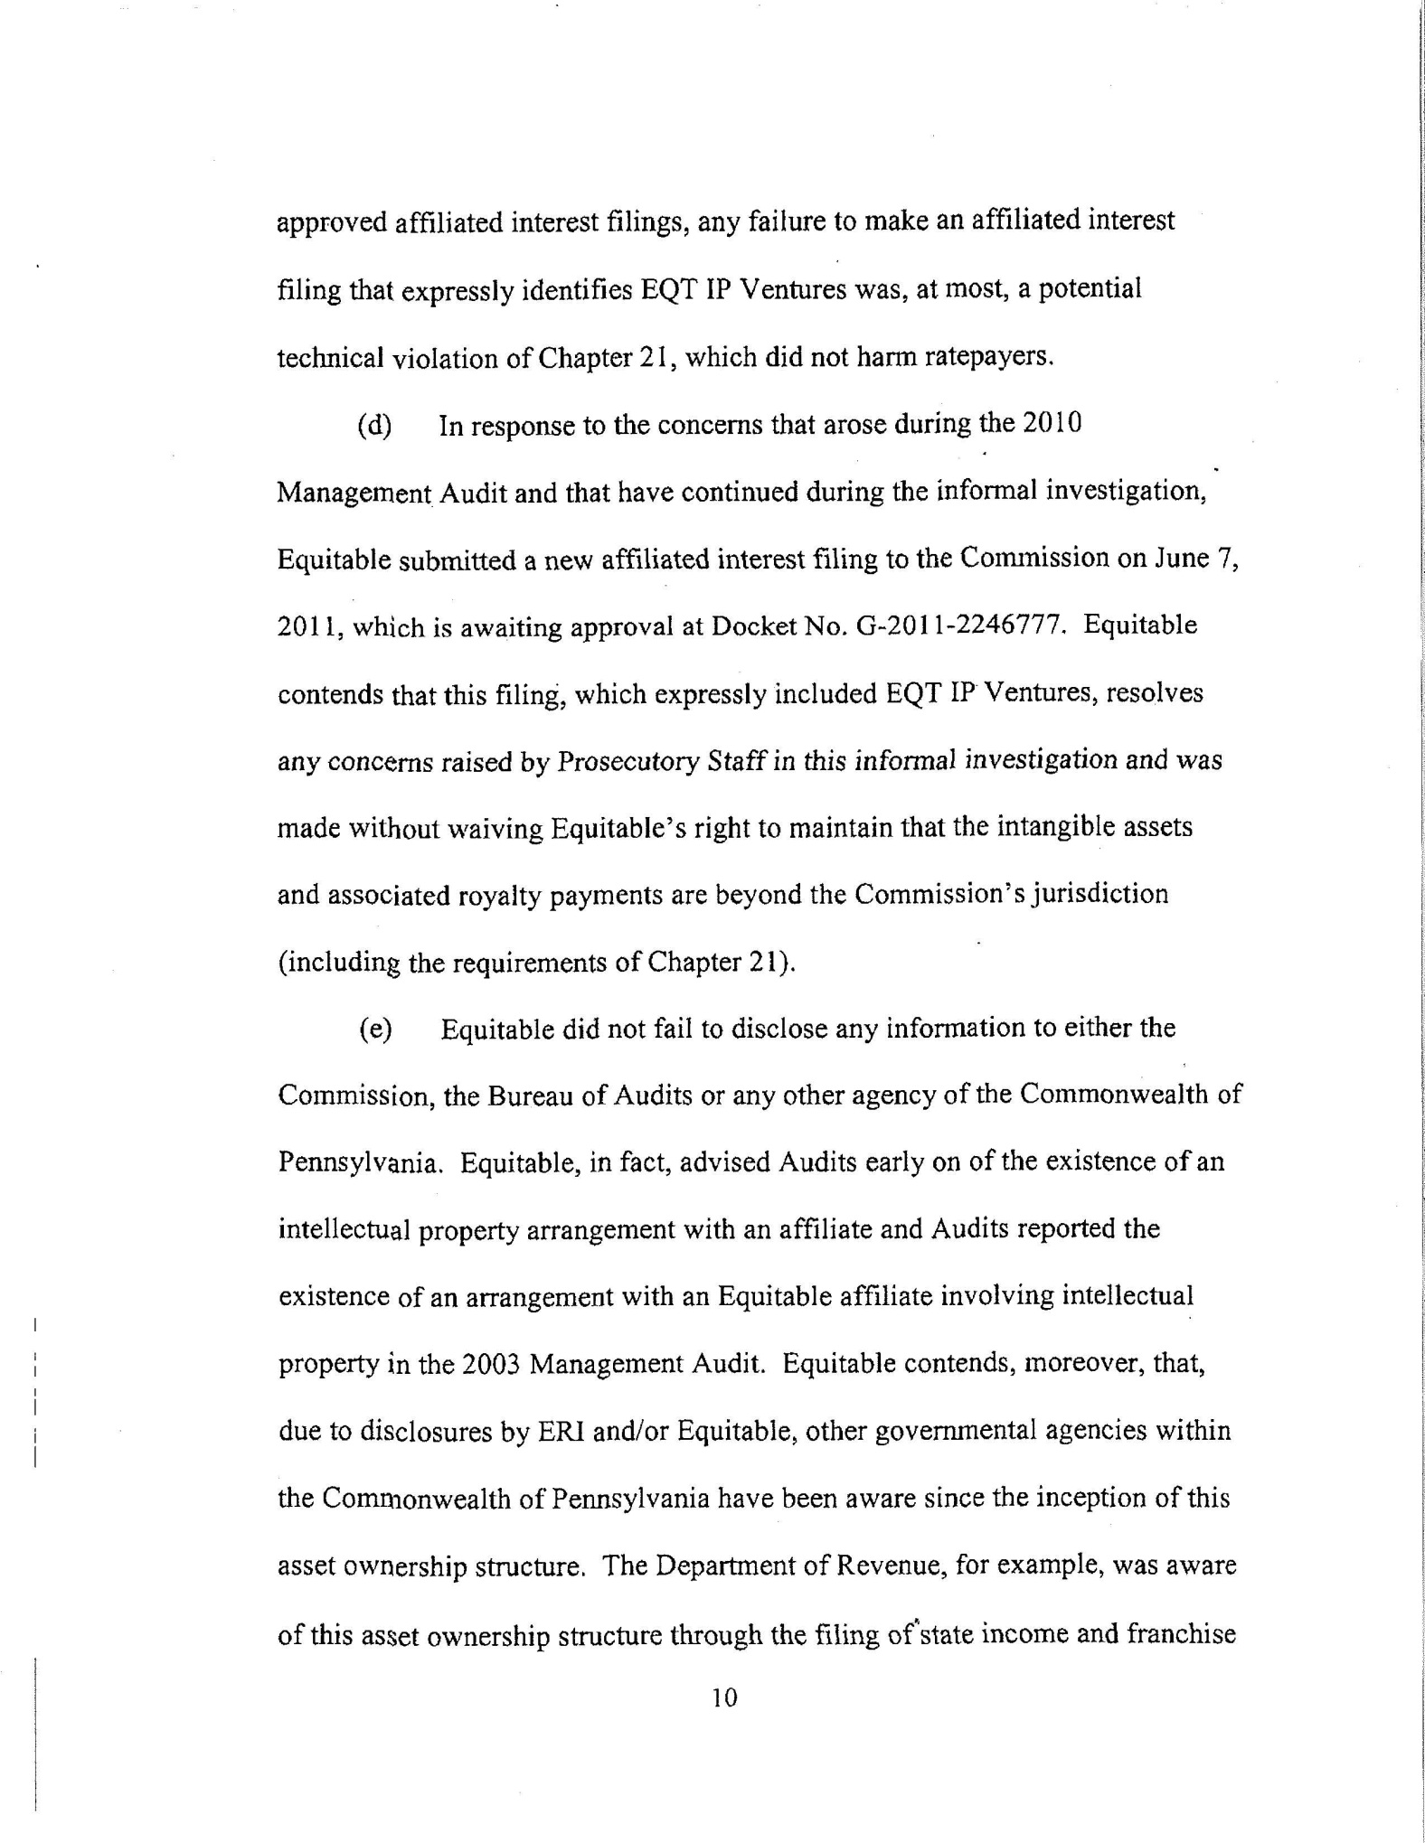
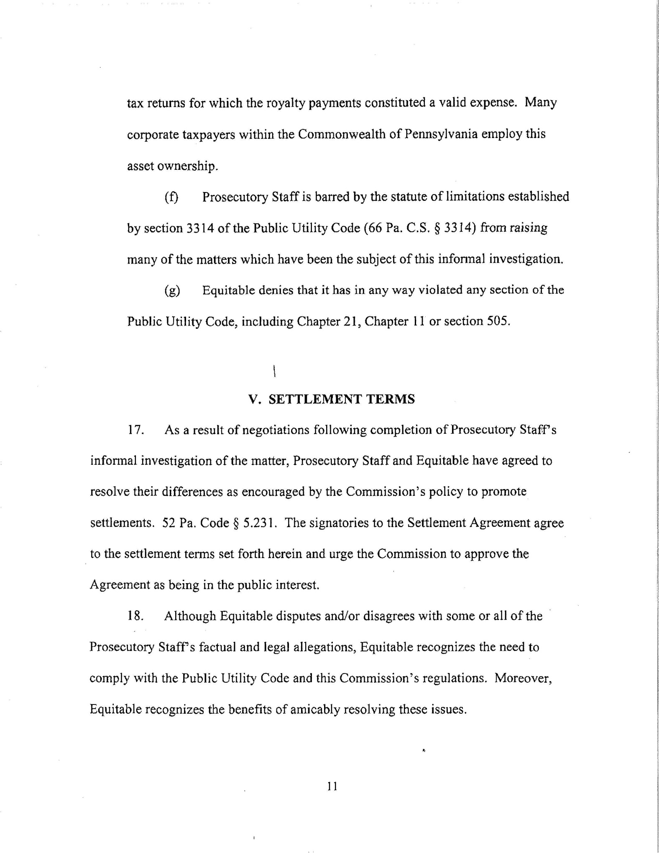
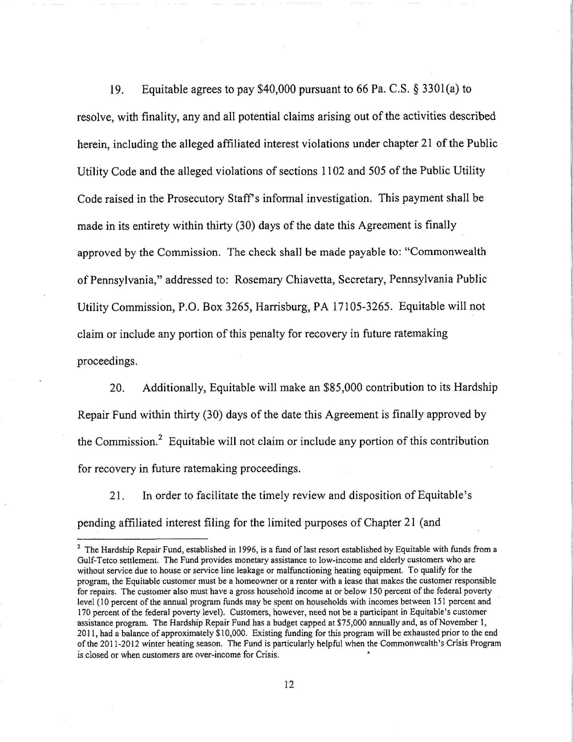
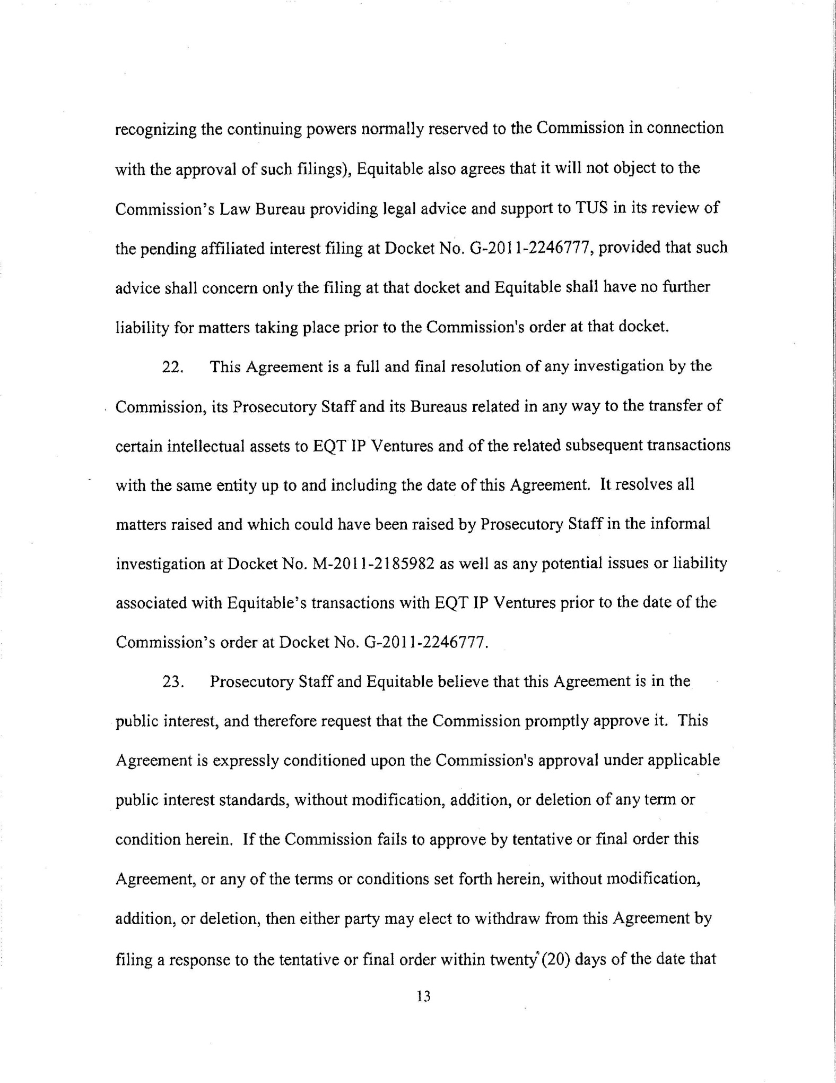
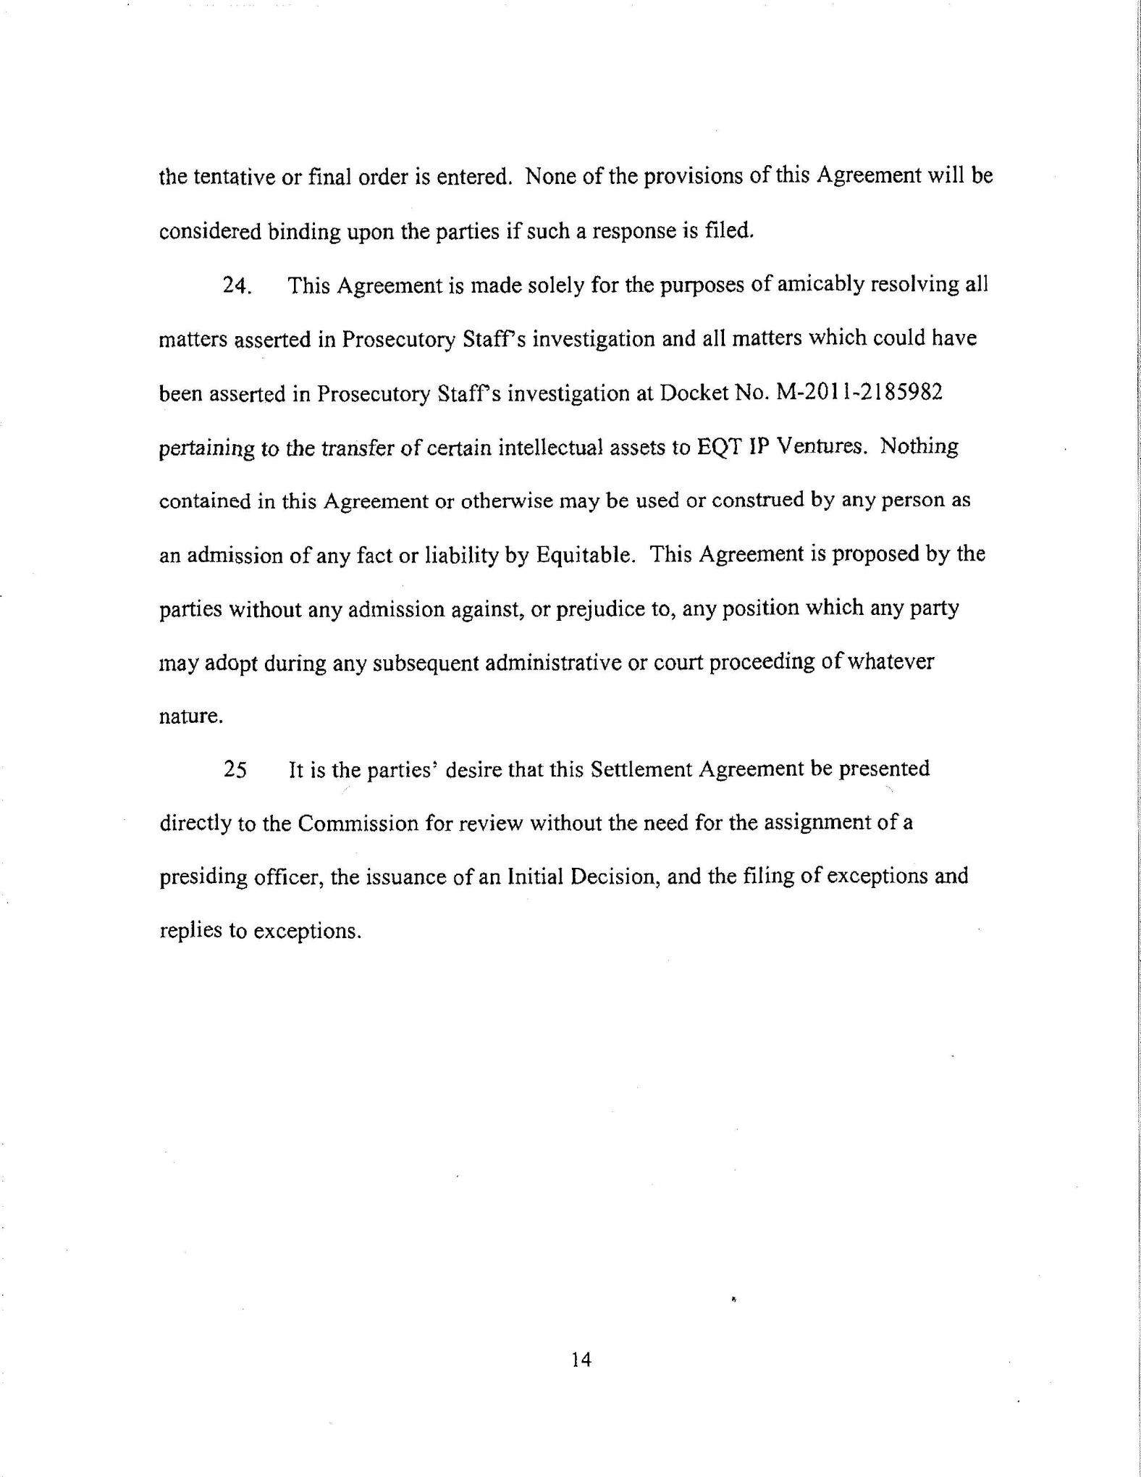
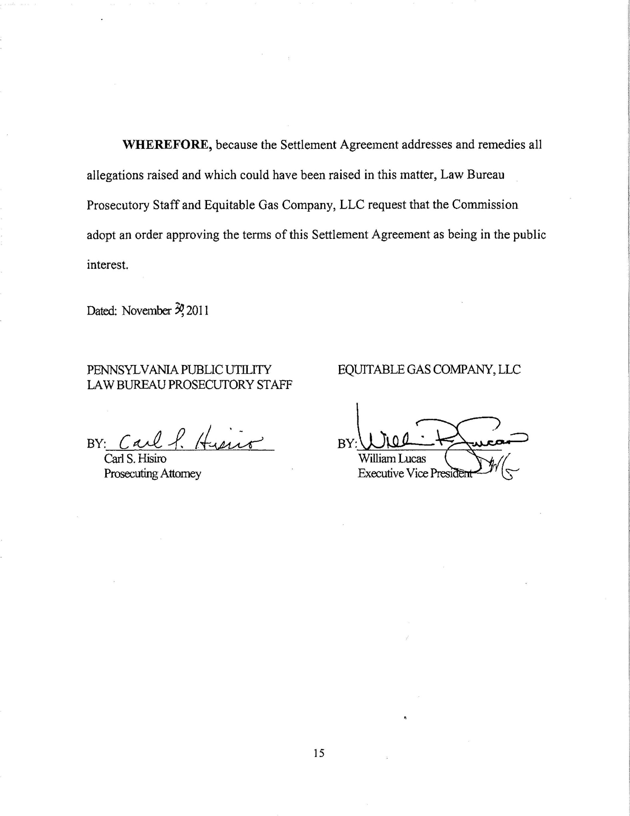
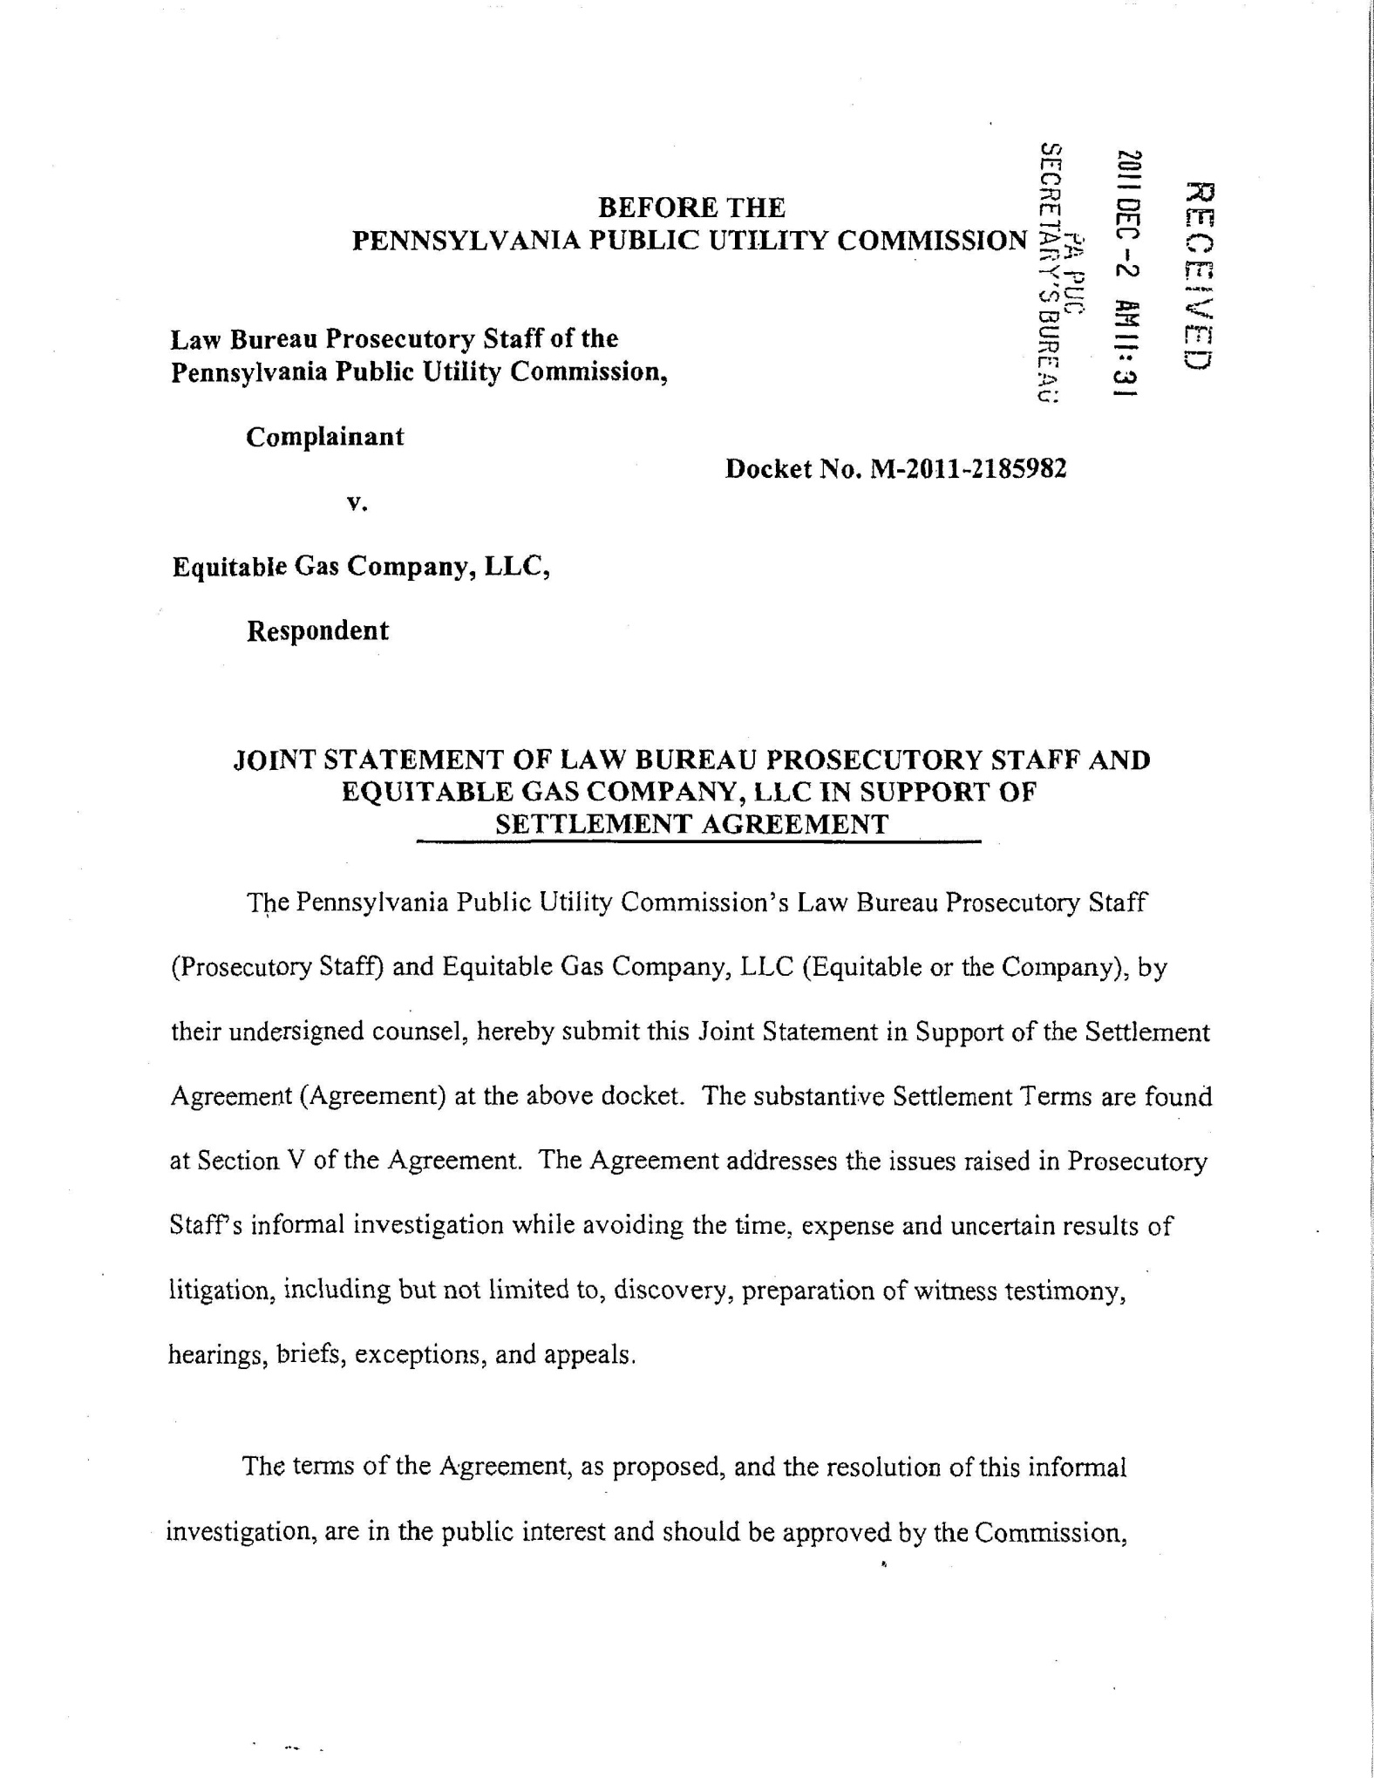
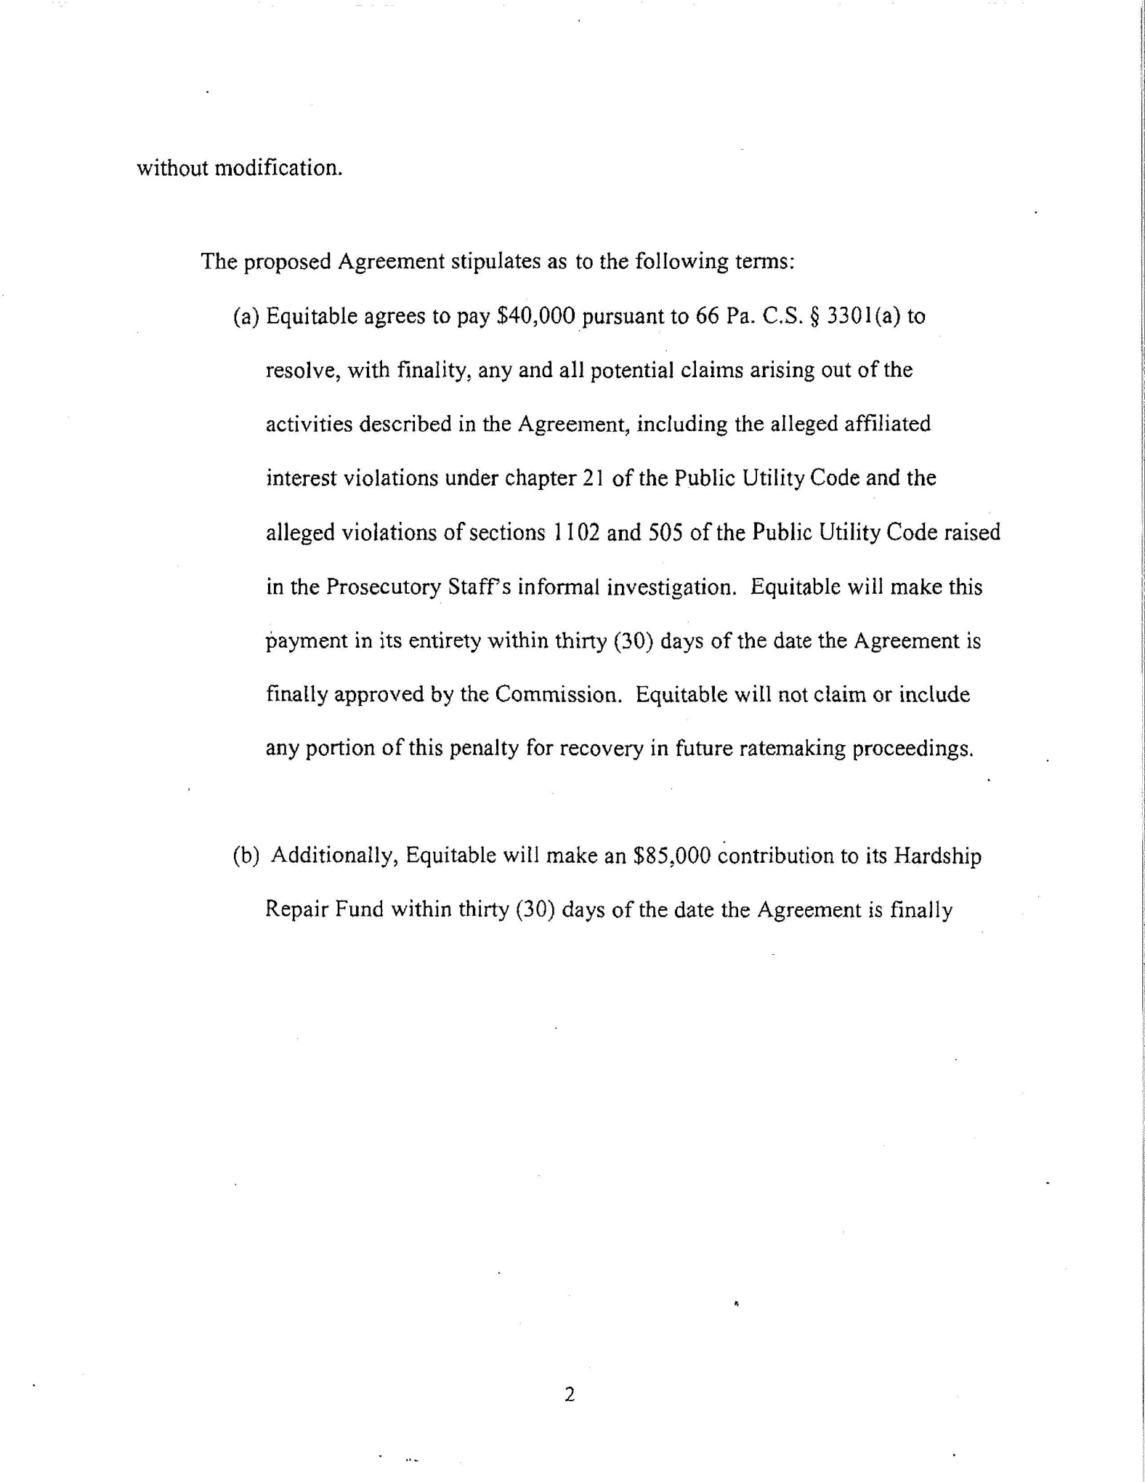
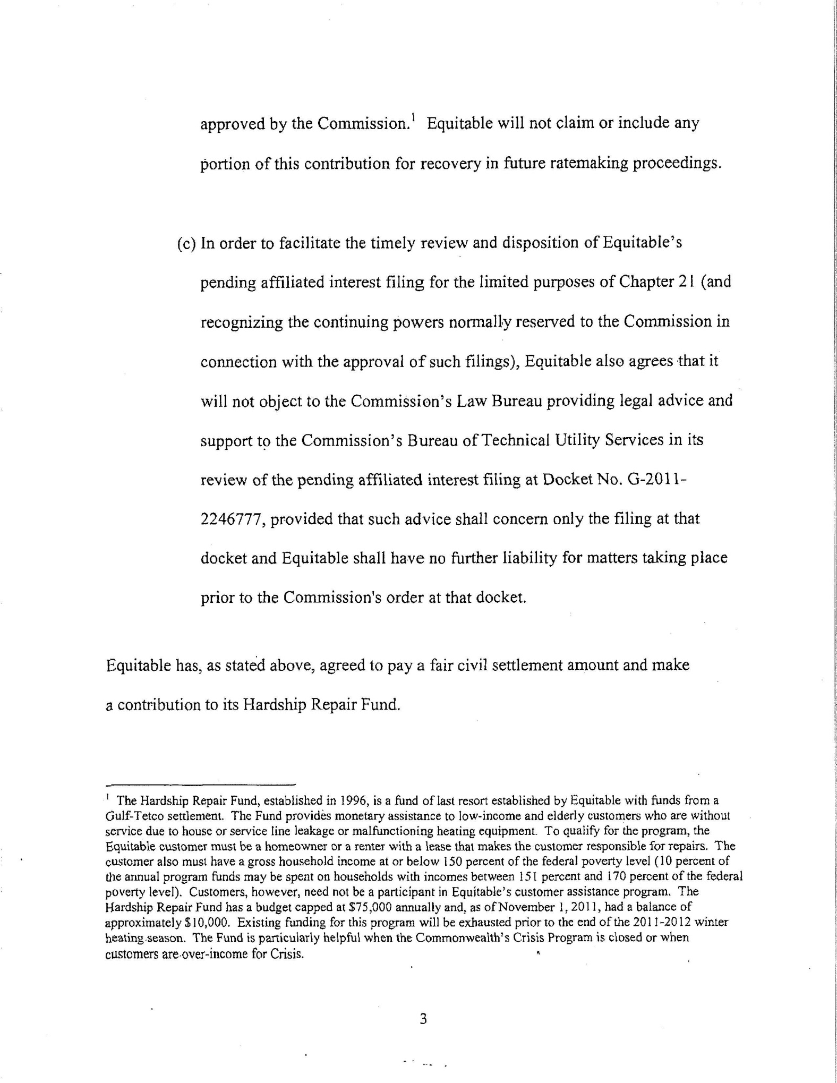
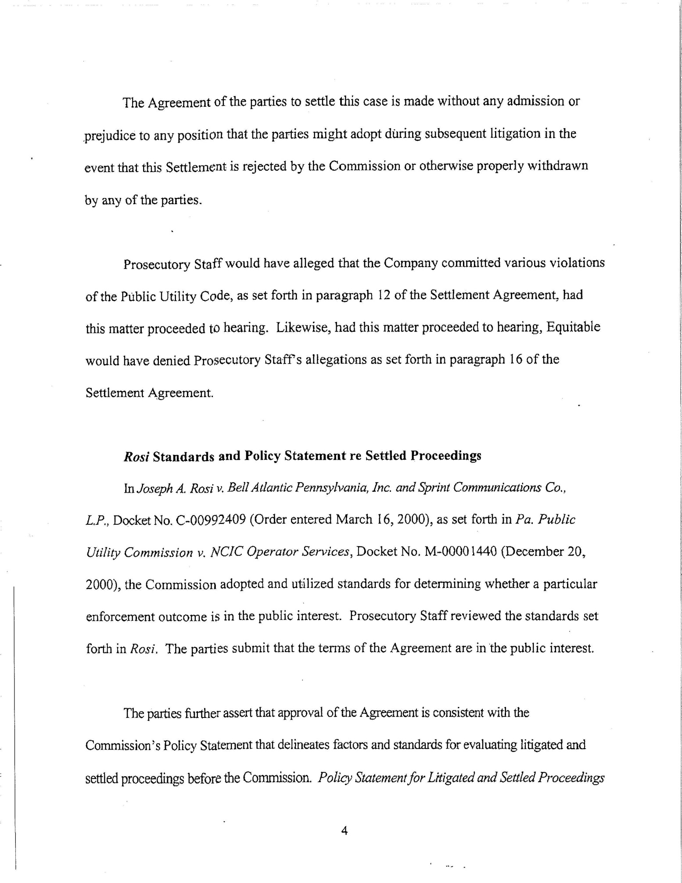
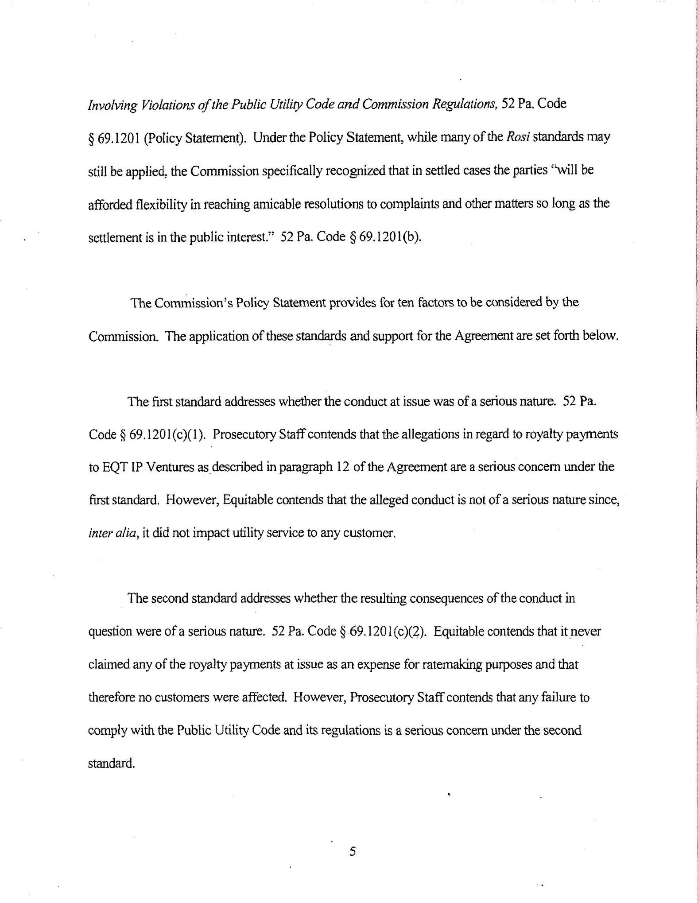
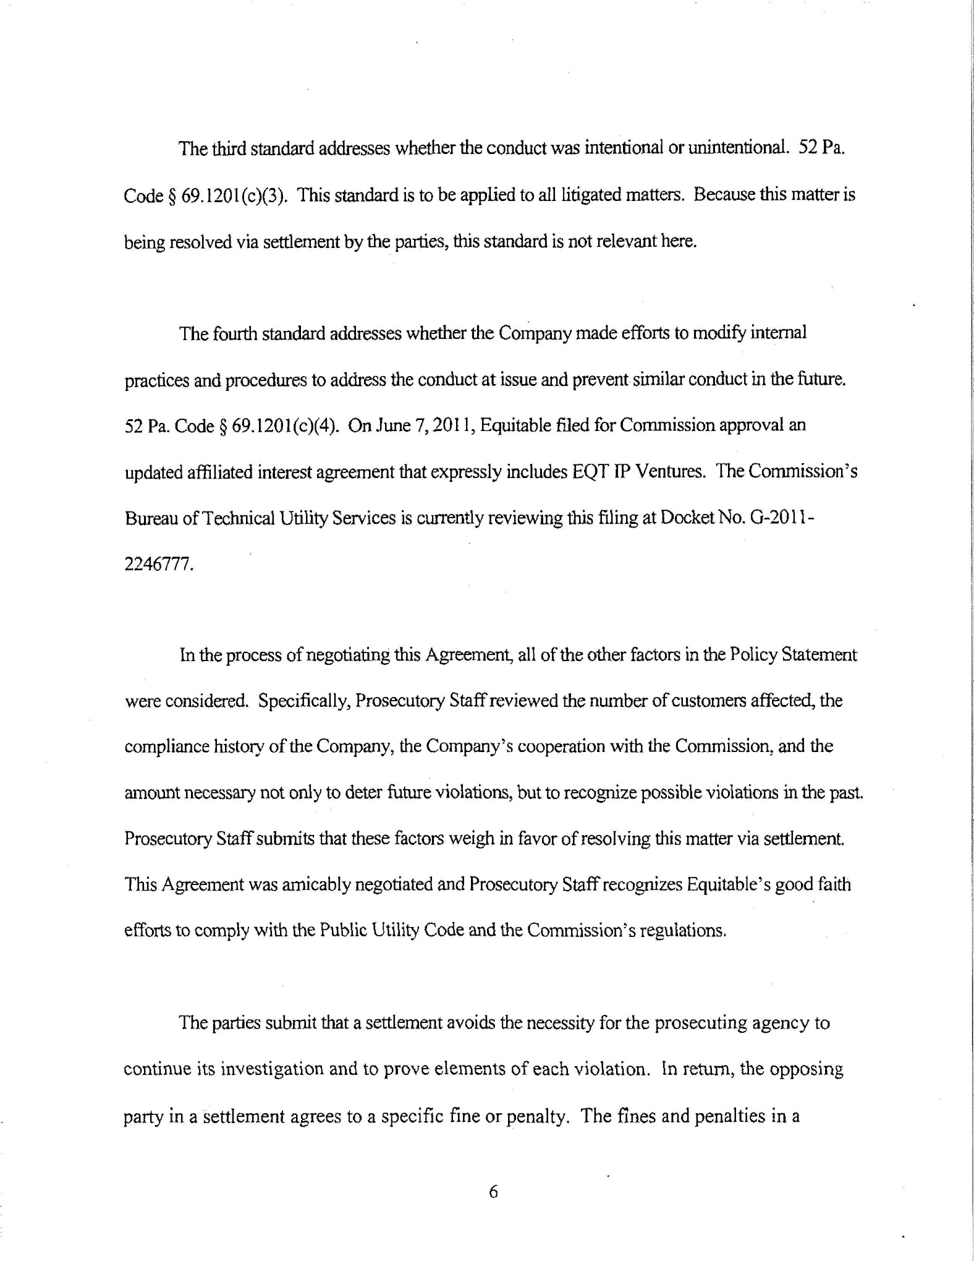
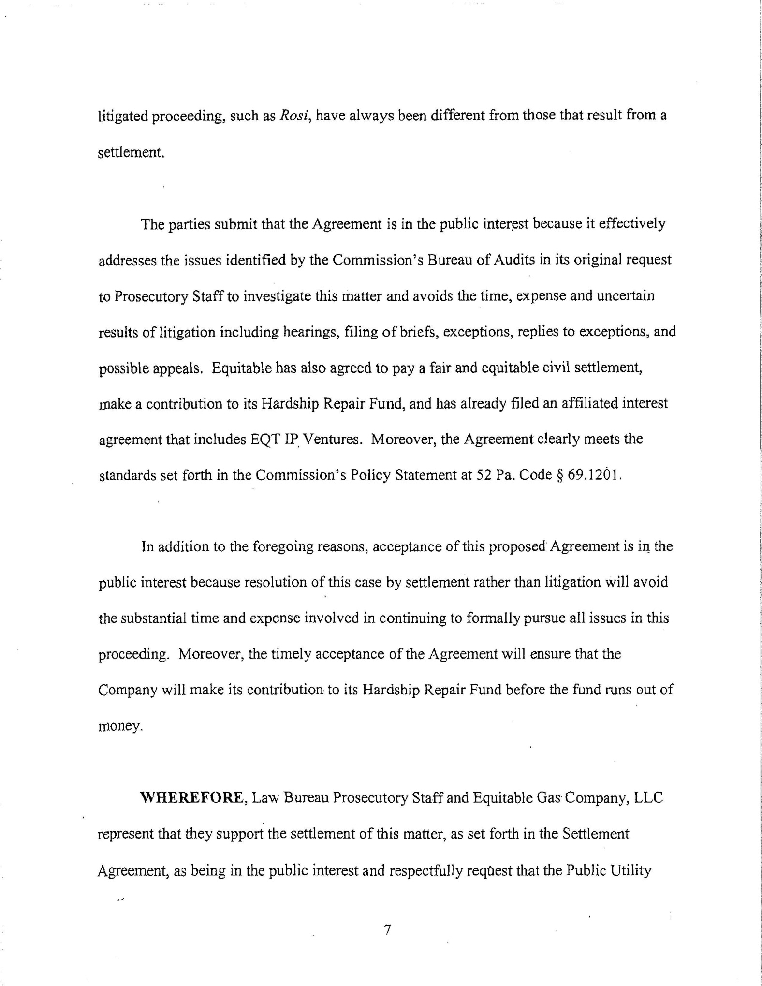
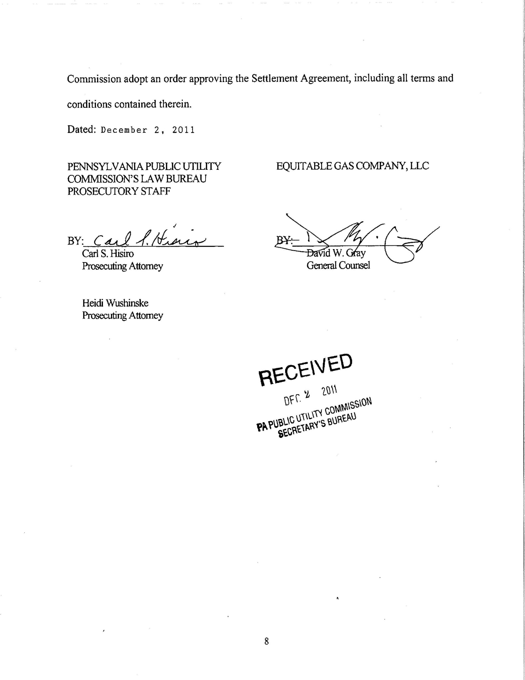

The reference herein to the “Prosecutory Staff” is intended to include and be binding on the Bureau of Investigation and Enforcement, the Bureau of Technical Utility Services and the Commission’s Law Bureau. Settlement at 1.
Prior to a July 2008 holding company reorganization approved by the Commission at Docket No. A-121100F0006, Equitable was a regulated operating division of ERI. The matters at issue herein occurred both prior and subsequent to the holding company reorganization. Therefore, “Equitable” denotes both the post-July 2008 regulated LLC and the pre-July 2008 regulated operating division of ERI. Settlement at 2.
We note that the affiliated interest agreement was officially filed with the Commission on June 8, 2012.
By Secretarial Letter dated July 1, 2011, the Commission extended the period for consideration of the affiliated interest agreement indefinitely until further action of the Commission. The affiliated interest agreement is still pending as of the date of this Opinion and Order.
The Hardship Repair Fund is a fund of last resort that was established by Equitable in 1996 with funds from a Gulf-Tetco settlement. The Fund provides monetary assistance to low-income and elderly customers who are without service due to house or service line leakage or malfunctioning heating equipment. To qualify for the program, a customer must be a homeowner or a renter with a lease that makes the customer responsible for repairs. The customer also must have a gross household income at or below 150 percent of the federal poverty level (10 percent of the annual program funds may be spent on households with incomes between 151 percent and 170 percent of the federal poverty level). Customers need not be participants in Equitable's customer assistance program. The Hardship Repair Fund has a budget capped at $75,000 annually and, as of November 1, 2011, it had a balance of approximately $10,000. The Parties projected that existing funding for this program will be exhausted prior to the end of the 2011-2012 winter heating season. The Parties stated that the Fund is particularly helpful when the Commonwealth's Crisis Program is closed or when customers are over-income for the Crisis Program. Settlement at 12.

