BEFORE THE
PENNSYLVANIA PUBLIC UTILITY COMMISSION

Pennsylvania Public Utility Commission : R-2011-2273539
Office of Consumer Advocate : C-2012-2285171
Office of Small Business Advocate : C-2012-2287034
:
v. :
:
Peoples TWP LLC :

ORDER CONSOLIDATING COMPLAINTS, ADMITTING SETTLEMENT PETITION AND STATEMENTS IN SUPPORT AND CLOSING THE RECORD

AND NOW, an initial hearing having been held in this proceeding on April 5, 2012, during which written testimony and exhibits were admitted into the record by stipulation; and on April 23, 2012, a Joint Petition for Settlement of The Rate Investigation Pursuant to 66 Pa. C.S. § 1307(f) with attached Statements in Support having been filed by the Bureau of Investigation and Enforcement (I&E) of the Pennsylvania Public Utility Commission (Commission), the Office of Consumer Advocate (OCA), the Office of Small Business Advocate (OSBA), and Peoples TWP LLC (Peoples TWP or the Company), the parties to the above-captioned proceeding, (Parties); and no further hearings in this matter are to be scheduled or held; and a Recommended Decision, which shall address the Settlement Petition, in this case is being prepared for issuance,

THEREFORE,

IT IS ORDERED:

- That the Formal Complaint of the Office of Consumer Advocate filed with the Commission at Docket No. C-2012-2285171 on January 26, 2012, and the Formal Complaint of the Office of Small Business Advocate filed with the Commission at Docket No. C-2012-2287034 on February 3, 2012, are consolidated with Peoples TWP LLC’s Purchase Gas Costs (PGC) filing pursuant to 66 Pa. C.S. § 1307(f) at Docket No. R-2011-2273539.

- That the Joint Petition for Settlement of The Rate Investigation Pursuant to 66 Pa. C.S. § 1307(f) filed by the Parties, I&E, OCA, OSBA, and Peoples TWP, with the Commission on April 23, 2012, is admitted into the record.

- That the record at Docket No. R-2011-2273539 is closed.
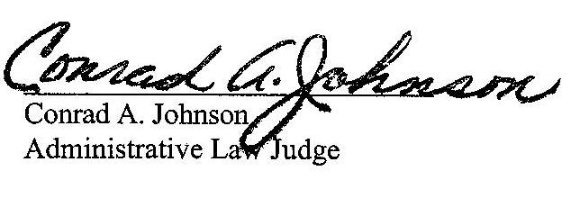

Date: May 18, 2012

R-2011-2273539 - PUC v. PEOPLES TWP LLC

C-2012-2285171 - OFFICE OF CONSUMER ADVOCATE v. PEOPLES TWP LLC

C-2012-2287034 - OFFICE OF SMALL BUSINESS ADVOCATE v. PEOPLES TWP LLC

(Revised 2-15-12)

ANDREW S TUBBS ESQUIRE
POST & SCHELL PC
17 NORTH SECOND STREET
12TH FLOOR
HARRISBURG PA 17101-1601

DAVID T EVRARD ESQUIRE
OFFICE OF CONSUMER ADVOCATE
555 WALNUT STREET
5TH FLOOR FORUM PLACE
HARRISBURG PA 17101-1923

ALLISON KASTER ESQUIRE
PA PUC BUREAU OF INVESTIGATION
AND ENFORCEMENT
400 NORTH STREET 2ND FLOOR WEST
PO BOX 3265
HARRISBURG PA 17105-3265

SHARON E WEBB ESQUIRE
OFFICE OF SMALL BUSINESS ADVOCATE
300 NORTH SECOND STREET SUITE 1102
HARRISBURG PA 17101

