 | COMMONWEALTH OF PENNSYLVANIA  PENNSYLVANIA PUBLIC UTILITY COMMISSION  P.O. BOX 3265, HARRISBURG, PA 17105-3265

May 29, 2012
Docket No. A-2010-2192350

AUNDREA WILLIAMS
RELIANT ENERGY NORTHEAST LLC
211 CARNEGIE CENTER
PRINCTON NJ 08540

Re: Electric Generation Supplier License A-2010-2192350

Dear Ms. Williams:

On October 18, 2010, the Commission issued a license at Docket No. A-2010-2192350, authorizing Reliant Energy Northeast, LLC d/b/a Reliant Energy (Reliant) the right to begin to offer, render, furnish, or supply electric generation supplier services to large commercial (over 25 kw), industrial and governmental customers in the electric distribution company (EDC) service territories of Allegheny Power, Duquesne Light Company, Metropolitan Edison Company, Pennsylvania Electric Company, Pennsylvania Power Company, PECO Energy Company, PPL Electric Utilities, Inc. and UGI Utilities, Inc., within the Commonwealth of Pennsylvania.
On May 19, 2011, the Commission approved an amendment to Reliant’s license to include all customer classes in all EDC service territories, with the Commonwealth of Pennsylvania.
On April 16, 2012, Reliant filed a letter stating that the licensee would also do business under the additional trade names of NRG Business Solutions and Reliant-NRG. Reliant has provided the proper Pennsylvania Department of State documentation.
Therefore, the Commission approves, by this Secretarial Letter, the change of Reliant Energy Northeast LLC d/b/a Reliant Energy’s name on its license for the provision of electric generation supplier services to residential, small commercial (25 kw demand and under), large commercial (over 25 kw demand), industrial and governmental customers in all electric distribution company service territories, within the Commonwealth of Pennsylvania, at Docket No. A-2010-2192350, to Reliant Energy Northeast LLC d/b/a Reliant Energy, NRG Business Solutions and Reliant-NRG. The Secretary’s Bureau will issue a new license with the name change.

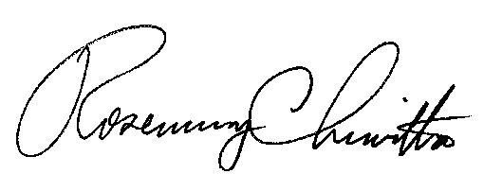
If you have any questions in this matter, please contact James Shurskis of the Bureau of Technical Utility Services, 717-787-8763, or email jshurskis@pa.gov.
Sincerely,

Rosemary Chiavetta
Secretary

LICENSE ENCLOSED

cc: Elaine McDonald, Bureau of Technical Utility Services

