COMMONWEALTH OF PENNSYLVANIA
PENNSYLVANIA PUBLIC UTILITY COMMISSION
P. O. BOX 3265, HARRISBURG PA 17105-3265
IN REPLY PLEASE
REFER TO OUR FILE
717-772-7777
Docket No. A-2012-2311422

July 17, 2012

Mr. Myron H. Tomb
H. A. Goal, Inc.
52 South 9th Street
Indiana, PA 15701

Dear Mr. Tomb:

This letter acknowledges the receipt of your company’s application for registration as a pipeline operator under Act 127 of 2011, the Gas and Hazardous Liquids Pipelines Act (Pipeline Act) in the Commonwealth of Pennsylvania. The docket number assigned to your application is A-2012-2311422. Please refer to this number in all future correspondence with the Public Utility Commission (PUC).

Should you have any questions pertaining to your registration, please contact our Bureau of Technical Utility Services at 717-783-5242.

Sincerely,
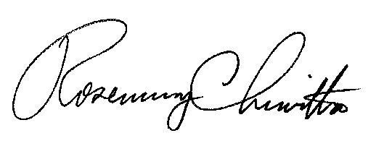

Rosemary Chiavetta
Secretary

