 | COMMONWEALTH OF PENNSYLVANIA  PENNSYLVANIA PUBLIC UTILITY COMMISSION  P.O. BOX 3265, HARRISBURG, PA 17105-3265 | IN REPLY PLEASE REFER TO OUR FILE

Date of Service: July 19, 2012 Docket Number: C-2012-2314499

LEONARD PAPA PRESIDENT
CENTRAL VAN & STORAGE OF CHARLESTON INC
595 MEADOWLANDS BLVD
WASHINGTON PA 15301

Bureau of Investigation and Enforcement
v.
CENTRAL VAN & STORAGE OF CHARLESTON, INC.

Dear Sir/Madam:

The Pennsylvania Public Utility Commission has delegated its authority to initiate prosecutory proceedings to several of its Commission bureaus with enforcement responsibilities. Pursuant to this delegated authority and Section 701 of the Public Utility Code, 66 Pa. C.S. § 701, Bureau of Investigation and Enforcement staff has filed the attached Complaint against you seeking a monetary penalty and/or revocation of your Certificate of Public Convenience.

Very truly yours,
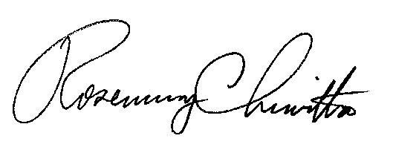

Rosemary Chiavetta
Secretary

ane

