PENNSYLVANIA
PUBLIC UTILITY COMMISSION
Harrisburg, PA 17105-3265
 |  | Public Meeting held August 2, 2012
Commissioners Present:
Robert F. Powelson, Chairman
John F. Coleman, Jr., Vice Chairman
Wayne E. Gardner
James H. Cawley
Pamela A. Witmer

Application of Total Energy Resources, LLC to Amend its Natural Gas Supplier License. |  |  |  | A-2010-2184373
ORDER

BY THE COMMISSION:

On April 17, 2012, Total Energy Resources, LLC (Total) filed an application to amend its natural gas supplier license to add the additional class of governmental customers.

Total, by Order entered January 27, 2011, is currently licensed by the Commission to offer, render, furnish or supply natural gas supply services in the Commonwealth of Pennsylvania to small commercial (less than 6,000 Mcf annually), large commercial (6,000 Mcf or more annually), and industrial customers in the NGDC service territories of National Fuel Gas Distribution Corporation and Columbia Gas of PA, Inc.

Total has provided proofs of publication in Pennsylvania newspapers of general circulation serving the geographical territories affected by the applications and proofs of service to the interested parties as required by the Commission.

Section 2208(c)(1), 66 Pa. C.S. § 2208(c)(1), provides that a natural gas supplier license shall not be issued unless the applicant furnishes a bond or other security in a form and amount to ensure its financial responsibility. The criteria used to establish the form and amount of the bond or other security is set forth in the NGDC’s tariff. The amount and form of the bond or other security may also be mutually agreed to between the NGDC and the natural gas supplier. Section 2208 also provides that should the parties fail to achieve an agreement, then the form and amount of bond or other financial security “shall be determined by criteria approved by the Commission.” Total has provided documentation to evidence its compliance with the Section 2208(c) bonding requirement for all of the NGDCs in whose service territories it proposes to expand its operations.

As of July 24, 2012, no protests have been filed. There are also no complaints on record concerning Total.

Upon full consideration of all matters of record, we find that approval of these applications is necessary and proper for the service, accommodation and convenience of the public; THEREFORE,

IT IS ORDERED:

1. That the application of Total Energy Resources, LLC is hereby approved, consistent with this Order.

2. That a license be issued authorizing Total Energy Resources, LLC to begin to offer, render, furnish or supply natural gas supply services to the additional class of governmental customers in the natural gas distribution company service territories of National Fuel Gas Distribution Corporation and Columbia Gas of PA, Inc.

3. That this proceeding at Docket No. A-2010-2184373 be closed.

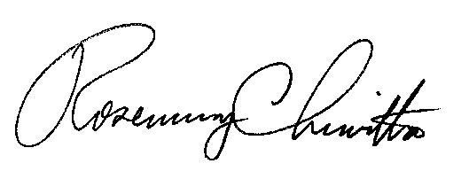
BY THE COMMISSION,

Rosemary Chiavetta
Secretary

(SEAL)

ORDER ADOPTED: August 2, 2012

ORDER ENTERED: August 2, 2012

