COMMONWEALTH OF PENNSYLVANIA
PENNSYLVANIA PUBLIC UTILITY COMMISSION
P.O. BOX 3265, HARRISBURG, PA 17105-3265

September 24, 2012
Docket No. A-2009-2132755

JAMES E GUY
SUTHERLAND ASBILL & BRENNAN LP
AUSTIN CENTRE
701 BRAZOS ST STE 970
AUSTIN TX 78701-3232

Re: Electric Generation Supplier License A-2009-2132755

Dear Mr. Guy:

On November 9, 2009, the Commission issued a license at Docket No. A-2009-2132755, authorizing BlueStar Energy Services, Inc. (BlueStar) the right to begin to offer, render, furnish, or supply electric generation supplier services to commercial, industrial and commercial customers in the electric distribution company service territory of PPL Electric Utilities Inc., within the Commonwealth of Pennsylvania.
On January 29, 2012, the Commission approved an amendment to the license of BlueStar authorizing BlueStar to provide electric generation supplier services to all customer classes in all electric distribution company service territories, within the Commonwealth of Pennsylvania.
On July 19, 2012, BlueStar filed a request that the Commission change the name on its license to provide electric generation supplier services to AEP Energy, Inc.
BlueStar has provided the proper Pennsylvania Department of State documentation and a bond or other approved security as required by this Commission.
Therefore, the Commission approves, by this Secretarial Letter, the change of the BlueStar Energy Services, Inc.’s name on its license for the provision of electric generation supplier services as a supplier to residential, small commercial (25 kW and Under), large commercial (over 25 kW), industrial and governmental customers in all electric distribution company service territories within the Commonwealth of Pennsylvania, at Docket No. A-2009-2132755, to AEP Energy, Inc.
The Secretary’s Bureau will issue a new license with the name change.

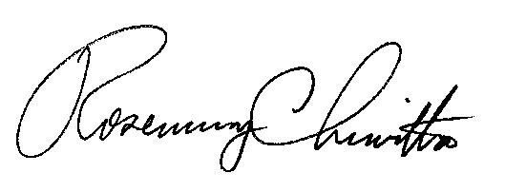
If you have any questions in this matter, please contact James Shurskis of the Bureau of Technical Utility Services, 717-787-8763, or email jshurskis@pa.gov.
Sincerely,

Rosemary Chiavetta
Secretary

LICENSE ENCLOSED

