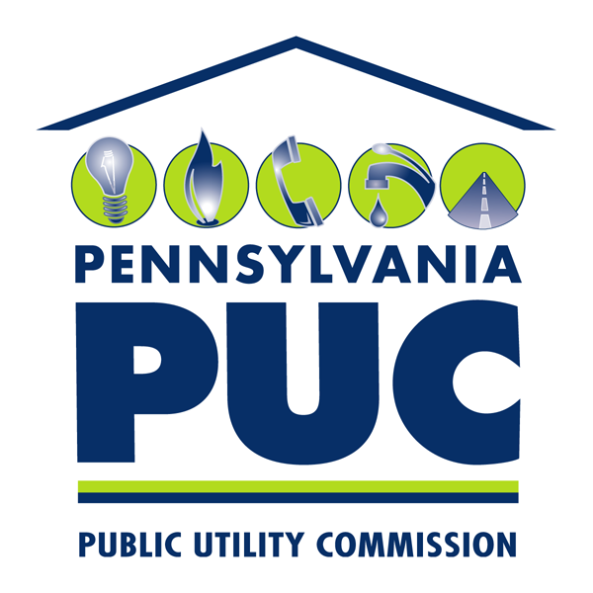 | COMMONWEALTH OF PENNSYLVANIA  PENNSYLVANIA PUBLIC UTILITY COMMISSION  P.O. BOX 3265, HARRISBURG, PA 17105-3265 | IN REPLY PLEASE REFER TO OUR FILE  M-2012-2289411
September 26, 2012

ATTN: All interested parties

Re: Phase II Implementation of Act 129 of 2008
Energy Efficiency and Conservation Plan Template
Docket No. M-2012-2289411

With this Secretarial Letter, the Pennsylvania Public Utility Commission (Commission) hereby issues an Energy Efficiency and Conservation Plan (EE&C Plan) filing template, which was developed pursuant to the Commission’s Phase II Implementation Order (Implementation Order), entered on August 3, 2012 at the above-referenced docket number. The Commission directs that all jurisdictional electric distribution companies (EDCs) with at least 100,000 customers use this EE&C Plan template in preparing and filing their Phase II EE&C Plans with the Commission by November 1, 2012. The attached template includes a number of blank tables that are available on the Commission’s website at http://www.puc.state.pa.us/electric/Act129/EEC_Program.aspx.

The Implementation Order provided a detailed discussion and specific directives regarding the requirements of the Act as it relates to these mandated EE&C Plans. In addition, the Implementation Order stated that the Commission would issue a Secretarial Letter establishing a more detailed format for plan filings. The purpose of the template is to provide EDCs with a standardized format for presenting and filing all the information required by the Act and the Implementation Order relating to their respective EE&C Plans.

On August 17, 2012, the Commission developed a draft template and circulated it among all interested parties for comment. Comments were to be submitted on or before September 4, 2012. Comments on the draft template were received by the Energy Association of Pennsylvania (EAPA), Industrial Energy Consumers of Pennsylvania (IECPA) and PPL Electric Utilities Corporation (PPL). The Commission reviewed these comments and appropriate revisions were made.

EAPA and PPL suggest that language requiring the EE&C Plans to achieve at least 25% of their consumption reduction target in each year should be addressed in Section 1 or Section 4 of the template rather than Section 3. EAPA Comments at 2 and PPL Comments at 2. The Commission agrees and moved the applicable language to Section 1. EAPA and PPL also request that the Commission permit EDCs to include ranges of projected data, including projected rebates, savings and participation levels, in their Phase II EE&C Plans. EAPA Comments at 2 and PPL Comments at 2. The Commission agrees and incorporated the new language in Section 3.2. EAPA and PPL also suggest the elimination of reporting requirements in Section 5.1.1 and 5.1.2. EAPA Comments at 3 and PPL Comments at 3. The Commission concurs that the reporting requirements were dictated within its Implementation Order and amended Section 5.1 to require the EDC to meet those reporting requirements. EAPA also requests the elimination of the reference to “load management” in Section 9.1.1, as the Commission has not prescribed demand response requirements in Phase II. EAPA Comments at 3. The Commission agrees and removed the “load management” language from Section 9.1.1. However, any EDC who wishes to include voluntary residential demand response programs in its Phase II EE&C Plan, is required to provide a full description of such a program within Section 3 – Program Descriptions – of its EE&C Plan.

PPL proposes several other changes to the template and related tables. We adopt all of PPL’s proposals, except the following:

- Section 2.1: add a definition of “measure” and revise definitions of customer sectors. PPL Comments at 2. The Commission disagrees with the definition of “measure” as proposed by PPL and was not incorporated into Section 2.1. The Commission, however, agrees with PPL’s definitions of customer sectors and incorporated them into Section 2.1.
- Section 9.2.5: eliminate the requirement that EDCs provide a list of all eligible federal and state funding programs to ratepayers for energy efficiency and conservation. PPL Comments at 4. The Commission disagrees. The section merely asks that the EDCs indicate they will provide a list to customers. The EDCs are not required to include this list in their EE&C Plans.
- Tables for EDC EE&C Plans:

Table 2:
- Delete “Total” in last column since MWh savings in each of the Program Year columns are cumulative savings. PPL Comments at 4. The Commission disagrees with this suggestion as the lifetime of a behavioral program may have an effect on the savings values in the “Total” column that was not reflected in previous program years.
- Add a row titled “Estimated Phase I Carryover” and add a row titled “Total Cumulative Projected Savings Phase 2 + Estimated Phase I Carryover” immediately after the row “EE&C Plan Total-Cumulative Projected Savings.” PPL Comments at 5. The Commission agrees and has modified the table accordingly. The Commission, however, will require the EDCs provide final, verified savings values for Phase I carryover (i.e. not estimates) in their annual reports.

Table 5:
- Clarify what is intended to be included as “other expenditures” in the column entitled “% of Total Budget Excluding Other Expenditures.” PPL Comments at 6. The Commission requires that the EDCs designate expenditures as “other expenditures” in the same manner in which such expenditures were addressed in Phase I EE&C Plans.
Table 6C:
- Delete this table as it is duplicative of Tables 3 and 6B. PPL Comments at 7. The Commission recognizes that the data within this table may be contained in various other tables within the template, but believes that the side-by-side comparison of “Total Costs by Sector” and “Common Costs by Sector,” as well as the column displaying the “Total of All Costs,” is useful and is not administratively burdensome on the EDCs to include in their EE&C Plans. As such, the Commission rejects PPL’s request to delete this table.
Table 7A:
- Remove the “T&D” column as avoided T&D costs are included as a component of energy costs. PPL Comments at 8. The Commission rejects this request as many of the EDCs do break out avoided T&D costs separate from energy costs. Additionally, per language in the Commission’s August 30, 2012 TRC Order, avoided T&D costs may be reviewed in the future and, as such, the Commission believes it would be beneficial to have such costs broken out in the EE&C Plans.

IECPA requests that the EDCs provide projected annual EE&C rates for each customer rate schedule to aid large customers in projected future electricity costs. IECPA Comments at 1 and 2. The Commission disagrees and believes that such an inclusion would provide little benefit to customers. Following an EDC’s initial EE&C Plan filing, the EDCs only file amended EE&C Plans as needed, as such, projected rates may quickly become out-of-date and inaccurate, providing little value to customers. IECPA also requests that EDCs be required to describe how customers may adopt the proposed measures included in the EDC’s EE&C Plan, including a designated contact person, milestones and timelines for application review, the information and documentation that must be submitted and any other information that may aid customers that wish to participate in the EDC’s EE&C programs. IECPA Comments at 2 and 3. The Commission believes this request to be administratively burdensome and, as such, did not include such a section within the template. The Commission, however, strongly encourages the EDCs to recognize the concerns raised by IECPA and consider addressing those concerns in any consumer education efforts and in any direct contacts with customers regarding Phase II EE&C Plan offerings. IECPA also requests the inclusion of various cost values, including common and acquisition costs, in Tables 6A and 6B. IECPA Comments at 3. Again, the Commission believes this request to be administratively burdensome and, as such, will not amend the tables as requested.

The Commission will require that, during the Phase II program term, each EDC maintain an electronic copy of its entire, currently-effective, Commission-approved Phase II EE&C Plan on the EDC’s website. The Commission also will require that the initial Phase II EE&C Plan be posted on the EDC’s website, as well as all subsequent revised versions, noting the date of Commission approval or, if not yet approved, a designation indicating that approval is pending before the Commission. The Commission will also maintain copies of all approved Phase II EE&C Plans on its own website.

If there are any technical questions regarding the attached EE&C template, please contact Charles Covage in the Commission’s Bureau of Technical Utility Services at ccovage@pa.gov, 717-783-3835. If there are any questions relating to legal or procedural issues involving the completion or filing of the EE&C Plans, please contact Kriss Brown in the Commission’s Law Bureau at kribrown@pa.gov, 717-787-4518.

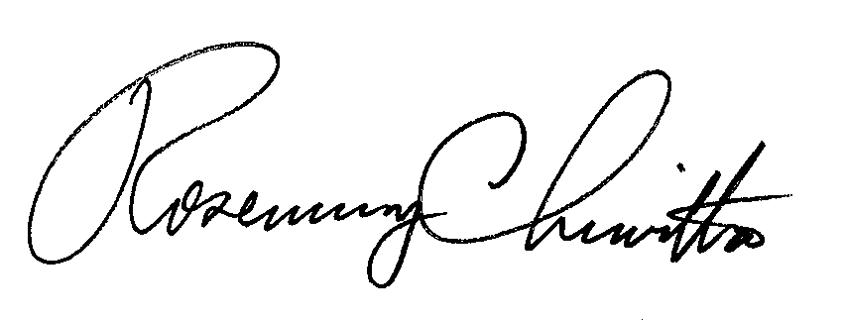
Sincerely,

Rosemary Chiavetta
Secretary

Attachment: EE&C Plan Template

Cc: Chairman’s Office
Vice Chairman’s Office
Commissioners’ Offices
Jan Freeman, Executive Director
Karen Oill Moury, Director of Regulatory Operations
Bohdan R. Pankiw, Chief Counsel, Law Bureau
Robert F. Young, Deputy Chief Counsel, Law Bureau
Kriss Brown, Assistant Counsel, Law Bureau
Paul Diskin, Director, Technical Utility Services
Darren Gill, Deputy Director, Technical Utility Services
Greg Shawley, Policy & Planning Supervisor, Technical Utility Services
Charles Covage, Utility Energy & Conservation Analyst, Technical Utility Services
Megan Good, Executive Policy Specialist, Technical Utility Services
Template for Pennsylvania EDC Energy Efficiency and Conservation Plans
To be submitted by EDCs by November 1, 2012

Contents
- Transmittal Letter
- Table of Contents
- Overview of Plan
- Energy Efficiency and Conservation Portfolio/Program Summary Tables and Charts
- Program Descriptions
- Program Management and Implementation Strategies
- Reporting and Tracking Systems
- Quality Assurance and Evaluation, Measurement, and Verification
- Cost Recovery Mechanism
- Cost Effectiveness
- Plan Compliance Information and Other Key Issues
- Appendices

Note:
If any of your answers require you to disclose what you believe to be privileged or confidential information, not otherwise available to the public, you should designate at each point in the EE&C Plan that the answer requires you to disclose privileged and confidential information. Explain briefly why the information should be treated as confidential. You should then submit the information on documents stamped “CONFIDENTIAL” at the top in clear and conspicuous letters and submit one copy of the information under seal to the Secretary’s Office along with the EE&C Plan. In addition, an expunged copy of the filing should also be included with the EE&C Plan. If someone requests to examine the information, or if Commission staff believes that the proprietary claim is frivolous or otherwise not justified, the Secretary’s Bureau will issue a Secretarial Letter directing that the EDC file a petition for protective order pursuant to 52 Pa. Code § 5.423.
Energy Efficiency and Conservation Plan

A. Transmittal Letter - with reference to statutory and regulatory requirements and Electric Distribution Company (EDC) contact that PA PUC should contact for more information.
B. Table of Contents - including lists of tables and figures.
- Overview of Plan (~10 pages)
(The objective of this section is to provide an overview of the entire plan)
  - Summary description of plan, plan objectives, and overall strategy to achieve energy efficiency and conservation goals.
  - Summary description of process used to develop the EE&C plan and key assumptions used in preparing the plan.
  - Summary tables of portfolio savings goals, budget and cost-effectiveness (see Tables 1, 2 and 3).
  - Summary of program implementation schedule over three-year plan period (see Chart 1 Notes).
  - Summary description of the EDC implementation strategy to acquire at least 25% of its consumption reduction target in each program year.
  - Summary description of the EDC implementation strategy to manage EE&C portfolios and engage customers and trade allies.
  - Summary description of EDC’s data management, quality assurance and evaluation processes; include how EE&C plan, portfolios, and programs will be updated and refined based on evaluation results.
  - Summary description of cost recovery mechanism.
- Energy Efficiency Portfolio/Program Summary Tables and Charts
(The objective of this section is to provide a quantitative overview of the entire plan for the three-year period. The audience will be those who want to see the “numbers”, but not all the details.)
  - Residential, Commercial/Industrial Small, Commercial/Industrial Large and Governmental/Educational/Non-profit Portfolio Summaries (see Table 4).
  - Plan data: Costs, Cost-effectiveness and Savings by program, sector and portfolio (see Tables 1-4).
  - Budget and Parity Analysis – (see Table 5).
- Program Descriptions (Up to 2 pages per program excluding charts, tables and list of measures)
(The objective of this section is to provide detailed descriptions of each proposed program and the background on why particular programs were selected and how they form balanced/integrated portfolios.)
  - Discussion of criteria and process used for selection of programs:
    - Describe portfolio objectives and metrics that define program success (e.g., energy and demand savings, customers served, number of units installed).
    - Describe how programs were constructed for each portfolio to provide market coverage sufficient to reach overall energy and demand savings goals. Describe analyses and/or research that were performed (e.g., market, best-practices, market modeling).
    - Describe how energy efficiency, conservation, solar, solar photovoltaic systems, geothermal heating, and other measures are included in the portfolio of programs as applicable.
    - Describe the comprehensive measures to be offered to the residential and small commercial rate classes
  - Residential Sector (as defined by EDC Tariff) Programs - include formatted descriptions of each program organized under the following headings:
- Program Title and Program years during which program will be implemented
- Objective(s)
- Target market
- Program description
- Implementation strategy (including expected changes that may occur in different program years)
- Program issues and risks and risk management strategy
- Anticipated costs to participating customers
- Ramp up strategy
- Marketing strategy
- Eligible measures and incentive strategy, include tables for each year of program, as appropriate showing financial incentives & rebate levels (e.g., $ per measure, $ per kWh or MW saved)
- Program start date with key schedule milestones
- Assumed Evaluation, Measurement, and Verification (EM&V) requirements required to document savings by the Commission’s statewide EE&C Plan Evaluator
- Administrative requirements – include internal and external staffing levels
- Estimated participation – includes tables indicating metric(s) with target value(s) or target ranges per year
- Estimated program budget (total) by year – include table with budget per year
- Estimated percentage of sector budget attributed to program
- Savings targets – include tables with estimated total MWh/yr and MW goals per year and/or ranges per year and cumulative tables that document key assumptions of estimated savings ranges per measure or project
- Cost-effectiveness – include TRC for each program
- Other information deemed appropriate

3.2.1. Low-Income Sector (as defined by 66 Pa. C.S. § 2806.1) Programs - include formatted descriptions of each program organized under the same headings as listed above for residential programs. As well, provide and detail all plans for achieving compliance with the August 2, 2012 Implementation Order.

  - Commercial/Industrial Small Sector (as defined by EDC Tariff) Programs - include formatted descriptions of each program organized under the same headings as listed above for residential programs.
  - Commercial/Industrial Large Sector (as defined by EDC Tariff) Programs - include formatted descriptions of each program organized under the same headings as listed above for residential programs.
  - Governmental/Educational/Non-Profit Sector (as defined by 66 Pa. C.S. § 2806.1) Programs - include formatted descriptions of each program organized under the same headings as listed above for residential programs. As well, provide and detail all plans for achieving compliance with the August 2, 2012 Implementation Order.
- Program Management and Implementation Strategies (~5 to 10 pages)
(The objective of this section is to provide detailed description of how EDC plans to manage and implement programs, including their approach to and use of Conservation Service Providers (CSPs).)
  - Overview of EDC Management and Implementation Strategies:
    - Describe the types of services to be provided by EDC as well as consultants, trade allies, and CSPs. Indicate which organizations will provide which services and the basis for such allocation. Reference reporting and EM&V information from Sections 5 and 6 below.
    - Describe how the risk categories of performance, technology, market and evaluation can affect the programs and any risk management strategies that will be employed to mitigate those risks.
    - Describe how EDC plans to address human resource and contractor resource constraints to ensure that adequate personnel and contractors are available to implement the EE&C plan successfully.
    - Describe “early warning systems” that will be utilized to indicate progress towards the goals and whether they are likely to be met. Describe EDC’s approach and process for shifting goals and funds, as needed, between programs and adding new measures/programs.
    - Provide implementation schedules with milestones.
  - Executive management structure:
    - Describe EDC structure for addressing portfolio strategy, planning, review of program metrics, internal and external communications, budgeting and financial management, program implementation, procurement, program tracking and reporting, and Quality Assurance/Quality Control (QA/QC). Include EDC organization chart for management team responsible for implementing EE&C plan.
    - Describe approach to overseeing the performance of sub-contractors and implementers of programs and how they can be managed to achieve results, within budget, and ensure customer satisfaction.
    - Describe basis for administrative budget.
  - Conservation Service Providers (CSPs):
    - List any selected CSPs, describe their qualifications and basis for selection (include contracts in Appendix).
    - Describe the work and measures being performed by CSPs.
    - Describe any pending RFPs to be issued for additional CSPs.
- Reporting and Tracking Systems (~5 pages)
(Objective of this section is to provide detailed description of reporting and the critical data management and tracking systems that EDCs need in order to implement programs and which Commission, and its statewide EE&C Plan Evaluator, need to access.)
  - Indicate that the EDC will provide quarterly and annual reports as prescribed in the August 2, 2012 Implementation Order.
  - Project Management Tracking Systems:
    - Provide brief overview of the data tracking system for managing and reporting measure, project, program and portfolio activities, status and performance as well as EDC and CSP performance and expenditures.
    - Describe the software format, data exchange format, and database structure you will use for tracking participant and savings data. Provide examples of data fields captured.
    - Describe access and mechanism for access for Commission and statewide EE&C Plan Evaluator.

- Quality Assurance and Evaluation, Measurement and Verification (~5 pages)
(Objective of this section is to provide detailed description of how the EDC’s quality assurance/quality control, verification and internal evaluation process will be conducted and how this will integrate with the statewide evaluation activities)
  - Quality Assurance/Quality Control:
    - Describe overall approach to quality assurance and quality control.
    - Describe procedures for measure and project installation verification, quality assurance and control, and savings documentation.
    - Describe process for collecting and addressing participating customer, contractor and trade ally feedback (e.g., suggestions and complaints).
  - Describe any planned market and process evaluations and how results will be used to improve programs.
  - Describe strategy for coordinating with the statewide EE&C Plan Evaluator (nature and type of data will be provided in a separate Commission Order).
- Cost-Recovery Mechanism (~5-10 pages with tables)
(Objective of this section is to provide detailed description and estimated values for cost recovery mechanism.)
  - Provide the amount of total annual revenues as of December 31, 2006, and provide a calculation of the total allowable EE&C costs based on 2% of that annual revenue amount.
  - Description of plan in accordance with 66 Pa. C.S. §§ 1307 and 2806.1 to fund the energy efficiency and conservation measures, to include administrative costs.
  - Provide data tables (see Tables 6A, 6B, and 6C).
  - Provide and describe tariffs and a Section 1307 cost recovery mechanism that will be specific to Phase II Program costs.. Provide all calculations and supporting cost documentation.
  - Describe how the cost recovery mechanism will ensure that measures approved are financed by the same customer class that will receive the direct energy and conservation benefits.
  - Describe how Phase II costs will be accounted for separate from Phase I costs.
- Cost Effectiveness (~5 pages)
(Objective of this section is to provide detailed description of the cost-effectiveness criteria and analyses. It can refer to appendices with program data.)
  - Explain and demonstrate how the proposed plan will be cost effective as defined by the Total Resource Cost Test (TRC) specified by the Commission.
  - Provide data tables (see Tables 7A thru 7E).

- Plan Compliance Information and Other Key Issues (~ 5–10 pages)
(Objective of this section is to have specific areas in EE&C plan where the Commission can review miscellaneous compliance items required in legislation and address key issues in EE&C plan, portfolio, and program design.)
  - Plan Compliance Issues.
    - Describe how the plan provides a variety of energy efficiency and conservation measures and will provide the measures equitably to all classes of customers in accordance with the August 2, 2012 Implementation Order.
    - Provide statement delineating the manner in which the EE&C plan will achieve the requirements of the program under 66 Pa. C.S. §§ 2806.1(c).
    - Provide statement delineating the manner in which the EE&C plan will achieve the Low-Income requirements prescribed in the August 2, 2012 Implementation Order.
    - Provide statement delineating the manner in which the EE&C plan will achieve the Government/Educational/Non-Profit requirements prescribed in the August 2, 2012 Implementation Order.
    - Describe how EDC will ensure that no more than two percent of funds available to implement the plan shall be allocated for experimental equipment or devices.
    - Describe how the plan will be competitively neutral to all distribution customers even if they are receiving supply from an EGS.

  - Other Key Issues:
    - Describe how this EE&C plan will lead to long-term, sustainable energy efficiency savings in the EDC’s service territory and in Pennsylvania.
    - Describe how this EE&C plan, and the EDC, will avoid possible overlaps between programs offered in different Pennsylvania EDC service territories as well as possibly programs offered in neighboring states.
    - Describe how this EE&C plan will leverage and utilize other financial resources, including funds from other public and private sector energy efficiency and solar energy programs.
    - Describe how the EDC will address consumer education for its programs.
    - Indicate that the EDC will provide a list of all eligible federal and state funding programs available to ratepayers for energy efficiency and conservation.
    - Describe how the EDC will provide the public with information about the results from the programs.
- Appendices
- Commission approved electricity consumption forecast for the period of June 1, 2009 through May 31, 2010.
- Approved CSP contract(s).
- Program by program calculation of savings and costs for each program year. Include separate sections for each program with sub-sections for each year describing savings and costs information. Cost data should include for each program (and for General Administrative Cost Areas of Planning, Evaluation and Other) and each program year separate budgets for (see Example Tables 6A, 6B, and 6C):
- Direct Program Costs
  - EDC labor
  - EDC materials and supplies
  - CSP labor
  - CSP materials and supplies
  - Other outside services (define)
  - Customer incentives
  - Other (define)

- Administrative Costs, including but not limited to costs relating to plan and program development, cost-benefit analysis, measurement and verification, and reporting.
- Total costs.
- Cost effectiveness calculations by program and by program year, indicating benefits by category (see Example Table 7A – 7E).

- Calculation methods and assumptions. Describe methods used for estimating all program costs, including administrative, marketing, and incentives costs; include key assumptions. Describe assumptions and present all calculations, data and results in a consistent format. Reference Appendix D.
Table 1: Portfolio Summary of Lifetime Costs and Benefits
Notes:
- Net Lifetime Benefits and TRC per the August 30, 2012 TRC Test Order.
- Includes only savings from measures installed and operable between June 1, 2013, and May 31, 2016, and excludes and carryover of Phase I savings.
Portfolio | Discount Rate | Total Discounted Lifetime Costs ($000) | Total Discounted Lifetime Benefits ($000) | Total Discounted Net¹ Lifetime Benefits ($000) | Cost-Benefit Ratio (TRC)
Residential (exclusive of Low-Income)
Residential Low-Income
Commercial/Industrial Small
Commercial/Industrial Large
Governmental/Educational/Non-Profit
Total
¹ “Net” refers to the arithmetic difference between the previous two columns. It does not refer to net verified savings.
Table 2: Summary of Portfolio Energy and Demand Savings
Notes:
- Program Year is June 1 – May 31.
- MWh saved are on a gross-verified basis.
MWh and kW Saved for Consumption Reductions | Program Year 2013 |  | Program Year 2014 |  | Program Year 2015 |  | Total
MWh and kW Saved for Consumption Reductions | MWh Saved | kW Saved | MWh Saved | kW Saved | MWh Saved | kW Saved | MWh Saved | kW Saved
Baseline¹
Residential Sector (exclusive of Low-Income) – Cumulative Projected Portfolio Savings²
Residential Low-Income Sector – Cumulative Projected Portfolio Savings²
Commercial/Industrial Small Sector – Cumulative Projected Portfolio Savings²
Commercial/Industrial Large Sector – Cumulative Net Weather Adjusted Savings²
Governmental/Educational/Non-Profit Sector – Cumulative Projected Portfolio Savings²
EE&C Plan Total – Cumulative Projected Savings
Estimated Phase I Carryover Savings
Total Cumulative Projected Savings Phase II + Estimated Phase I Carryover Savings
EE&C Plan Total – Percentage of Target to be Met³
Percent Reduction from Baseline
Commission-Identified Goal¹
Percent Savings due to Portfolio Above or Below Commission-Identified Goal
¹ As defined in the August 2, 2012 Implementation Order.
² Adjusted for weather and extraordinary load, as applicable.
³ The August 2, 2012 Implementation Order directed that at least 25% of an EDC’s target amount in each program year.
Table 3: Summary of Portfolio Costs
Notes:
- Program Year is June 1 – May 31.
 | Program Year 2013 |  | Program Year 2014 |  | Program Year 2015
 | Portfolio Budget |  | Portfolio Budget |  | Portfolio Budget
 | $000 | % | $000 | % | $000 | %
Residential Portfolio Annual Budget
Residential Low-Income Portfolio Annual Budget
Commercial/Industrial Small Portfolio Annual Budget
Commercial/Industrial Large Portfolio Annual Budget
Governmental/Educational/Non-Profit Portfolio Annual Budget
Total Portfolio Annual Budget

Table 4: Program Summaries
Notes:
- Includes only savings from measures installed and operable between June 1, 2013, and May 31, 2016, and excludes and carryover of Phase I savings.
 | Program Name | Program Market | Program Two-Sentence Summary | Program Years Operated | Lifetime MWh Savings | kW Savings | Percentage of Portfolio and Total Lifetime MWh Savings (% / %)
Residential Portfolio Programs (exclusive of Low-Income)
Residential Portfolio Programs (exclusive of Low-Income) | Totals for Residential Sector
Residential Low-Income Sector Programs
Residential Low-Income Sector Programs | Totals for Low-Income Sector
Commercial/Industrial Small Portfolio Programs
Commercial/Industrial Small Portfolio Programs | Totals for C&I Small Sector
Commercial/Industrial Large Portfolio Programs
Commercial/Industrial Large Portfolio Programs | Totals for C&I Large Sector
Governmental/Educational/Non-Profit Portfolio Programs
Governmental/Educational/Non-Profit Portfolio Programs | Total for G/E/NP Sector
Total for Plan

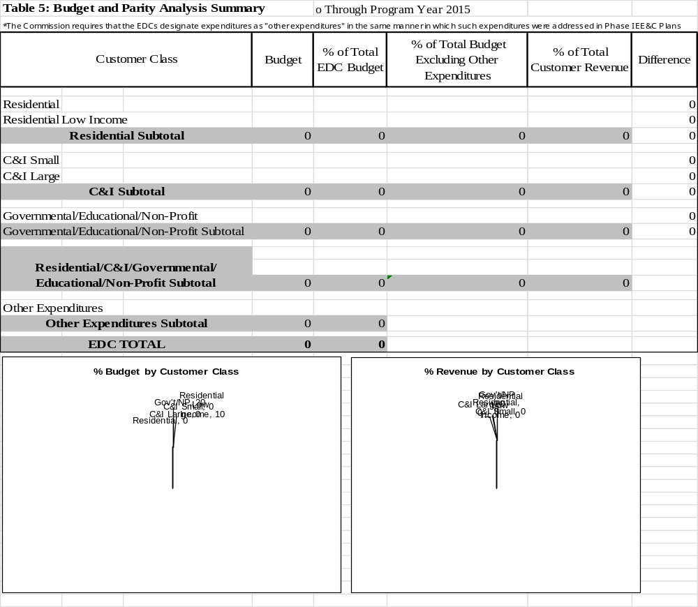

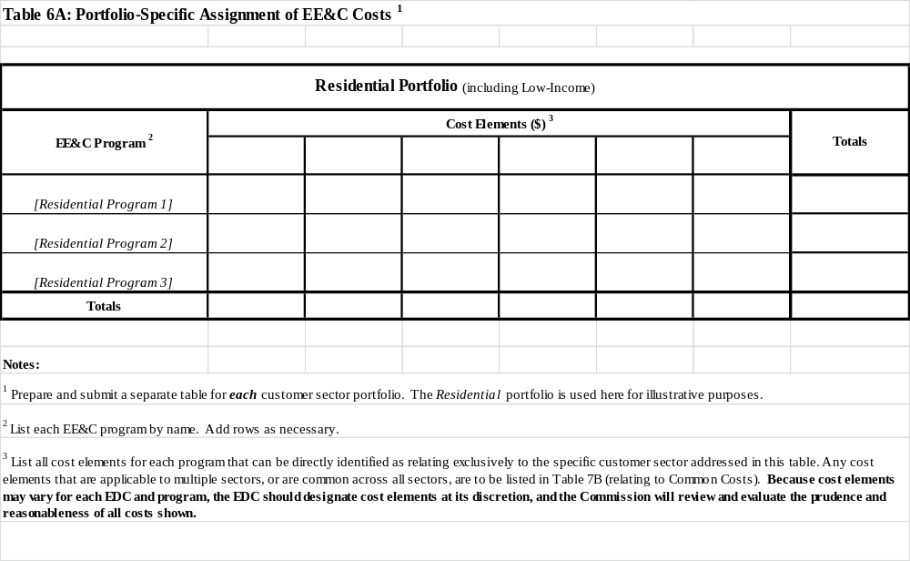

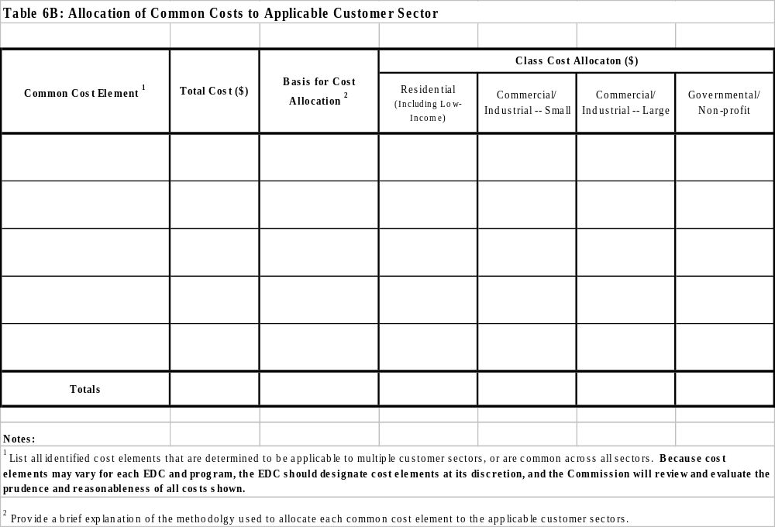

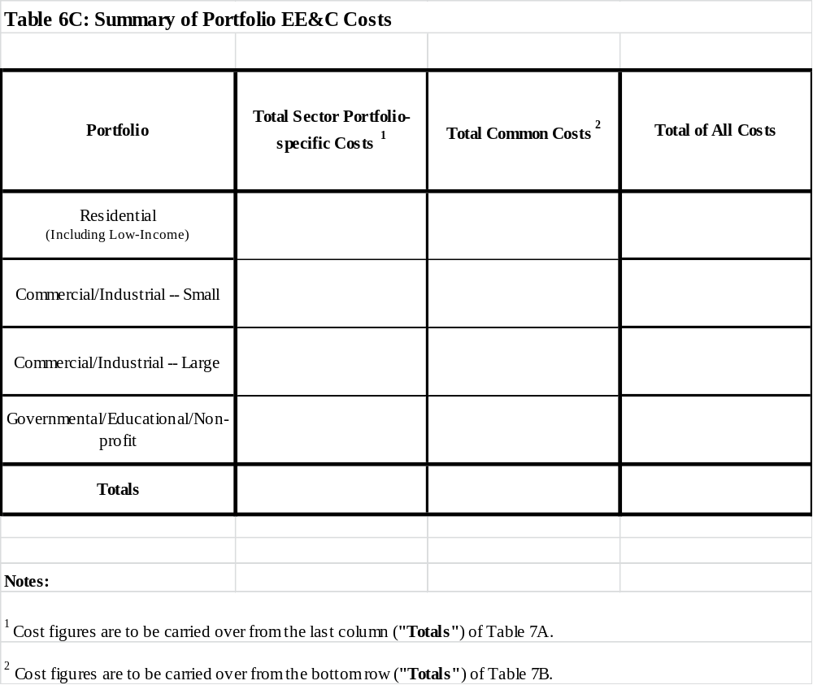

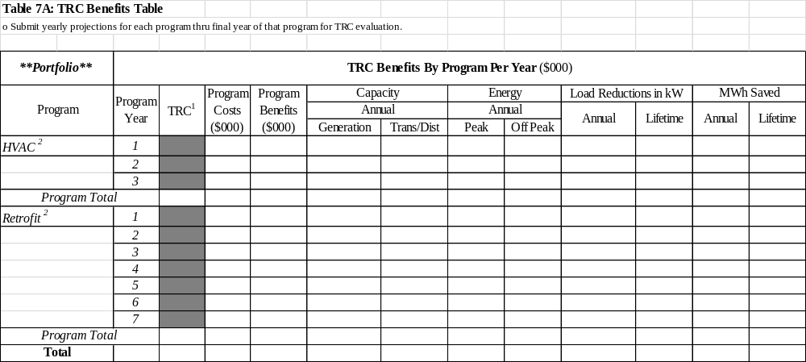

Chart 1: Gantt Chart of Program Schedule Summary (For Section 1.4)

- Chart will be formatted to fit on one 8½ - 11 page
- It will use color to differentiate schedule items
- Provide a separate chart for each Portfolio that includes:

- Start and completion dates for the launch and close of Residential Portfolio programs for Program Years 2013, 2014 & 2015
- Start and completion dates for the launch and close of Commercial/Industrial Small portfolio programs for Program Years 2013, 2014 & 2015
- Start and completion dates for the launch and close of Commercial/Industrial Large portfolio programs for Program Years 2013, 2014 & 2015
- Start and completion dates for the launch and close of Governmental/Educational/Non-Profit portfolio programs for Program Years 2013, 2014 & 2015

As well, include the following for each chart:
    - Start and completion dates for design of each Program Year
    - Dates at which CSPs will be selected and placed under contract for each portfolio
    - Dates at which EDC will provide annual program reports to Commission

A number of the tables have had reformatting done in order to incorporate proposed changes from the Commenters and, as such, may have a different appearance than originally proposed.
See PPL Comments at 2-8.
See, 2012 PA Total Resource Cost (TRC) Test, Order at M-2012-2300653, entered August 30, 2012, at 59-61.
EDCs should post clean and redlined versions of all plan revisions.
http://www.puc.state.pa.us/electric/Act129/EEC_Program.aspx.
Whenever assumptions are used, provide the basis for using that assumption.
Tables (and Chart) referenced in the template outline are located in the separate master spreadsheet.
A project is an activity or course of action involving one or multiple energy efficiency measures, at a single facility or site. A program is a group of projects, with similar characteristics and installed in similar applications. Individual programs include those that involve encouraging and/or incenting the installation of equipment or practices associated with new-construction and retrofit solar energy and energy efficiency projects. The portfolio consists of all the programs in the residential, commercial/industrial small, commercial/industrial large or governmental/educational/non-profit sectors. Residential sector programs include participants with a residential rate schedule. Commercial/Industrial Small sector programs include participants with a small C/I rate schedule. Commercial/Industrial Large sector programs include participants with large C/I rate schedule. Governmental/Educational/Non-Profit includes customers in any rate schedule who are Federal, State, Municipal, and Local Governments; as well as school districts, institutions of higher learning, and non-profit entities. The applicable EE&C sector designation is based on a customer’s rate schedule not the size of the energy efficiency project or the type of building.
It is assumed that there are three program years, each starting June 1 and ending May 31st. The first program year (PY) is Program Year 2013 and the last is Program Year 2015.
Services to be offered by EDC or others may include marketing, customer recruiting, demonstration projects, audits and or installation of new efficiency measures, verification of installations and or baseline usage, response to customer concerns, program tracking and program evaluation.
Performance risk is the risk that, due to design or implementation flaws, the program does not deliver expected savings. Technology risk is the risk that technologies targeted by a program fail to deliver the savings expected. Market risk is the risk that customers, or other key market players (e.g., contractors), choose not to participate in a program. Evaluation risk is the risk that independent EM&V will, based on different assumptions, conclude that savings fall short of what the implementers have estimated.
This Section may be modified if the Commission’s statewide EE&C Plan Evaluator develops further reporting and tracking systems that are approved by the Commission.
These sub-sections may reference other chapters of the plan as they may restate what was included elsewhere in the plan, and are collected here only for convenience of review.

