BEFORE THE
PENNSYLVANIA PUBLIC UTILITY COMMISSION

Equitable Gas Company, LLC Request for Approval of : R-2012-2304727
Supplement No. 79 to Tariff Gas Pa. P.U.C. No. 22 :

Equitable Gas Company, LLC Request for Approval of : R-2012-2304731
Supplement No. 80 to Tariff Gas Pa. P.U.C. No. 22 :
Equitable Gas Company, LLC Request for Approval of : R-2012-2304735
Supplement No. 81 to Tariff Gas Pa. P.U.C. No. 22 :

Office of Consumer Advocate : C-2012-2309502
: C-2012-2309538
v. : C-2012-2309549
:
Equitable Gas Company :

FOURTH INTERIM ORDER DENYING EQUITABLE’S MOTION TO QUASH DOMINION RETAIL’S REPLY BRIEF AND GRANTING EQUITABLE’S ALTERNATIVE MOTION FOR LEAVE TO RESPOND TO SAID REPLY BRIEF

On October 9, 2012, Equitable Gas Company, LLC (Equitable), filed a Motion to Quash or, in the Alternative, for Leave to Respond to the Reply Brief of Dominion Retail, Inc. (Motion). Equitable submitted, as Attachment A to the Motion, Response of Equitable Gas Company, LLC to Reply Brief of Dominion Retail, Inc. (Response).

On October 15, 2012, I issued a Third Interim Order setting October 17, 2012 as the due date for a responsive pleading for any party electing to respond to Equitable’s Motion. On October 16, 2012, Dominion Retail, Inc. (Dominion) filed an Answer to the Motion (Answer). Dominion contends Equitable’s Motion to Quash should be denied, but “… does not object to the ALJ considering Equitable’s Response.” No other party filed a responsive pleading to Equitable’s Motion.
After due consideration of the Motion and Answer, Equitable’s Motion to Quash Dominion’s Reply Brief is denied. Equitable’s Alternative Motion for Leave to Respond to Dominion’s Reply Brief is granted.

The Response of Equitable Gas Company, LLC to Reply Brief of Dominion Retail, Inc., which was submitted as Attachment A to Equitable’s Motion, is hereby deemed filed.

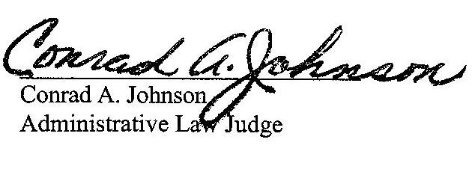
Date: October 19, 2012

R-2012-2304727, R-2012-2304731 & R-2012-2304735 EQUITABLE GAS COMPANY, LLC

CHARLES E THOMAS JR ESQUIRE
THOMAS LONG NIESEN & KENNARD
212 LOCUST ST
PO BOX 9500
HARRISBURG PA 17108-9500
cthomasjr@thomaslonglaw.com
717.255.7615
Represents Equitable Gas Company, LLC

ALLISON C KASTER ESQUIRE
PA PUC BUREAU OF INVESTIGATION & ENFORCEMENT LEGAL TECHNICAL
PO BOX 3265
400 NORTH STREET
HARRISBURG PA 17105-3265
akaster@pa.gov
717.783.7998

DARRYL A LAWRENCE ESQUIRE
OFFICE OF CONSUMER ADVOCATE
5TH FLOOR FORUM PLACE
555 WALNUT STREET
HARRISBURG PA 17101-1923
dlawrence@paoca.org
717.783.5048
C-2012-2309502; C-2012-2309538;
C-2012-2309549

SHARON WEBB ESQUIRE
OFFICE OF SMALL BUSINESS ADVOCATE
SUITE 1102
300 NORTH SECOND STREET
HARRISBURG PA 17101
swebb@pa.gov
717.783.2525

CRAIG R BURGRAFF ESQUIRE
HAWKE MCKEON & SNISCAK LLP
P O BOX 1778
100 N TENTH STREET
HARRISBURG PA 17105-1778
CRBurgraff@hmslegal.com
717.236.1300
Represents Intervenor Retail Energy Supply Association

TODD S STEWART ESQUIRE
HAWKE MCKEON & SNISCAK LLP
P O BOX 1778
100 N TENTH STREET
HARRISBURG PA 17105-1778
TSStewart@hmslegal.com
717.236.1300
Represents Intervenor Dominion Retail, Inc., d/b/a Dominion Energy Solutions

