 | COMMONWEALTH OF PENNSYLVANIA  PENNSYLVANIA PUBLIC UTILITY COMMISSION  P.O. BOX 3265, HARRISBURG, PA 17105-3265 | IN REPLY PLEASE REFER TO OUR FILE

October 25, 2012

Docket No. A-2012-2327971

JOHN D ERVIN
HEALTHTRUST PURCHASING GROUP LP
155 FRANKLIN ROAD SUITE 400
BRENTWOOD TN 37027

Re: Natural Gas Supplier License Application of
HealthTrust Purchasing Group, L.P.

Dear Mr. Ervin:

The Commission’s Regulation at 52 Pa. Code 62.109(b) states that:
Completed applications, with all supporting documentation, including any documentation or clarifying information requested by Commission staff, if unprotested, will be processed within 45 days after acceptance by the Commission. If the application is not processed within the time period, the application will be deemed approved. The review period may be extended for a reasonable period of time by Secretarial Letter.
You are hereby notified that the Commission has extended the period for consideration of the Application for authority to market natural gas until further order of the Commission.
If you are dissatisfied with the resolution of this matter, you may, as set forth in 52 Pa. Code § 5.44, file a petition with the Commission within twenty (20) days of the date of this letter.
Please direct any questions to Marc Hoffer, Bureau of Technical Utility Services at (717) 787-1869.
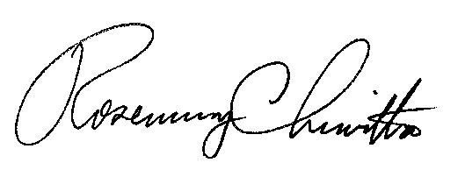
Sincerely,

Rosemary Chiavetta
Secretary

cc: Marc Hoffer, TUS

