PENNSYLVANIA
PUBLIC UTILITY COMMISSION
Harrisburg, PA 17105-3265

DAVID KEATING :
:
v. : C-2012-2287152
:
TOWN AND COUNTRY :
MOVING AND STORAGE :

FINAL ORDER

In accordance with the provisions of Section 332(h) of the Public Utility Code, 66 Pa. C.S. §332(h), the decision of Administrative Law Judge Eranda Vero dated August 2, 2012, has become final without further Commission action;

THEREFORE,

IT IS ORDERED:

1. That the formal Complaint filed by David J. Keating against Genco Enterprises LLC d/b/a Town and Country Moving and Storage at Docket No. C-2012-2287152 is denied for failure to carry the burden of proof.

2. That Genco Enterprises LLC d/b/a Town and Country Moving and Storage must allow David J. Keating to submit an insurance claim upon receipt of full payment of the price shown in the bill of lading dated December 21, 2011.

3. That the record at Docket Number C-2012-2287152 be marked closed.

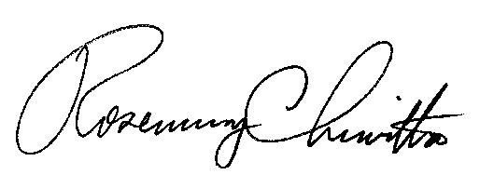
BY THE COMMISSION,

Rosemary Chiavetta
Secretary

(SEAL)

ORDER ENTERED: November 8, 2012

