PENNSYLVANIA
PUBLIC UTILITY COMMISSION
Harrisburg, PA. 17105-3265

Public Meeting held January 24, 2013

Commissioners Present:

Robert F. Powelson, Chairman
John F. Coleman, Jr., Vice Chairman
James H. Cawley,
Wayne E. Gardner,
Pamela A. Witmer

Request for Approval of Appointment of Docket No. M-00031715F0003
Bernard Zavatone to the Board of Directors
of the Sustainable Energy Fund of
Central Eastern Pennsylvania

ORDER
BY THE COMMISSION:

Before the Commission is a letter petition of the PPL Sustainable Energy
Fund of Central Eastern Pennsylvania (SEF) filed on November 6, 2012, for approval of one individual to its Board of Directors. This approval is required under the PPL Company restructuring settlement. Application of Pennsylvania Power & Light Company for Approval of its Restructuring Plan Under Section 2806 of the Public Utility Code, et al, Docket No. R-00973954 (Opinion and Order entered August 27, 1998). Commission approval of the proposed director is also required by SEF’s governing bylaws. PP&L Inc. Sustainable Energy Fund By-laws, Docket No. R-00973954 (Order entered June 2, 2000). The governing bylaws of the SEF were most recently updated in 2011. Request for Approval of Revisions to the Bylaws of the PPL Sustainable Energy Fund of Central Eastern Pennsylvania, Docket No. M-00031715F0003 (Order entered April 1, 2011).

There currently exists one vacancy on the SEF Board of Directors. The SEF’s Board of Directors unanimously voted to approve Bernard Zavatone at its Board meeting of October 31, 2012.

Bernard Zavatone brings a comprehensive technical skill set to the SEF Board. He is a licensed Professional Engineer at FL Smidth Company in Bethlehem, PA, a custom manufacturer of pneumatic conveying & material handling systems. Mr. Zavatone has worked for FL Smidth since 1993 and is currently General Manager of the Pneumatic Transportation Department. Mr. Zavatone has served in several other high-level capacities at FLSmidth including Sales Manager, Chief Engineer, and Project Manager. He holds a Bachelor of Science degree in Mechanical Engineering from Lehigh University and is a Licensed Professional Engineer.

Mr. Zavatone has a strong interest in the mission of the SEF from both a personal and professional standpoint. He has prior Board experience, nonprofit and community involvement and a technical and project management skill set that will add value to the Board.

The SEF’s Board and staff, in conjunction with its consultant, Menapace Business Consulting, conducted a search process for a qualified board member. The search process was conducted in conformity to the SEF’s bylaws, as amended, and as approved by the Commission. Further, the recruitment process was followed according to the PA Sustainable Energy Board Best Practice for Nomination, Election and Approval of Directors.

Based on a review of all relevant information, we find this nominee to be well qualified to serve on the SEF’s Board of Directors and he is, thereby, approved.

THEREFORE,

IT IS ORDERED:

1. That the nomination of Mr. Bernard Zavatone to the Sustainable Energy Fund Board of Directors is approved.

2. That a copy of this order be served on the Sustainable Energy Fund and Mr. Bernard Zavatone, the Office of Consumer Advocate and the Office of Small Business Advocate.
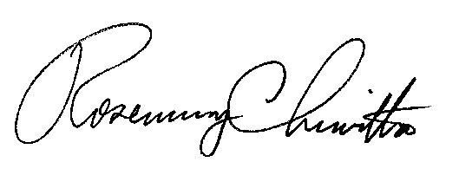
BY THE COMMISSION

Rosemary Chiavetta
Secretary

(SEAL)
ORDER ADOPTED: January 24, 2013
ORDER ENTERED: January 24, 2013

