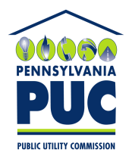 | COMMONWEALTH OF PENNSYLVANIA  PENNSYLVANIA PUBLIC UTILITY COMMISSION  P.O. BOX 3265, HARRISBURG, PA 17105-3265 | IN REPLY PLEASE REFER TO OUR FILE

February 27, 2013

Docket No. A-2009-2100320

PETER METZGER
ATTORNEY FOR PALMCO ENERGY PA LLC
CULLEN AND DYKMAN LLP
44 WALL STREET
NEW YORK NY 10005

Re: Natural Gas Supplier License Application for Additional Territory of
Palmco Energy PA, LLC.

Dear Mr. Metzger:

The Commission’s Regulation at 52 Pa. Code 62.109(b) states that:
Completed applications, with all supporting documentation, including any documentation or clarifying information requested by Commission staff, if unprotested, will be processed within 45 days after acceptance by the Commission. If the application is not processed within the time period, the application will be deemed approved. The review period may be extended for a reasonable period of time by Secretarial Letter.
You are hereby notified that the Commission has extended the period for consideration of the Application for authority to market natural gas until further order of the Commission.
If you are dissatisfied with the resolution of this matter, you may, as set forth in 52 Pa. Code § 5.44, file a petition with the Commission within twenty (20) days of the date of this letter.
Please direct any questions to Lee Yalcin, Bureau of Technical Utility Services at lyalcin@pa.gov or at (717) 787-6723.
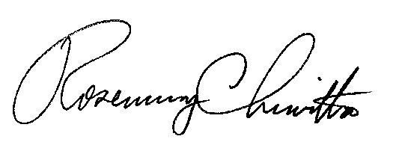
Sincerely,

Rosemary Chiavetta
Secretary

cc: Lee Yalcin, Bureau of Technical Utility Services

