NOTICE TO BE PUBLISHED

BEFORE THE
PENNSYLVANIA PUBLIC UTILITY COMMISSION

Pennsylvania Public Utility Commission Bureau of Investigation and Enforcement
v.
Steven J. Butts

Transportation Complaint C-2012-2325083

Hearing Notice

This is to inform you that a hearing on the above-captioned case will be held as follows:

Type: Initial Hearing

Date: Thursday, May 16, 2013

Time: 10:00 a.m.

Location: Hearing Room 2
Plaza Level
Commonwealth Keystone Building
400 North Street
Harrisburg, PA 17120

Presiding: Administrative Law Judge Susan Colwell
P.O. Box 3265
Harrisburg, PA 17105-3265
Phone: 717-787-1399
Fax: 717-787-0481

Attention: You may lose the case if you do not come to this hearing and present facts on the issues raised.

If you intend to file exhibits, 2 copies of all hearing exhibits to be presented into evidence must be submitted to the reporter. An additional copy must be furnished to the Presiding Officer. A copy must also be provided to each party of record.

Individuals representing themselves do not need to be represented by an attorney. All others (corporation, partnership, association, trust or governmental agency or subdivision) must be represented by an attorney. An attorney representing you should file a Notice of Appearance before the scheduled hearing date.

If you are a person with a disability, and you wish to attend the hearing, we may be able to make arrangements for your special needs. Please call the scheduling office at the Public Utility Commission at least five (5) business days prior to your hearing to submit your request.

If you require an interpreter to participate in the hearings, we will make every reasonable effort to have an interpreter present. Please call the scheduling office at the Public Utility Commission at least ten (10) business days prior to your hearing to submit your request.

- Scheduling Office: 717.787.1399
- AT&T Relay Service number for persons who are deaf or hearing-impaired: 1.800.654.5988

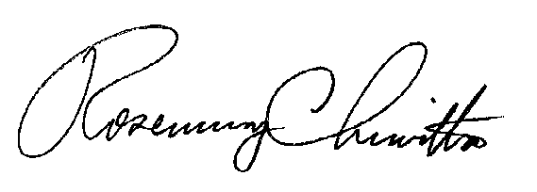
BY THE COMMISSION

Rosemary Chiavetta
Secretary

