 | COMMONWEALTH OF PENNSYLVANIA  PENNSYLVANIA PUBLIC UTILITY COMMISSION  P.O. BOX 3265, HARRISBURG, PA 17105-3265 | IN REPLY PLEASE REFER TO OUR FILE
May 29, 2013

MS TISHEKIA E WILLIAMS
SENIOR COUNSEL
DUQUESNE LIGHT COMPANY
411 SEVENTH AVENUE
16TH FLOOR MAIL DROP 16-1
PITTSBURGH PA 15219

RE: Consumer Education Surcharge Effective June 1, 2013
M-2013-2356644

Dear Ms. Williams:

The Bureau of Audits has reviewed revised proposed Supplement No. 73 to Tariff Electric - PA. P.U.C. No. 24 and the supporting rate computations submitted on May 22, 2013 to become effective on June 1, 2013.

Based upon staff review, it appears that the proposed Consumer Education Surcharge (CES) rates for the twelve month period of June 1, 2013 through May 31, 2014 are consistent with the tariff and, accordingly, are permitted to become effective as filed.

The Consumer Education Surcharge is subject to continuous Commission review and audit as well as reconciliation reports in accordance with Section 1307(e) of the Public Utility Code, 66 Pa. C.S. §1307(e).

Any subsequent submissions to the Commission related to this docketed case should reference Docket No. M-2013-2356644.
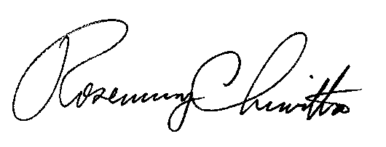
Very truly yours,

Rosemary Chiavetta
Secretary

Contact Person: Thomas R. Schwab
(412) 820-2601

cc: Office of Communications
Bureau of Investigation and Enforcement
Bureau of Technical Utility Services

