BEFORE THE
PENNSYLVANIA PUBLIC UTILITY COMMISSION

Pennsylvania Public Utility Commission : R-2013-2350914
Office of Small Business Advocate : C-2013-2354071
Daniel Killmeyer : C-2013-2355180
Office of Consumer Advocate : C-2013-2355226
Elizabeth F. Smith : C-2013-2359509
:
v. :
:
Peoples Natural Gas Company LLC :

THIRD INTERIM ORDER CORRECTING THE NAME OF THE
RESPONDENT IN THE CAPTION OF THE SECOND INTERIM ORDER

On March 1, 2013, Peoples Natural Gas Company LLC (Peoples or Company or Respondent) submitted its Purchased Gas Cost (PGC) pre-filing to the Pennsylvania Public Utility Commission’s (Commission) Secretary’s Bureau, pursuant to Section 1307(f) of the Public Utility Code, 66 Pa. C.S. §1307(f) and Section 53.64 of the Commission’s regulations, 52 Pa. Code §53.64. The pre-filing was captioned, “Pennsylvania Public Utility Commission v. Peoples Natural Gas Company LLC,” and docketed at No. R-2013-2350914. Subsequent to the pre-filing, other parties filed complaints which were consolidated with Docket No R-2013-2350914.

On May 28, 2013, the Second Interim Order Suspending and Revising, In Part, Litigation Schedule and Consolidating Complaints (Second Interim Order) issued in this proceeding incorrectly listed the Respondent in the caption. The Second Interim Order listed the Respondent as “Peoples TWP LLC” in the caption. The correct name of the Respondent is Peoples Natural Gas Company LLC.

This Third Interim Order hereby corrects the caption of the Second Interim Order to list the Respondent as Peoples Natural Gas Company LLC.

Except for the correction of Respondent’s name in the caption, the Second Interim
Order shall remain the same in all other respects.

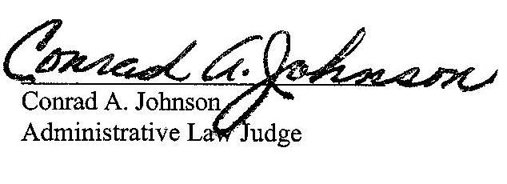
Date: May 31, 2013

_________________________________
Jeffrey Watson
Administrative Law Judge

R-2013-2350914, C-2013-2354071, C-2013-2355180, C-2013-2355226 & C-2013-2359509 – PUC, ET AL V. PEOPLES NATURAL GAS COMPANY LLC
LIMITED SERVICE LIST

Revised 5/31/13

MICHAEL W GANG ESQUIRE
ANTHONY D KANAGY ESQUIRE
ANDREW S TUBBS ESQUIRE
POST & SHELL PC
17 NORTH SECOND STREET
12TH FLOOR
HARRISBURG PA 17101-1601
717.731.1970
mgang@postshell.com
akanagy@postshell.com
atubbs@postshell.com

RICHARD KANASKIE ESQUIRE
CARRIE B WRIGHT ESQUIRE
PA PUC BUREAU OF INVESTIGATION
& ENFORCEMENT LEGAL TECHNICAL
PO BOX 3265
400 NORTH STREET
HARRISBURG PA 17105-3265
717.783.6184
rkanaskie@pa.gov
carwright@pa.gov

ARON J BEATTY ESQUIRE
BRANDON J PIERCE ESQUIRE
OFFICE OF CONSUMER ADVOCATE
5TH FLOOR FORUM PLACE
555 WALNUT STREET
HARRISBURG PA 17101-1923
717.783.5048
ABeatty@paoca.org
BPierce@paoca.org
ELIZABETH ROSE TRISCARI ESQUIRE
OFFICE OF SMALL BUSINESS ADVOCATE
SUITE 1102
300 NORTH SECOND STREET
HARRISBURG PA 17101
717.783.2525
etriscari@pa.gov

DANIEL KILLMEYER
184 MCKAY ROAD
SAXONBURG PA 16056
724.352.5029

ELIZABETH F SMITH
305 PINE STREET
ZELIENOPLE PA 16063
724.473.0784
C-2013-2359509

