PENNSYLVANIA
PUBLIC UTILITY COMMISSION
Harrisburg, PA 17105-3265

Juan Carlos Rodriguez Juavez :
:
v. : F-2012-2327298
:
PPL Electric Utilities Corporation :

FINAL ORDER

In accordance with the provisions of Section 332(h) of the Public Utility Code, 66 Pa. C.S. §332(h), the decision of Administrative Law Judge Ember S. Jandebeur dated April 29, 2013, has become final without further Commission action;

THEREFORE,

IT IS ORDERED:

- That the Formal Complaint of Juan Carlos Rodriguez Juavez is denied and dismissed.

- That the Secretary’s Bureau mark Docket No. F-2012-2327298 closed.

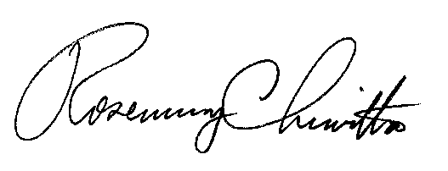
BY THE COMMISSION,

Rosemary Chiavetta
Secretary

(SEAL)

ORDER ENTERED: June 6, 2013

