 | COMMONWEALTH OF PENNSYLVANIA  PENNSYLVANIA PUBLIC UTILITY COMMISSION  P.O. BOX 3265, HARRISBURG, PA 17105-3265 | IN REPLY PLEASE REFER TO OUR FILE
August 22, 2013
Docket No. U-2013-2378064

PAUL E RUSSELL
ASSOCIATE GENERAL COUNSEL
PPL ELECTRIC UTILITIES CORPORATION
TWO NORTH NINTH STREET
ALLENTOWN PA 18101-1179

Re: Agreement of Sale between PPL Electric Utilities Corporation and Borough of Slatington, Lehigh County, PA.

Dear Mr. Russell:

On August 6, 2013, you filed an agreement between PPL Electric Utilities Corporation and Borough of Slatington, docketed at U-2013-2378064.

Title 66 Pa. C.S.A. § 507 states that:

“Upon notice to the municipal authorities, and the public utility concerned, the Commission may, prior to the effective date of such contract or agreement, institute proceedings to determine the reasonableness, legality or any other matter affecting the validity thereof. Upon the institution of such proceedings, such contract or agreement shall not be effective until the Commission grants its approval thereof.

You are hereby notified that the Commission is instituting a proceeding to review the Agreement of Sale, and the period for consideration of this agreement is extended until further order of the Commission.

If you are dissatisfied with the resolution of this matter, you may, as set forth in 52 Pa. Code §5.44, file a petition with the Commission within (20) days of the date of this letter.

Please direct any questions to Nicholas Okoro, Bureau of Technical Utility Services at (717) 772-0613.
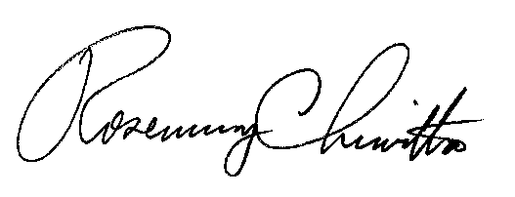
Sincerely,

Rosemary Chiavetta
Secretary

