PENNSYLVANIA
PUBLIC UTILITY COMMISSION
Harrisburg, PA 17105-3265

Donald Mulzet :
:
v. : C-2013-2367132
:
PPL Electric Utilities Corporation :

FINAL ORDER

In accordance with the provisions of Section 332(h) of the Public Utility Code, 66 Pa. C.S. §332(h), the decision of Administrative Law Judge David A. Salapa dated July 22, 2013, has become final without further Commission action;

THEREFORE,

IT IS ORDERED:

1. That the preliminary objections filed by PPL Electric Utilities Corporation at Docket No. C-2013-2367132 are sustained.

2. That the complaint of Donald Mulzet at Docket No. C-2013-2367132 against PPL Electric Utilities Corporation is dismissed.

3. That the docket at Docket No. C-2013-2367132 is marked closed.

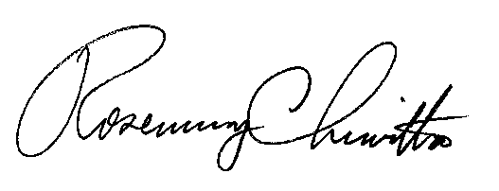
BY THE COMMISSION,

Rosemary Chiavetta
Secretary

(SEAL)

ORDER ENTERED: August 28, 2013

