PENNSYLVANIA
PUBLIC UTILITY COMMISSION
Harrisburg, PA 17105-3265

Michele Jones : :
v. : C-2013-2356361 :
PECO Energy Company :

FINAL ORDER

In accordance with the provisions of Section 332(h) of the Public Utility Code, 66 Pa. C.S. §332(h), the decision of Administrative Law Judge Elizabeth H. Barnes dated July 16, 2013, has become final without further Commission action;

THEREFORE,

IT IS ORDERED:

1. That PECO Energy Company’s Preliminary Objections are hereby sustained.

2. That the Complaint filed by Michele Jones against PECO Energy Company docketed at Docket Number C-2013-2356361 is dismissed and the docket be marked closed.

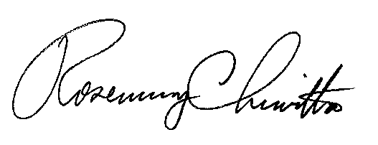
BY THE COMMISSION,

Rosemary Chiavetta
Secretary

(SEAL)

ORDER ENTERED: August 28, 2013

