PENNSYLVANIA
PUBLIC UTILITY COMMISSION
Harrisburg, PA 17105-3265

LouiGens Piller :
:
v. : C-2013-2365623
:
Philadelphia Gas Works :

FINAL ORDER

In accordance with the provisions of Section 332(h) of the Public Utility Code, 66 Pa. C.S. §332(h), the decision of Administrative Law Judge Susan D. Colwell dated July 29, 2013, has become final without further Commission action;

THEREFORE,

IT IS ORDERED:

1. That the Complaint filed in the case captioned LouiGens Piller v. Philadelphia Gas Works, filed at PUC Docket No. C-2013-2365623, is dismissed.

2. That the Secretary mark this docket closed.
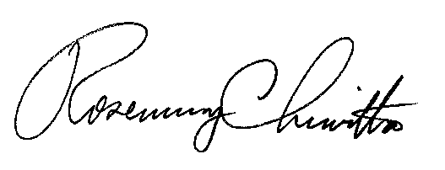
BY THE COMMISSION,

Rosemary Chiavetta
Secretary

(SEAL)

ORDER ENTERED: August 28, 2013

