PENNSYLVANIA
PUBLIC UTILITY COMMISSION
Harrisburg, PA 17105-3265

Public Meeting held August 29, 2013

Commissioners Present:

Robert F. Powelson, Chairman
John F. Coleman, Jr., Vice Chairman
Wayne E. Gardner
James H. Cawley
Pamela A. Witmer

Application of Clyde L. Jackson, Jr., A-00123040
for the discontinuance of service and cancellation A-2013-2357419
of his Certificate of Public Convenience as a common
carrier, by motor vehicle at A-00123040 authorizing
the transportation of persons in paratransit service
between points in the borough of Spartansburg,
Crawford County, and within an airline distance
of 100 statute miles of the limits of said borough.

ORDER

BY THE COMMISSION:

This matter comes before the Commission on an application filed April 1, 2013. Public notice of the application was given in the Pennsylvania Bulletin of July 6, 2013, with protests due by July 22, 2013. No protests were filed and no hearings were held. The unopposed application is certified to the Commission for its decision without oral hearing.

DISCUSSION AND FINDINGS

Clyde L. Jackson, Jr., has made application for discontinuance of paratranit authority. The Applicant has met the Commission's requirements for the discontinuance of service to eliminate the following right:

To transport, as a common carrier, persons in paratransit service, between points in the borough of Spartansburg, Crawford County, and within an airline distance of 100 statute miles of the limits of said borough.

IT IS ORDERED: That the application for abandonment and discontinuance of service be and is hereby approved, and that the Certificate issued on May 11, 2007 at A-00123040, under Order entered March 23, 2007, be and is hereby cancelled. Applicant does not hold any other active authority with the Commission.
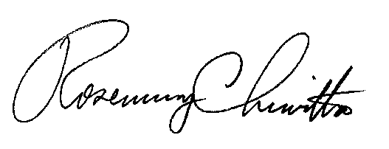
BY THE COMMISSION,

Rosemary Chiavetta
Secretary

(SEAL)

ORDER ADOPTED: August 29, 2013

ORDER ENTERED: August 29, 2013

