PENNSYLVANIA
PUBLIC UTILITY COMMISSION
Harrisburg, PA 17105-3265

Margaret Bush :
:
v. : C-2013-2366259
:
PPL Electric Utilities Corporation :

FINAL ORDER

In accordance with the provisions of Section 332(h) of the Public Utility Code, 66 Pa. C.S. §332(h), the decision of Administrative Law Judge Ember S. Jandebeur dated July 24, 2013, has become final without further Commission action;

THEREFORE,

IT IS ORDERED:

1. That the motion of PPL Electric Utilities Corporation to dismiss the Complaint of Margaret Bush at Docket No. C-2013-2366259 is granted.

2. That the Formal Complaint filed by Margaret Bush against PPL Electric Utilities Corporation at Docket No. C-2013-2366259 is dismissed with prejudice for failure to prosecute.

3. That the Secretary’s Bureau shall mark Docket No. C-2013-2366259 closed.

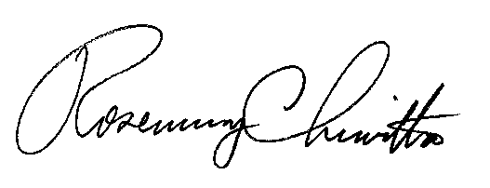
BY THE COMMISSION,

Rosemary Chiavetta
Secretary

(SEAL)

ORDER ENTERED: August 30, 2013

