PENNSYLVANIA
PUBLIC UTILITY COMMISSION
Harrisburg, PA 17105-3265

Shelly Siegfried :
:
v. : F-2012-2339635
:
PECO Energy Company :

FINAL ORDER

In accordance with the provisions of Section 332(h) of the Public Utility Code, 66 Pa. C.S. §332(h), the decision of Administrative Law Judge Cynthia Williams Fordham dated July 12, 2013, has become final without further Commission action;

THEREFORE,

IT IS ORDERED:

1. That the complaint filed by Shelly Siegfried against the PECO Energy Company at Docket No. F-2012-2339635 is granted with respect to the payment arrangement allegations and denied regarding the termination without notice allegations.

2. That the Complainant shall make monthly payments consisting of her budget bill plus one twenty-fourth (1/24th) of the balance accrued on her account, beginning with the first billing due date following the entry of a final Commission Order in this case.

3. That as long as the Complainant makes payments as directed in this Order, the Respondent shall not suspend or terminate her utility service except for valid safety or emergency reasons or assess late payments or finance charges against her account.

4. That, if the Complainant does not make payments as directed in this Order, the Respondent is authorized to suspend or terminate her utility service in accordance with the Commission’s statute and regulations.

5. That this case is marked closed.

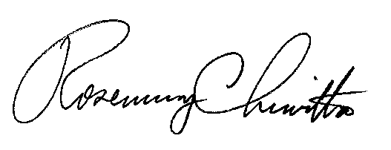
BY THE COMMISSION,

Rosemary Chiavetta
Secretary

(SEAL)

ORDER ENTERED: August 30, 2013

