PENNSYLVANIA
PUBLIC UTILITY COMMISSION
Harrisburg, PA 17105-3265

Pierre Alexandre :
:
v. : C-2012-2337351
:
Philadelphia Gas Works :

FINAL ORDER

In accordance with the provisions of Section 332(h) of the Public Utility Code, 66 Pa. C.S. §332(h), the decision of Administrative Law Judge Darlene Heep dated July 10, 2013, has become final without further Commission action;

THEREFORE,

IT IS ORDERED:

1. That the Complaint of Pierre Alexandre against Philadelphia Gas Works filed at C-2012-2337351 is dismissed, with prejudice;

2. That the docket at C-2012-2337351 be marked closed.

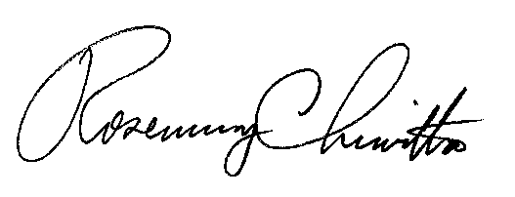
BY THE COMMISSION,

Rosemary Chiavetta
Secretary

(SEAL)

ORDER ENTERED: August 30, 2013

