PENNSYLVANIA
PUBLIC UTILITY COMMISSION
Harrisburg, PA 17105-3265

Leslie Marant :
:
v. : C-2012-2335264
:
Philadelphia Gas Works :

FINAL ORDER

In accordance with the provisions of Section 332(h) of the Public Utility Code, 66 Pa. C.S. §332(h), the decision of Administrative Law Judge Christopher P. Pell dated July 17, 2013, has become final without further Commission action;

THEREFORE,

IT IS ORDERED:

1. That the complainant’s Petition for Leave to Withdraw her Complaint filed at Docket No. C-2012-2335264 is granted;

2. That the Complaint of Leslie Marant filed November 9, 2012 at Docket No. C-2012-2335264, is withdrawn; and

3. That the Secretary’s Bureau shall mark Docket No. C-2012-2335264 as closed.

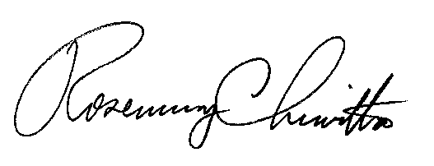
BY THE COMMISSION,

Rosemary Chiavetta
Secretary

(SEAL)

ORDER ENTERED: August 30, 2013

