PENNSYLVANIA
PUBLIC UTILITY COMMISSION
Harrisburg, PA 17105-3265

Amtreccia Wilson :
:
v. : C-2013-2359541
:
PECO Energy Company :

FINAL ORDER

In accordance with the provisions of Section 332(h) of the Public Utility Code, 66 Pa. C.S. §332(h), the decision of Special Agent Tiffany A. Hunt dated July 29, 2013, has become final without further Commission action;

THEREFORE,

IT IS ORDERED:

1. That the Formal Complaint filed by Amtreccia Wilson against PECO Energy Company at Docket No. C-2013-2359541 is denied in part and granted in part.

2. That the Complaint is denied as to Amtreccia Wilson’s request for a payment agreement on the portion of her balance that is subject to Customer Assistance Program rates.

3. That the Complaint is granted as to Amtreccia Wilson’s request for a payment agreement on the portion of her balance that is not subject to Customer Assistance Program rates.

4. That Amtreccia Wilson shall make monthly payments consisting of her current charges or budget bill plus one twenty-fourth (1/24th) of the balance accrued on her account that is not subject to Customer Assistance Program rates, beginning with the first billing due date following the entry of a final Commission Order in this case.

5. That as long as Amtreccia Wilson keeps the payment schedule stated in this Order, PECO Energy Company shall not suspend or terminate her utility service except for valid safety or emergency reasons or assess late payments or finance charges against her account.

6. That, if Amtreccia Wilson does not keep the payment schedule stated in this Order, PECO Energy Company is authorized to suspend or terminate her utility service in accordance with the Commission’s statute and regulations.

7. That the Secretary mark this docket closed.

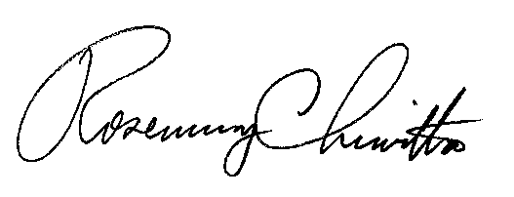
BY THE COMMISSION,

Rosemary Chiavetta
Secretary

(SEAL)

ORDER ENTERED: September 4, 2013

