PENNSYLVANIA
PUBLIC UTILITY COMMISSION
Harrisburg, PA 17105-3265

Erica A. Rodriguez :
:
v. : C-2013-2356611
:
Philadelphia Gas Works :

FINAL ORDER

In accordance with the provisions of Section 332(h) of the Public Utility Code, 66 Pa. C.S. §332(h), the decision of Administrative Law Judge Christopher P. Pell dated August 2, 2013, has become final without further Commission action;

THEREFORE,

IT IS ORDERED:

- That the motion of Philadelphia Gas Works to dismiss the Complaint filed at Docket No. C-2013-2356611 is granted;

- That the Complaint of Erica A. Rodriguez against Philadelphia Gas Works at Docket No. C-2013-2356611 is dismissed with prejudice; and

- That the Secretary’s Bureau shall mark Docket No. C-2013-2356611 as closed.
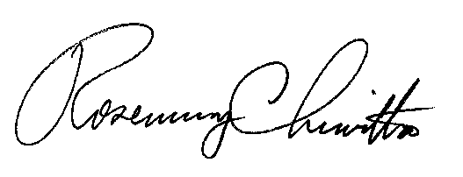
BY THE COMMISSION,

Rosemary Chiavetta
Secretary
(SEAL)

ORDER ENTERED: September 9, 2013

