PENNSYLVANIA
PUBLIC UTILITY COMMISSION
Harrisburg, PA 17105-3265

Yi Jing Groeber :
:
v. : C-2012-2326167
:
Verizon Pennsylvania LLC f/k/a :
Verizon Pennsylvania Inc. :

FINAL ORDER

In accordance with the provisions of Section 332(h) of the Public Utility Code, 66 Pa. C.S. §332(h), the decision of Administrative Law Judge Angela T. Jones dated July 5, 2013, has become final without further Commission action;

THEREFORE,

IT IS ORDERED:

1. That the formal Complaint filed by Yi Jing Groeber against Verizon Pennsylvania LLC f/k/a Verizon Pennsylvania Inc. at Docket No. C-2012-2326167 is dismissed.

2. That the Secretary’s Bureau shall mark the matter at Docket No. C-2012-2326167 closed.

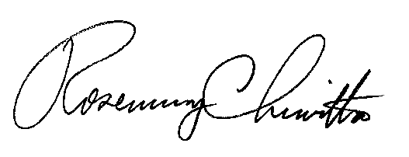
BY THE COMMISSION,

Rosemary Chiavetta
Secretary

(SEAL)

ORDER ENTERED: September 9, 2013

