PENNSYLVANIA
PUBLIC UTILITY COMMISSION
Harrisburg, PA 17105-3265

Jacque Whaumbush :
:
v. : C-2013-2351152
:
PECO Energy Company :

FINAL ORDER

In accordance with the provisions of Section 332(h) of the Public Utility Code, 66 Pa. C.S. §332(h), the decision of Administrative Law Judge Marta Guhl dated July 12, 2013, has become final without further Commission action;

THEREFORE,

IT IS ORDERED:

1. That the motion of PECO Energy Company to dismiss the Complaint filed at Docket No. C-2013-2351152 is granted;

2. That the Complaint of Jacque Whaumbush against PECO Energy Company at Docket No. C-2013-2351152 is dismissed with prejudice; and

3. That the case at Docket No. C-2013-2351152 be marked closed.

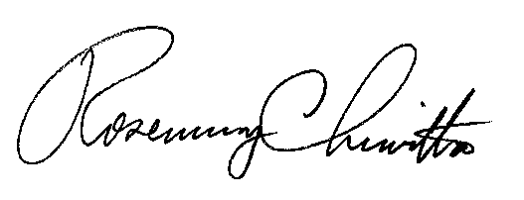
BY THE COMMISSION,

Rosemary Chiavetta
Secretary

(SEAL)

ORDER ENTERED: September 9, 2013

