 | COMMONWEALTH OF PENNSYLVANIA  PENNSYLVANIA PUBLIC UTILITY COMMISSION  P.O. BOX 3265, HARRISBURG, PA 17105-3265 | IN REPLY PLEASE REFER TO OUR FILE
September 17, 2013

MR RICHARD G WEBSTER JR
VICE PRESIDENT REGULATORY POLICY AND STRATEGY
PECO ENERGY COMPANY
2301 MARKET STREET S15
PHILADELPHIA PA 19103

RE: Smart Meter Cost Recovery Surcharge
Section 1307(e) Reconciliation Statement
For the twelve months ended June 30, 2013
M-2013-2378089

Dear Mr. Webster:

The Commission’s Bureau of Audits has reviewed the Smart Meter Cost Recovery Surcharge (SMCRS) Section 1307(e) Reconciliation Statement for the twelve months ended June 30, 2013.

Based upon staff review, it appears that the SMCRS Section 1307(e) Reconciliation Statement, filed on August 1, 2013, is mathematically accurate and, accordingly shall be deemed an adequate filing within the meaning of Section 1307(e) of the Public Utility Code, 66 Pa. C.S. §1307(e).

Acceptance of the SMCRS Section 1307(e) Reconciliation Statement is expressly subject to such further review and revision as may be found necessary as the result of a subsequent Commission audit pursuant to Section 1307(d) of the Public Utility Code, 66 Pa. C.S. §1307(d), or some other proceeding. Acceptance shall not constitute approval of either the accuracy of the reported figures or the reasonableness of the underlying transactions.

This Secretarial Letter does not preclude a party from later filing a complaint on the substance or operation of the adjustment clause rate change filing. Any subsequent submissions to the Commission related to this docketed case should reference Docket No. M-2013-2378089.

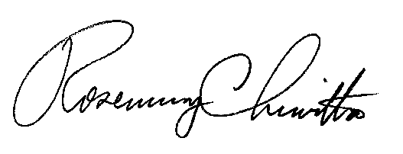
Sincerely,

Rosemary Chiavetta Secretary

Contact Person: Keith L. Mather
(717) 772-3440

