PENNSYLVANIA
PUBLIC UTILITY COMMISSION
Harrisburg, PA 17105-3265

Yuhan Group, LLC :
:
v. : C-2013-2371550
:
Philadelphia Gas Works :

FINAL ORDER

In accordance with the provisions of Section 332(h) of the Public Utility Code, 66 Pa. C.S. §332(h), the decision of Administrative Law Judge Ember S. Jandebeur dated August 22, 2013, has become final without further Commission action;

THEREFORE,

IT IS ORDERED:

1. That the Preliminary Objection filed on July 22, 2013, by Philadelphia Gas Works in the above-captioned case challenging the jurisdiction of the Pennsylvania Public Utility Commission is sustained.

2. That the Complaint filed June 24, 2013, by Yuhan Group, LLC against Philadelphia Gas Works, Docket No. C-2013-2371550, is dismissed.

3. That the docket at Docket No. C-2013-2371550 be marked closed.

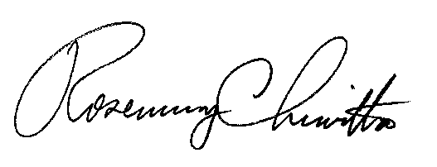
BY THE COMMISSION,

Rosemary Chiavetta
Secretary

(SEAL)

ORDER ENTERED: October 7, 2013

